Contents
1.1 Purpose and Scope 8
2 Design Overview 9
2.1 List of the required interfaces 9
2.2 Type of the interface 9
2.3 Interface class structure 9
2.4 Call management 11
2.5 Usage 11
2.5.1 Protocol 11
2.5.2 Error handling 11
2.6 Example 12
2.7 Detailed description 12
2.7.1 CmessageManagerBase class 13
2.7.2 Methods: 13
2.8 CMessageRouterProxy class 14
2.8.1 CMmDataPackage and other packaging classes 15
2.8.2 Code architecture 15
3 Plugin Specifications 15
3.1 Generic functionality 15
3.1.1 Response with an error from Baseband 15
3.1.2 Connecting to Baseband failed 15
3.1.3 Cancelling operations 16
3.1.4 Notifications 16
3.1.5 Boot–up 16
3.1.6 Two-phased methods 18
3.2 Voice call interface 18
3.2.1 Generic sequences for all call requests 18
3.2.2 Creating a voice call 20
3.2.3 Creating an emergency call 21
3.2.4 Creating a voice call through a third party application 22
3.2.5 Incoming voice call 23
3.2.6 Mobile originated call clearing 25
3.2.7 Mobile terminated call clearing 26
3.2.8 Holding a voice call 27
3.2.9 Resuming a call 29
3.2.10 Swapping active and held voice calls 29
3.2.11 Call transfering 30
3.2.12 Blacklist clearing 31
3.2.13 Remote call event 31
3.2.14 Activate the User-To-User Signalling service 32
3.2.15 Receive User-To-User Information 32
3.3 Phone interface 33
3.3.1 Sending DTMF tones 33
3.3.2 Starting and stopping a DTMF tone 34
3.4 Conference call interface 35
3.4.1 Creating a conference 35
3.4.2 Adding a call to a conference 35
3.4.3 Swapping conference 37
3.4.4 Hanging up a conference 41
3.4.5 Going one-to-one with one party 41
3.5 Circuit-switched data interface 43
3.5.1 Notify modem detected 43
3.5.2 Notifying of HSCSD information change 44
3.5.3 Notifying of mobile data call caps change 44
3.5.4 Notifying of multimedia data rate change 45
3.5.5 Setting dynamic HSCSD parameters 45
3.5.6 Getting call parameters 46
3.5.7 Getting bearer service information 46
3.5.8 Loaning data port 46
3.5.9 Recovering data port 47
3.5.10 Generic sequences for all data call requests 47
3.5.11 Creating a data call 48
3.5.12 Incoming data call 48
3.5.13 Mobile originated data call clearing 48
3.5.14 Mobile terminated data call clearing 48
3.6 Networking interface 48
3.6.1 Get home network 48
3.6.2 Get network registration status 49
3.6.3 Indication of current network change 50
3.6.4 Indication of network mode 50
3.6.5 Indication of network registration 51
3.6.6 Indication of network selection setting change 51
3.6.7 Indication of time and zone information 52
3.6.8 Indication of signal strength 52
3.6.9 Manual network selection 53
3.6.10 Manual network selection cancel 54
3.6.11 Manual network search 54
3.6.12 Manual network search cancel 54
3.6.13 Set network selection setting 55
3.6.14 Get ciphering indicator status 56
3.6.15 Indication of network security level change 56
3.6.16 Custom get ciphering information 57
3.6.17 Custom net wakeup information 57
3.6.18 Custom get operator name 58
3.6.19 Custom reset network registration status 58
3.6.20 Indication of custom network connection failure 59
3.6.21 Custom get system network modes 59
3.6.22 Custom set system network mode 60
3.6.23 Custom get current system network modes 60
3.6.24 Custom read HSUPA/HSDPA Status 61
3.6.25 Custom write HSUPA/HSDPA Status 61
3.6.26 Indication of custom HSUPA/HSDPA Status change 61
3.6.27 Custom get cell info 62
3.6.28 Indication of custom cell info change 63
3.6.29 Get cell info 63
3.6.30 Register for indication of cell info change 64
3.6.31 Indication of cell info change 64
3.7 Packet data interface 64
3.7.1 Packet service initialisation 64
3.7.2 Packet service, PDP context and QoS activation and deactivation 66
3.7.3 Packet service, MBMS context activation and deactivation 68
3.7.4 Packet service attach 70
3.7.5 Packet service detach 70
3.7.6 Packet service GetNetworkRegistrationStatus 71
3.7.7 Packet service RejectActivationRequested 71
3.7.8 Packet service SetAttachMode 72
3.7.9 Packet service GetAttachMode 73
3.7.10 Packet service SetDefaultContextParameters 73
3.7.11 Packet service SetPreferredBearer 74
3.7.12 Packet service get static capabilities 75
3.7.13 Packet service get Mbms network service status 75
3.7.14 Packet service notify Mbms network service status change 76
3.7.15 Packet service update Mbms monitor service list 76
3.7.16 Packet service notify Mbms service availability change 77
3.7.17 Packet service enumerate Mbms monitor service list 78
3.7.18 Packet service enumerate Mbms active service list 78
3.7.19 Packet context initialisation 80
3.7.20 Packet context configuration 80
3.7.21 Packet context activation 81
3.7.22 Packet context deactivation 82
3.7.23 Packet context deletion 82
3.7.24 Packet context GetDataVolumeTransferred 83
3.7.25 Packet context Set QoS profile parameters 84
3.7.26 Packet context Add packet filters 84
3.7.27 Packet context Remove packet filters 85
3.7.28 Packet context Add media authorization parameters 85
3.7.29 Packet context Remove media authorization parameters 85
3.7.30 Packet service NotifyTransferCaps 86
3.7.31 Packet service Custom Set Always On 86
3.7.32 Packet service Custom Notify Rau Event 87
3.7.33 MBMS context initialisation 87
3.7.34 MBMS context configuration 88
3.7.35 MBMS context session update 88
3.7.36 MBMS context activation 89
3.7.37 MBMS context deactivation 89
3.7.38 MBMS context deletion 90
3.7.39 Packet Context - GetConnectionInfo 91
3.7.40 Packet Context – NotifyConnectionInfoChange 91
3.8 Supplementary services interface 91
3.8.1 Getting the call barring status 91
3.8.2 Getting the call forwarding status 92
3.8.3 Getting the call waiting status 94
3.8.4 Getting the identity service status 94
3.8.5 Setting the call barring status 95
3.8.6 Setting the call forwarding status 96
3.8.7 Setting the call waiting status 97
3.8.8 Setting the supplementary services password 98
3.8.9 Setting ICC Message Waiting Indicators 99
3.8.10 Getting ICC Message Waiting Indicators 100
3.8.11 Notify if ICC Message Waiting Indicators are changed 100
3.8.12 Setting ICC call forwarding status indicator 101
3.8.13 Getting ICC call forwarding status indicator 101
3.9 Security interface 102
3.9.1 Getting the “Is blocked” status 102
3.9.2 Checking the security code 103
3.9.3 Disabling the phone lock 104
3.9.4 Getting lock information 104
3.9.5 Changing the security code 105
3.9.6 Aborting an ongoing security related request 106
3.9.7 Verifying the security code 106
3.9.8 Setting lock setting 107
3.9.9 Notifying security event 107
3.9.10 Notifying lock information change 108
3.9.11 Getting active PIN state 109
3.9.12 Cancelling security code check 109
3.9.13 Modem status ready notification on phone boot-up 110
3.9.14 SIM status ready notification on phone boot-up 110
3.9.15 Security ready notification on phone boot-up 111
3.9.16 Getting RF status on phone boot-up 111
3.9.17 Getting the SIM ICC type 112
3.9.18 Delivering the security code 112
3.9.19 Getting information of the PIN1 disable support 112
3.9.20 Getting security code information 113
3.9.21 Notifying security code information change 114
3.10 Messaging interface 114
3.10.1 USSD 114
3.10.2 Cell broadcast 115
3.10.3 SMS 117
3.11 Phone storage interface 126
3.11.1 Phonebook initialisation 126
3.11.2 Filling the phonebook cache 126
3.11.3 Reading entries 127
3.11.4 Writing an entry 127
3.11.5 Deleting an entry 128
3.11.6 Deleting all entries 129
3.11.7 Getting the phonebook storage information 129
3.11.8 Resetting the phonebook cache 130
3.11.9 Reading emergency number store (ENstore) entry 131
3.11.10 Reading all emergency number store (ENstore) entries 131
3.11.11 Getting the emergency number store (ENstore) information 132
3.11.12 Reading own number store (ONstore) entry 132
3.11.13 Getting the own number store (ONstore) information 133
3.11.14 Deleting an own number store (ONstore) entry 133
3.11.15 Deleting all own number store (ONstore) entries 134
3.11.16 Writing own number store (ONstore) entry 134
3.11.17 Reading own number store (ONstore) read size 135
3.11.18 Reading own number store (ONstore) write size 135
3.11.19 Reading own number store (ONstore) entry in read all sequence 136
3.11.20 Writing own number store (ONstore) entry in write all sequence 136
3.12 WIM interface 136
3.12.1 Powering SIM on 136
3.12.2 Powering SIM off 137
3.12.3 SIM warm reset 137
3.12.4 Getting an answer to reset status 138
3.12.5 Sending of an Application Data Unit (APDU) 139
3.12.6 Getting SIM CardReader Status 139
3.12.7 Notify SIM Card Status 140
3.12.8 Send APDU request 140
3.13 SIM interface 141
3.13.1 Start browsing the SIM Cell Broadcast Topics 141
3.13.2 Deleting SIM Cell Broadcast Topic 141
3.13.3 Reading SIM File 142
3.13.4 Getting SIM authentication data 142
3.13.5 Getting IMS authentication data (CustomAPI) 143
3.13.6 Getting IMS authorization information 143
3.13.7 Authenticating IMS data 144
3.13.8 Reading ViagHomeZoneParams 144
3.13.9 Reading ViagHomeZoneCache 145
3.13.10 Writing ViagHomeZoneCache 145
3.13.11 Writing ViagHomeZoneUHZIUESettings 146
3.13.12 GetNetworkProviderName 146
3.13.13 SatRefreshComplete Notification 147
3.14 SIM Lock interface 147
3.14.1 Activating SimLock 147
3.14.2 Deactivating SimLock 148
3.15 Miscellaneous Phone 148
3.15.1 Getting customer service profile 148
3.15.2 Getting service table 149
3.15.3 Getting phone ID 149
3.15.4 Getting subscriber ID 150
3.15.5 Getting active ALS line 150
3.15.6 Setting active ALS line 150
3.15.7 Getting fixed dialling numbers status 151
3.15.8 Setting fixed dialling numbers setting 151
3.15.9 Getting service provider name 152
3.15.10 Setting drive mode 152
3.15.11 Getting mailbox numbers 153
3.15.12 Enumerating Access Point Name (APN) control list entries 153
3.15.13 Getting Access Point Name (APN) entry 154
3.15.14 Deleting Access Point Name (APN) entry 154
3.15.15 Writing Access Point Name (APN) entry 155
3.15.16 Getting Access Point Name (APN) control list status 155
3.15.17 Setting Access Point Name (APN) control list status 156
3.15.18 Notifying APN control list service status change 156
3.15.19 Notifying APN list change 157
3.16 Telephony Audio Control 157
3.16.1 Mobile originated Call setup with Telephony Audio Control 157
3.16.2 Mobile originated call clearing with Telephony Audio Control 159
3.16.3 Mobile terminated voice call with Telephony Audio Control 160
3.16.4 Mobile terminated call clearing with Telephony Audio Control 162
3.16.5 Holding and resuming a Voice call with Telephony Audio Control 163
3.16.6 Telephony Audio Control error reporting 164
4 Index of supported and unsupported IPCs 164
4.1 Call interface 164
4.1.1 Voice call IPCs 164
4.1.2 Line IPCs 167
4.1.3 DTMF IPCs 168
4.1.4 Conference call IPCs 168
4.1.5 Custom Call IPCs 169
4.1.6 CSD IPCs 169
4.2 Network IPCs 172
4.3 Packet data IPCs 174
4.3.1 Packet context IPCs 174
4.3.2 Packet service IPCs 175
4.3.3 QoS IPCs 177
4.4 Supplementary service IPCs 178
4.4.1 Call forwarding IPCs 178
4.4.2 Call barring IPCs 178
4.4.3 Call waiting IPCs 179
4.4.4 Identity service IPCs 179
4.4.5 Advice of Charge Service IPCs 179
4.4.6 CCBS Service IPCs 180
4.4.7 USSD Service IPCs 180
4.4.8 Custom Supplementary Service IPCs 180
4.4.9 Message Waiting Indicator IPCs 181
4.5 Security IPCs 181
4.6 Phone store IPCs 182
4.6.1 Phonebook Store IPCs 182
4.6.2 Emergency Number Store IPCs 183
4.6.3 Own Number Store IPCs 184
4.7 Messaging IPCs 185
4.7.1 SMS IPCs 185
4.7.2 USSD IPCs 186
4.7.3 Cell BroadCast IPCs 187
4.8 SIM Interface 188
4.8.1 SIM IPCs 188
4.8.2 SIM Lock IPCs 188
4.8.3 WIM IPCs 188
4.9 Info IPCs 189
4.10 GPRS IPCs 189
4.11 Miscellaneous Phone IPCs 189
5 Further Information 194
5.1 References 194
5.2 Open Issues 194
5.3 Glossary 194
Appendix A - <Error Mapping> 195
A.1 Common TSY Error codes 195

Introduction

Purpose and Scope
The Common TSY Plug-in API provides a communication interface for two independent layers of TSY: Common TSY and Licensee TSY. Common TSY is a Symbian component that contains the common parts of TSY. Licensee TSY contains licensee-specific functionality, which adapts to the licensee’s Baseband.
Licensee TSY is the only client of the Common TSY Plug-in API. The API classes provide a framework for the Licensee layer implementation of the TSY but do not define the implementation.
Figure 2.1 shows the layering between ETel and Baseband.
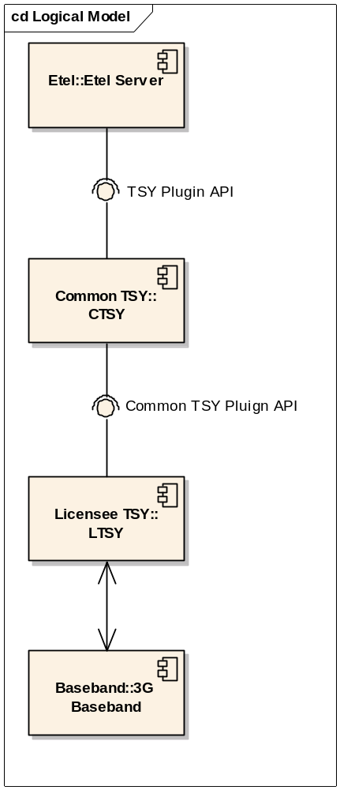
Figure 2.1 Layering between ETel and Baseband
ETel Server provides the following interfaces for Phone Engine and other clients: ETel MM API, ETel Core API and ETel Packet Data API. Common TSY uses the TSY plug-in API from Symbian to connect to ETel Server.
Common TSY is provided by Symbian and includes the common parts of the TSY.
The Common TSY Plug-in API is provided by Symbian. It follows the style of the TSY plug-in API: the interface is generic and adding licensee-specific features or parameters is easy. The API provides interfaces to methods in ETel APIs that are supported in Common TSY and which need access to the licensee’s Baseband.
Licensee TSY contains the licensee’s adaptation between Common TSY and Baseband. The tasks of Licensee TSY are the following:
- Converting Symbian OS types to Baseband specific types and sending Baseband specific request(s) to Baseband.
- Interpreting responses/indications received from Baseband and converting Baseband specific data types to Symbian OS data types.
- Stating machines for response/indication sequences coming from Baseband if the required information is not available in a single indication, or the request needs two requests to do the same that another Baseband does with one request.
- Error mapping. Depending on Baseband, the error values can either be very similar (network errors defined by 3GPP specifications), or very different.

The Baseband is the operating system used in the cellular modem of the licensee.
This document shows the API functionality in Sections 3.2 to 3.11. Note that the collection is not exhaustive: only the most important sequences are shown.

Design Overview
This document should be read together with reference documents [R1] [R2]and [R3], which provide more information on types and their values.

List of the required interfaces
Licensee TSY uses the licensee’s Domestic OS through the licensee’s own API(s). The Common TSY Plug-in API does not depend on any specific Licensee TSY implementation as long as the needed functionality is provided.

Type of the interface
Common TSY and the Common TSY Plug-in API communicate with the CMmMessageManagerBase class methods, which are implemented in the class CMmMessageManager. CMmMessageRouterBase is also an empty class and routing requests to Licensee TSY message handlers are implemented in Licensee TSY CMmMessageRouter.
Each request contains an IPC number to uniquely identify it. The used IPC numbers are the same as in ETel APIs and Common TSY Multimode ETel Custom API. There are also internal IPC numbers defined in Common TSY. Common TSY handles a single request per IPC number at a time. The supported/unsupported IPCs are described in Section 4.

Interface class structure
Figure 2.2 presents the classes that are related to the Common TSY Plug-in API. Symbian implements the Common TSY and Common TSY Plug-in API packages. The Licensee TSY is the place where the licensee should implement the adaptation to Baseband.
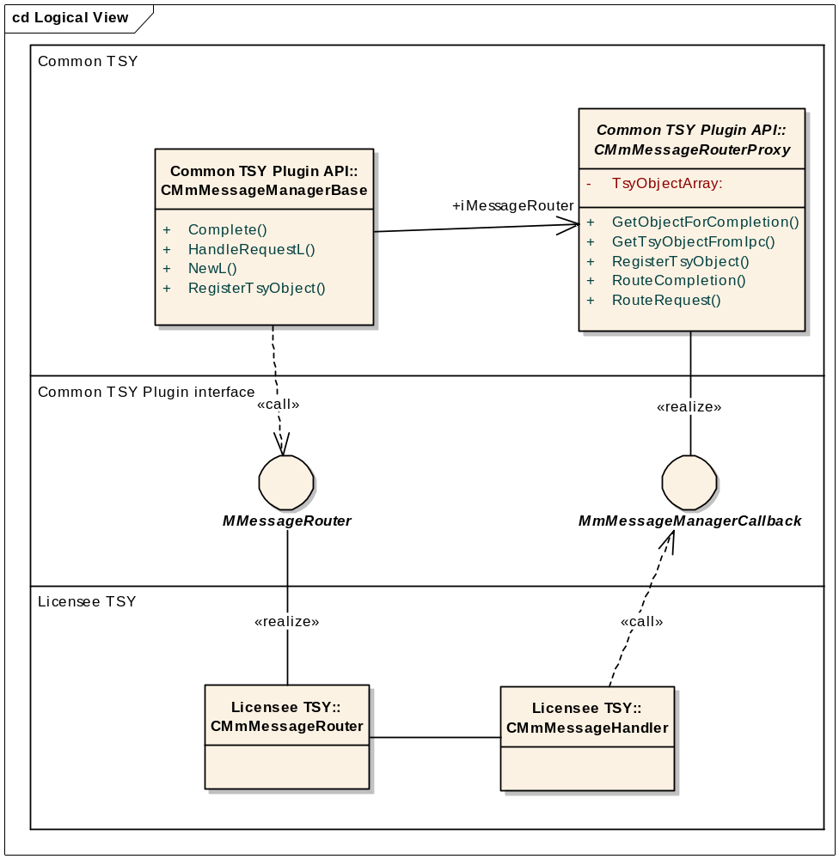
Figure 2.2 Classes related to the Common TSY Plug-in API
The Common TSY Plug-in API does not define the implementation of the Licensee TSY design. The functionalities of the Licensee TSY can be divided into any number of message handlers or helper classes.
When a request comes from Common TSY to Licensee TSY, the licensees have to implement CMessageRouter according to their own design to route the call to any message handler.
When a response or indication comes from Licensee TSY to Common TSY, CMessageRouterBase does the message routing, and the licensee should not override the used logic.

Class | Owner | Description | Header file
CMmMessage  ManagerBase | Symbian | This class and all its methods are abstract. The purpose of this base class is to hide the details of message managing from other modules, and to provide a placeholder for alternative message managing designs. | CMmMessageManagerBase.h
CMmMessageRouterProxy | Symbian | The CMessageRouterProxy base class is responsible for routing indications and responses to the Symbian OS layer objects. | CMmMessageRouterBase.h
CMmDataPackage  CMmCallDataPackage  CmmPhoneBookDataPackage  CMmPacketDataPackage | Symbian | These classes provide a packaging and unpackaging mechanism to exchange data between the two layers in a type-independent way so the API remains generic.  CMmDataPackage is a general class and the other classes extend its functionality to each one’s special area. | CMmDataPackage.h  CMmCallDataPackage.h  CMmPhoneBookDataPackage.h  CMmPacketDataPackage.h
MmMessageRouter | Symbian | This class provides the signature of the ExtFunc method, which should be implemented to message handlers. | MmMessageRouter.h
MmMessageManagerCallback | Symbian | This class provides the signature of the Complete method, which should be called by the message handlers to post a message to the Common TSY. | MmMessageManagerCallback.h
CMmMessageRouter | Licensee | CMessageRouter contains the implementation of routing requests to the correct message handlers and creating all message handlers during boot-up. Licensees have to implement the routing to Licensee TSY layer in this class (for example, implement as many message handlers as they wish). Licensees might have a different number of message handlers so they can easily group features as they like. | CMmMessageRouter.h
MessageHandler | Licensee | One or more classes which take care of the adaptation between the Common TSY Plug-in API and the Licensee’s Baseband. These classes implement CMmMessHandlerBase. | Not defined

Call management
Common TSY takes care of call management. When call status changes and the Licensee TSY gets the indication of the status change from Baseband, the Licensee TSY must inform Common TSY about it. Common TSY handles all the rest, such as notifying the client (for example, Phone Engine) about the status change and the dynamic capabilities, storing the current status and triggering various events.
Call status information is stored in Common TSY and is not visible to Licensee TSY. Common TSY requests Licensee TSY to perform operations on calls on the basis of call ID.

Usage

Protocol
Not applicable.

Error handling
Two kinds of error values are mapped in Licensee TSY: errors coming from the network and errors coming from Baseband.
Section 3 presents presents the two general error case sequences.
Section Appendix A - shows the mapping between Common TSY and GSM cause values.

Example
The Set Network Selection Setting operation gives a simple example of a request coming from ETel Server. Common TSY calls HandleRequest in the Common TSY Plug-in API. The API requests Licensee TSY using the ExtFuncL method. When the request is completed in Baseband and returned to Licensee TSY, the API method Complete is called. Then the API can complete the request to Common TSY and further to ETel Server.
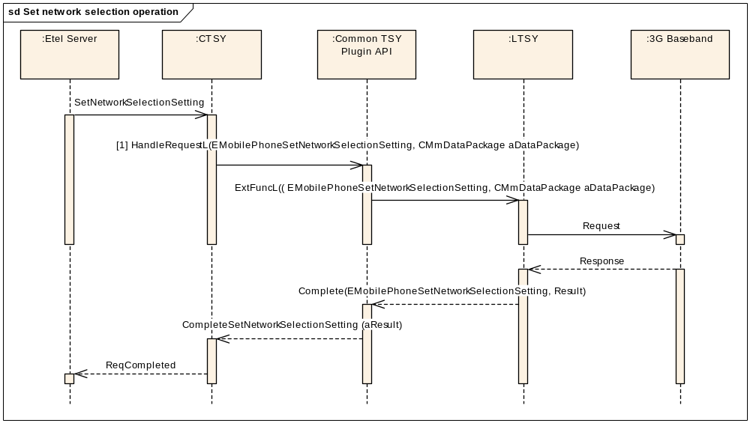
Figure 2.3 Set network selection operation
Parameters of [1]:
- EMobilePhoneSetNetworkSelectionSetting is the IPC value for the Set Network Selection Setting operation and is defined in Symbian's ETel Server's ETELMMCS.h file.
- aDataPackage contains an RMobilePhone::TMobilePhoneNetworkSelectionV1 type.

Detailed description
Figure 2.4 presents the common TSY Plug-in API classes and their relation to Licensee TSY classes. Also the most important methods are listed.
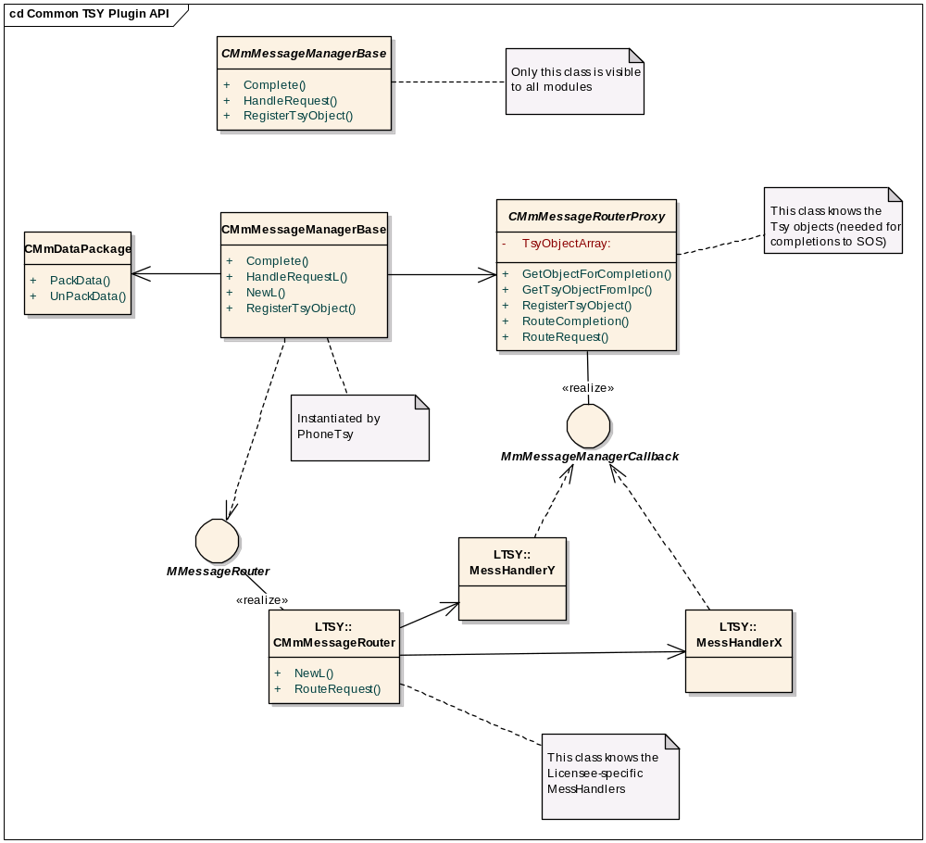
Figure 2.4 Common TSY Plug-in API classes and the message router from Licensee TSY

CmessageManagerBase class
This class forwards TSY requests from Symbian OS to Baseband.

Methods:
Forwards a request to the Baseband layer. The request does not contain any data.

virtual TInt HandleRequestL(const TInt aIpc ) = 0;

Forwards a request to the Baseband layer. The request contains packaged data from Common TSY.

virtual TInt HandleRequestL(const TInt aIpc,
const CMmDataPackage* aDataPackage ) = 0;

Forwards a request to the Baseband layer. The request contains packaged data from ETel Server.

virtual TInt HandleRequestL(const TInt aIpc,
const TDataPackage* aDataPackage ) = 0;

Completes a request or a notification without data.

virtual void Complete( TInt aIpc, TInt aResult ) = 0;

Completes a request or a notification with a data package.

virtual void Complete( TInt aIpc, CMmDataPackage* data, TInt aResult ) = 0;

Registers a TSY object for request and notification completions.

virtual void RegisterTSYObject( TTSYObjects aTSYObjectType, CBase* aTSYObject ) = 0;

CMessageRouterProxy class
This class routes calls between TSY objects and message handler objects.

Public methods:
Returns a pointer to the message handler for this request based on the IPC number.

virtual CMmMessHandlerBase* RouteRequest( TInt aIpc ) = 0;

Completes a request or notification via the specific TSY object based on IPC number and data package.

virtual void RouteCompletion( TInt aIpc,
CMmDataPackage* aDataPackage, TInt aResult );

Registers a TSY object for request and notification completions.

void RegisterTSYObject(CMmMessageManagerBase::TTSYObjects aTSYObjectType, CBase* aTSYObject );

Protected methods:
Returns the type of the TSY object needed for completion based on the IPC number.

CMmMessageManagerBase::TTSYObjects GetTSYObjectFromIpc( const TInt aIpc ) const;

Returns a pointer to the TSY object needed for completion based on the IPC number and the data package.

virtual CBase* GetObjectForCompletion(
const TInt aIpc,
CMmDataPackage* callPackage );

CMmDataPackage and other packaging classes
These classes provide a packaging/unpackaging mechanism. Other packaging classes include packet data, phonebook and call data related special methods.

Code architecture
Common TSY consists of two DLLs, phoneTSY.tsy and CommonTSY.dll. Licensee TSY consists of one or several DLLs.

Plugin Specifications

Generic functionality
Because the Common TSY Plug-in API does not define the number and responsibilities of the message handlers in the Licensee TSY, all sequences use MessageHandlerX, which can be implemented by one or several handlers.
Here are two general error cases, which are generic to all interfaces. The voice call interface adds one error sequence, which is presented in Section 3.2. This chapter also explains general aspects of cancelling and ordering notifications.

Response with an error from Baseband
This sequence presents a generic situation when Baseband responds with an error value. The Licensee TSY should complete the request to the Common TSY Plug-in API, including the error value.
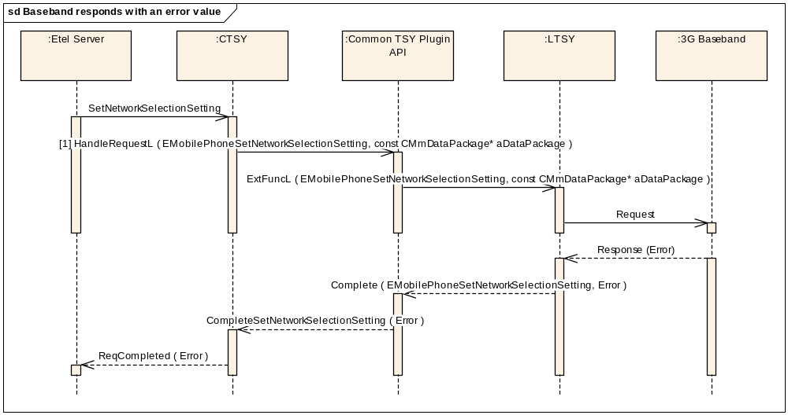
Figure 3.5 Baseband responds with an error value
In successful cases of voice and conference call, it is enough that Licensee TSY calls the status change method; there is no need to complete the request because Common TSY will complete it to ETel Server anyway.

Connecting to Baseband failed
This sequence presents a situation where the Licensee TSY is not able to send the request to Baseband. The Baseband services can be out of use, or message sending has failed. The error is propagated back to ETel Server. In this case, Common TSY completes the request to ETel Server with an error value.
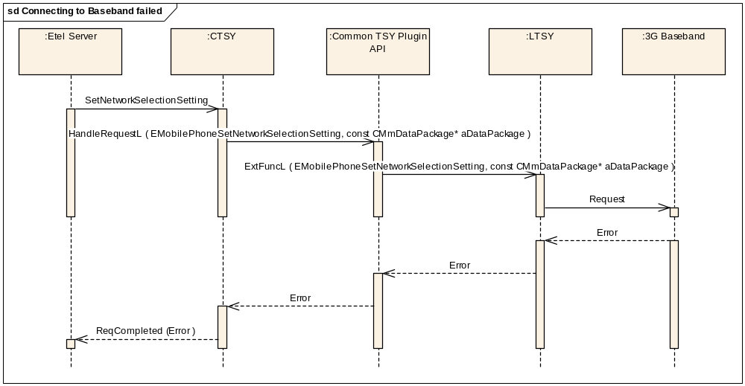
Figure 3.6 Connecting to Baseband failed

Cancelling operations
Only those ETel MM cancel operations that need implementation in the Licensee TSY are passed there. Other operations cannot be cancelled, but Common TSY waits until they are completed.
Cancel operations that need implementation are shown in Section 4 and include, for example, Network search and Network selection.

Notifications
Common TSY does not order notifications from Licensee TSY. The notifications presented in the following sections need to be completed to Common TSY without any registration. If Licensee TSY receives other events from Baseband than the named ones, they cannot be completed to Common TSY.

Boot–up
The boot sequence is divided into three phases:
- Indication that Baseband is ready: Baseband is ready for receiving a request from Common TSY (this also means that Licensee TSY is up and running); Licensee TSY must inform Common TSY by issuing the EMmTSYBootNotifyModemStatusReadyIPC indication. Common TSY then issues the required requests (as shown in Figure 3.7).
- Indication that the SIM access is ready: Whenever Baseband is ready for receiving SIM-related requests from Common TSY, Licensee TSY must inform Common TSY by issuing the CompleteNotifySimStatusReady indication. Common TSY then issues the required requests (as shown in Figure 3.7).
- Caching of phonebook data: Once all the SIM requests have been issued and the security is ready (PIN, UPIN has been validated if required in boot), Common TSY proceeds with the phonebook information caching.

Precondition: ETel Server is loaded, Common TSY and Licence TSY are created, and communication channel(s) between Licensee TSY and Baseband are ready.
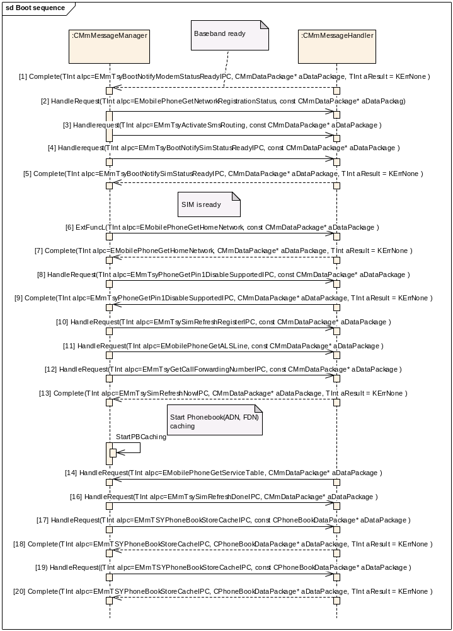
Figure 3.7 Boot sequence
Parameters:
- [1] aDataPackage is empty.
- [2] aDataPackage is empty.
- [3] aDataPackage is empty.
- [4] aDataPackage is empty.
- [5] aDataPackage is empty.
- [6] aDataPackage is empty.
- [7] aDataPackage.iPtr1: RMobilePhone::TMobilePhoneNetworkInfoV8*
- [8] aDataPackage is empty.
- [9] aDataPackage.iPtr1: TBool*
- [10] aDataPackage is empty.
- [11] aDataPackage is empty.
- [12] aDataPackage is empty.
- [13] aDataPackage.iPtr1: TUint16
- [14] aDataPackage.iPtr1:RMobilePhone::TMobilePhoneServiceTable
- [15] aDataPackage.iPtr1: RMobilePhone::TMobilePhoneServiceTableV1
- [16] aDataPackage.iPtr1: TBool*
- [17] aDataPackage.iPtr1: TName* = KETelIccAdnPhoneBook
- aDataPackage.iPtr2: CArrayPtrSeg<TPhoneBookStoreEntry>*
- [18] aDataPackage.iPtr1: TName = KETelIccAdnPhoneBook
- [19] aDataPackage.iPtr1: TName* = KETelIccFdnPhoneBook
- aDataPackage.iPtr2: CArrayPtrSeg<TPhoneBookStoreEntry>*
- [20] aDataPackage.iPtr1: TName = KETelIccFdnPhoneBook

Two-phased methods
There are methods e.g. in the Networking, Messaging and Supplementary Services interfaces that have two phases. These methods involve moving an element list from TSY to ETel. The list is stored in Common TSY. In the first phase, ETel asks the size of the list to be able to allocate the memory needed. In the second phase, the list is copied to ETel. The first phase is triggered by ETel client and involves both Common TSY and Licensee TSY. The second phase is triggered by ETel and only involves Common TSY.

Voice call interface

Generic sequences for all call requests

Mobile call information change
The mobile call information change sequence is common for all voice and conference call use cases. Mobile call information should be delivered to Common TSY before status change information.
Precondition: A voice call is in any state and the mobile call information related to that call changes.
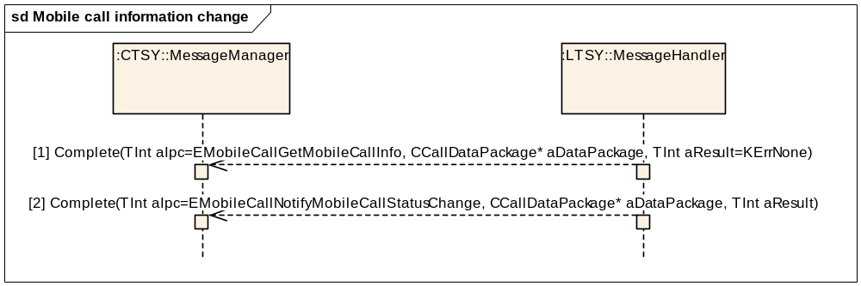
Figure 3.8 Mobile call information change

Parameters:
[1] aDataPackage.iCallId: X, the call ID of the call.
aDataPackage.iCallMode: RMobilePhone::TMobileService = RMobilePhone::EVoiceService
aDataPackage.iPtr1 RMobileCall::TMobileCallInfoV1* callInfo
[2] aDataPackage.iCallId: Call ID X.
aDataPackage.iCallMode: RMobilePhone::TMobileService = RMobilePhone::EVoiceService
aDataPackage.Ptr1: RMobileCall::TMobileCallStatus*
The information elements to be updated to Common TSY are expressed by setting the corresponding validity flags.
The information that may be updated with the Mobile Call Information notification is the following (other fields are updated by Common TSY):
- mobileCallInfo.iService
- mobileCallInfo.iEmergency
- mobileCallInfo.iRemoteParty.iCallingName
- mobileCallInfo.iRemoteParty.iRemoteIdStatus
- mobileCallInfo.iRemoteParty.iRemoteNumber.iTelNumber
- mobileCallInfo.iRemoteParty.iRemoteNumber.iNumberPlan
- mobileCallInfo.iRemoteParty.iRemoteNumber.iTypeOfNumber
- mobileCallInfo.iDialledParty.iTypeOfNumber
- mobileCallInfo.iDialledParty.iNumberPlan
- mobileCallInfo.iDialledParty.iTelNumber
- mobileCallInfo.iForwarded
- mobileCallInfo.iValid (related to the data fields above)

Creating a voice call
Precondition: Mobile Station (MS) is in the Idle state and connected to a network. There are no other calls.
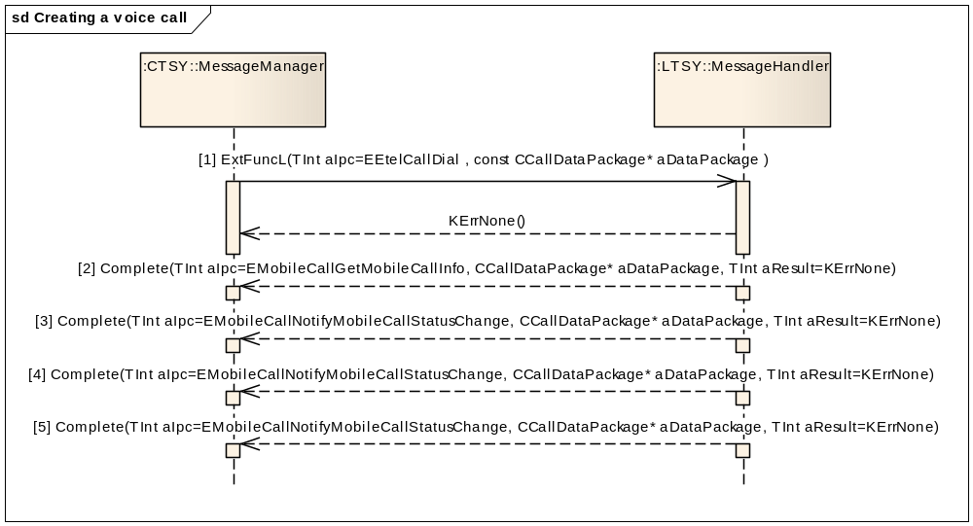
Figure 3.9 Creating a voice call

Parameters:
[1] aDataPackage.iCallId: 0
aDataPackage.iCallMode: RMobilePhone::TMobileService = RMobilePhone::EVoiceService
aDataPackage.iPtr1: RMobileCall::TMobileCallParamsV1Pckg* callParams
aDataPackage.iPtr2: RMobileCall::TMobileCallInfoV1* callInfo
[2] aDataPackage.iCallId: Call ID X allocated by the Licencee TSY layer or Baseband (possible values for X = 1-7, and the same value will be shown in the UI).
aDataPackage.iCallMode: RMobilePhone::TMobileService = RMobilePhone::EVoiceService
aDataPackage.iPtr1: RMobileCall::TMobileCallInfoV1* callInfo
[3] aDataPackage.iCallId: Call ID X.
aDataPackage.iCallMode: RMobilePhone::TMobileService = RMobilePhone::EVoiceService
aDataPackage.iPtr1: RMobileCall::TMobileCallStatus* = RMobileCall::EStatusDialling
[4] aDataPackage.iCallId: Call ID X.
aDataPackage.iCallMode: RMobilePhone::TMobileService = RMobilePhone::EVoiceService
aDataPackage.iPtr1: RMobileCall::TMobileCallStatus* = RMobileCall::EStatusConnecting
[5] aDataPackage.iCallId: Call ID X.
aDataPackage.iCallMode: RMobilePhone::TMobileService = RMobilePhone::EVoiceService
aDataPackage.iPtr1: RMobileCall::TMobileCallStatus* = RMobileCall::EStatusConnected
Cancelling dialing uses the HangUp IPC number (see Sections 3.2.6 and 3.2.7).

Creating an emergency call
Precondition: MS is in the Idle state and connected to a network.
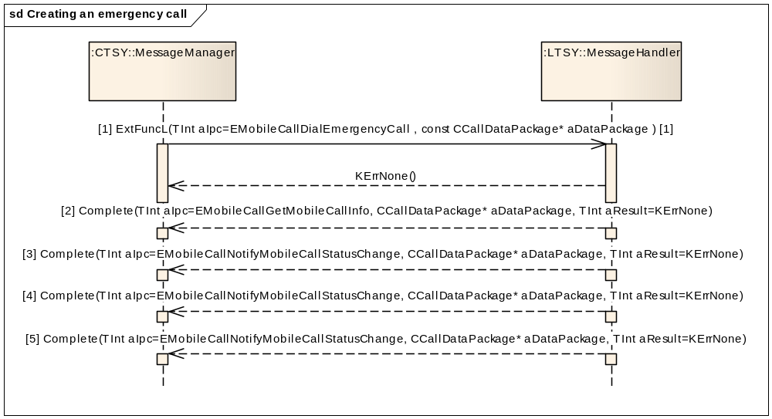
Figure 3.10 Creating an emergency call
Parameters:

[1] aDataPackage.iCallId: 0
aDataPackage.iCallMode: RMobilePhone::TMobileService = RMobilePhone::EVoiceService
aDataPackage.iPtr1: TDesC* emergencyNumber
[2] aDataPackage.iCallId: Call ID X allocated by the Licencee TSY layer or Baseband (possible values for X = 1-7, and the same value will be shown in the UI).
aDataPackage.iCallMode: RMobilePhone::TMobileService = RMobilePhone::EVoiceService
aDataPackage.iPtr1: RMobileCall::TMobileCallInfoV1* callInfo
[3] aDataPackage.iCallId: Call ID X.
aDataPackage.iCallMode: RMobilePhone::TMobileService = RMobilePhone::EVoiceService
aDataPackage.iPtr1: RMobileCall::TMobileCallStatus* = RMobileCall::EStatusDialling
[4] aDataPackage.iCallId: Call ID X.
aDataPackage.iCallMode: RMobilePhone::TMobileService = RMobilePhone::EVoiceService
aDataPackage.Ptr1: RMobileCall::TMobileCallStatus* = RMobileCall::EStatusConnecting.
[5] aDataPackage.iCallId: Call ID X.
aDataPackage.iCallMode: RMobilePhone::TMobileService = RMobilePhone::EVoiceService
aDataPackage.Ptr1: RMobileCall::TMobileCallStatus* = RMobileCall::EStatusConnected.

Creating a voice call through a third party application
Precondition: MS is in the Idle state and connected to a network. No other calls.
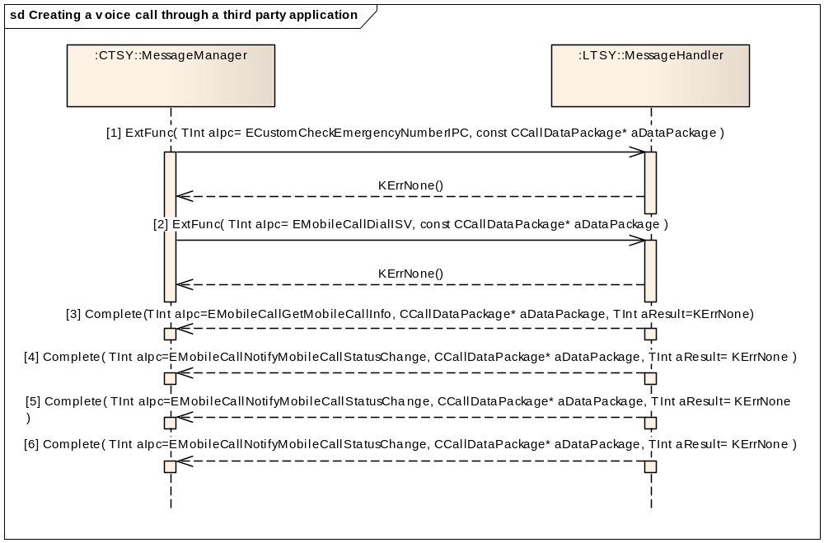
Figure 3.11 Creating a voice call through a third party application

Parameters:
[1] aDataPackage.iPtr1: RMmCustomAPI::TEmerNumberCheckMode* aNumberMode
[2] aDataPackage.iCallId: 0
aDataPackage.iCallMode: RMobilePhone::TMobileService = RMobilePhone::EVoiceService
aDataPackage.iPtr1: RMobileCall::TMobileCallParamsV1Pckg* callParams
aDataPackage.iPtr2: RMobileCall::TMobileCallInfoV1* callInfo
[3] aDataPackage.iCallId: Call ID X allocated by the Licencee TSY layer or Baseband (possible values for X = 1-7, and the same value will be shown in the UI).
aDataPackage.iCallMode: RMobilePhone::TMobileService = RMobilePhone::EVoiceService
aDataPackage.iPtr1: RMobileCall::TMobileCallInfoV1* callInfo
[4] aDataPackage.iCallId: Call ID X allocated by Licencee TSY layer or Baseband (possible values for X = 1-7, and the same value will be shown in the UI).
aDataPackage.iCallMode: RMobilePhone::TMobileService = RMobilePhone::EVoiceService
aDataPackage.iPtr1: RMobileCall::TMobileCallStatus* = RMobileCall::EStatusDialling
[5] aDataPackage.iCallId: Call ID X.
aDataPackage.iCallMode: RMobilePhone::TMobileService = RMobilePhone::EVoiceService
aDataPackage.Ptr1: RMobileCall::TMobileCallStatus* = RMobileCall::EStatusConnecting
[6] aDataPackage.iCallId: Call ID X.
aDataPackage.iCallMode: RMobilePhone::TMobileService = RMobilePhone::EVoiceService
aDataPackage.Ptr1: RMobileCall::TMobileCallStatus* = RMobileCall::EStatusConnected
Cancelling Dial uses the HangUp IPC number (see Sections 3.2.6 and 3.2.7).

Incoming voice call

Incoming call while there are no other calls
Precondition: MS is in the Idle state and connected to a network.
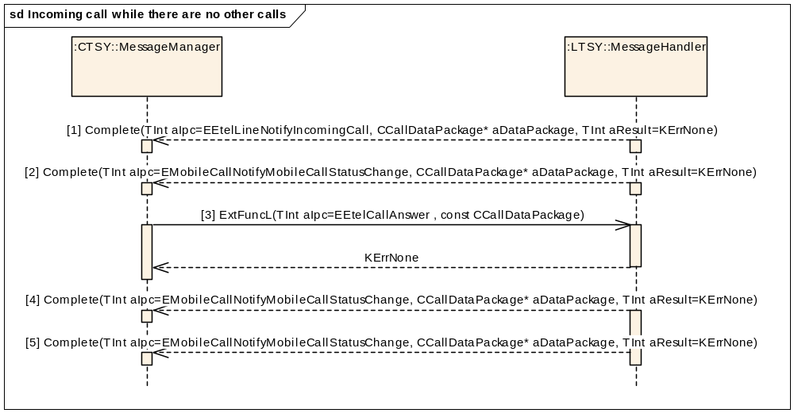
Figure 3.12 Incoming call while there are no other calls
Parameters:
[1] aDataPackage.iCallId: X allocated by the Licencee TSY layer or Baseband (possible values for X = 1-7, and the same value will be shown in the UI).
aDataPackage.iCallMode: RMobilePhone::TMobileService = RMobilePhone::EVoiceService
aDataPackage.iPtr1: RMobileCall::TMobileCallInfoV1* callInfo
[2] aDataPackage.iCallId: Call ID X
aDataPackage.iCallMode: RMobilePhone::TMobileService = RMobilePhone::EVoiceService
aDataPackage.iPtr1: RMobileCall::TMobileCallStatus* = RMobileCall::EStatusRinging.
[3] aDataPackage.iCallId: X
aDataPackage.iCallMode: RMobilePhone::TMobileService = RMobilePhone::EVoiceService
[4] aDataPackage.iCallId: Call ID X.
aDataPackage.iCallMode: RMobilePhone::TMobileService = RMobilePhone::EVoiceService
aDataPackage.Ptr1: RMobileCall::TMobileCallStatus* = RMobileCall::EStatusAnswering.
[5] aDataPackage.iCallId: Call ID X.
aDataPackage.iCallMode: RMobilePhone::TMobileService = RMobilePhone::EVoiceService
aDataPackage.Ptr1: RMobileCall::TMobileCallStatus* = RMobileCall::EStatusConnected.

Incoming call as a waiting call
Precondition: MS is in the Idle state and connected to a network. One call is in the Connected state.
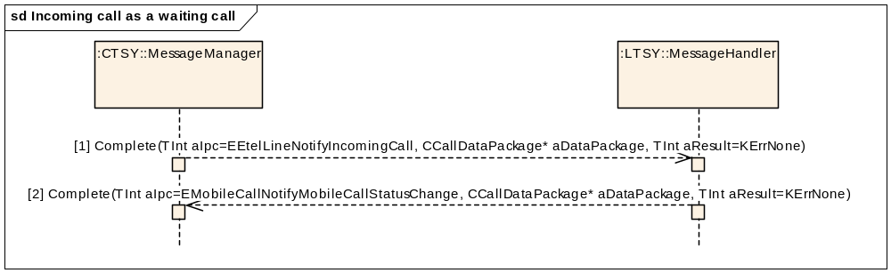
Figure 3.13 Incoming call as a waiting call
Parameters:
[1] aDataPackage.iCallId: X allocated by the Licencee TSY layer or Baseband (possible values for X = 1-7, and the same value will be shown in the UI).
aDataPackage.iCallMode: RMobilePhone::TMobileService = RMobilePhone::EVoiceService
aDataPackage.iPtr1: RMobileCall::TMobileCallInfoV1* callInfo
[2] aDataPackage.iCallId: Call ID X
aDataPackage.iCallMode: RMobilePhone::TMobileService = RMobilePhone::EVoiceService
aDataPackage.iPtr1: RMobileCall::TMobileCallStatus* = RMobileCall::EStatusRinging.

Answering to an incoming call through a third party application
Precondition: MS is in the Idle state and connected to a network.
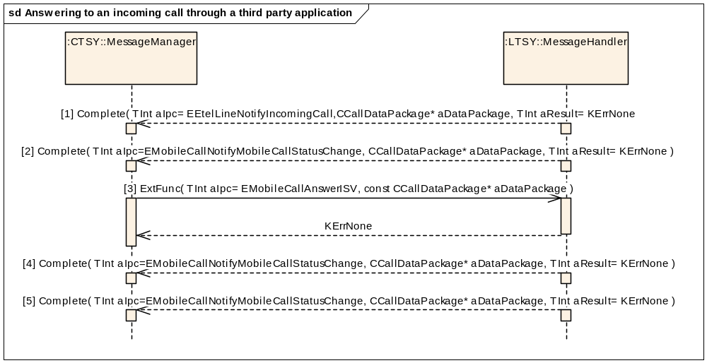
Figure 3.14 Answering to an incoming call through a third party application
Parameters:
[1] aDataPackage.iCallId: X allocated by the Licencee TSY layer or Baseband (possible values for X = 1-7, and the same value will be shown in the UI).
aDataPackage.iCallMode: RMobilePhone::TMobileService = RMobilePhone::EVoiceService
aDataPackage.iPtr1: RMobileCall::TMobileCallInfoV1* callInfo
[2] aDataPackage.iCallId: Call ID X
aDataPackage.iCallMode: RMobilePhone::TMobileService = RMobilePhone::EVoiceService
aDataPackage.iPtr1: RMobileCall::TMobileCallStatus* = RMobileCall::EStatusRinging.
[3] aDataPackage.iCallId: X
aDataPackage.iCallMode: RMobilePhone::TMobileService = RMobilePhone::EVoiceService
[4] aDataPackage.iCallId: Call ID X.
aDataPackage.iCallMode: RMobilePhone::TMobileService = RMobilePhone::EVoiceService
aDataPackage.Ptr1: RMobileCall::TMobileCallStatus* = RMobileCall::EStatusAnswering.
[5] aDataPackage.iCallId: Call ID X.
aDataPackage.iCallMode: RMobilePhone::TMobileService = RMobilePhone::EVoiceService
aDataPackage.Ptr1: RMobileCall::TMobileCallStatus* = RMobileCall::EStatusConnected.

Mobile originated call clearing
Precondition: MS is connected to a network and one voice call is in the Connected state.
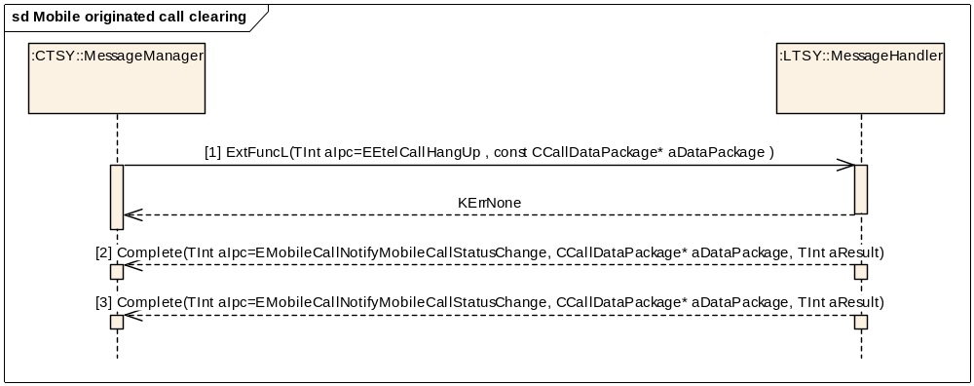
Figure 3.15 Mobile originated call clearing
Parameters:
[1] aDataPackage.iCallId: X (the call ID of the connected call)
aDataPackage.iCallMode: RMobilePhone::TMobileService = RMobilePhone::EVoiceService
aDataPackage.iPtr1: TInt* symbianCauseValue (the possible values are KErrGsmReleaseByUser and KErrGsmBusyUserRequest)*
aDataPackage.iPtr2: TBool autoStChangeDisable
(Indicates if a waiting call is wanted to become automatically active)
[2] aDataPackage.iCallId: Call ID X.
aDataPackage.iCallMode: RMobilePhone::TMobileService = RMobilePhone::EVoiceService
aDataPackage.iPtr1: RMobileCall::TMobileCallStatus* = RMobileCall::EStatusDisconnecting
aResult: A Symbian error value #
[3] aDataPackage.iCallId: Call ID X.
aDataPackage.iCallMode: RMobilePhone::TMobileService = RMobilePhone::EVoiceService
aDataPackage.Ptr1: RMobileCall::TMobileCallStatus* = RMobileCall::EStatusIdle
aResult: A Symbian error value #
# In case of successful call clearing, the Symbian error value must be the same as received with the HangUp request (either KErrGsmReleaseByUser or KErrGsmBusyUserRequest).

Mobile terminated call clearing
Mobile terminating (MT) call clearing is shown here in two ways. When inband is used, the network sends the Busy tones to MS and then disconnects. When inband is not used, the network just disconnects and MS must play the Busy tones locally.

MT call clearing with inband information
Precondition: MS is connected to a network and one voice call is in the Connected state.
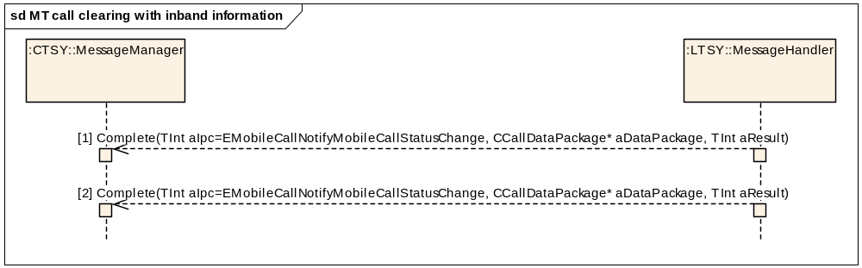
Figure 3.16 MT call clearing with inband information
Parameters:
[1] aDataPackage.iCallId: Call ID X.
aDataPackage.iCallMode: RMobilePhone::TMobileService = RMobilePhone::EVoiceService
aDataPackage.iPtr1: RMobileCall::TMobileCallStatus* = RMobileCall::EStatusDisconnectingWithInband
aResult: A Symbian error value
[2] aDataPackage.iCallId: Call ID X.
aDataPackage.iCallMode: RMobilePhone::TMobileService = RMobilePhone::EVoiceService
aDataPackage.Ptr1: RMobileCall::TMobileCallStatus* = RMobileCall::EStatusIdle
aResult: A Symbian error value

MT call clearing without inband information
Precondition: MS is connected to a network and one voice call is in the Connected state.
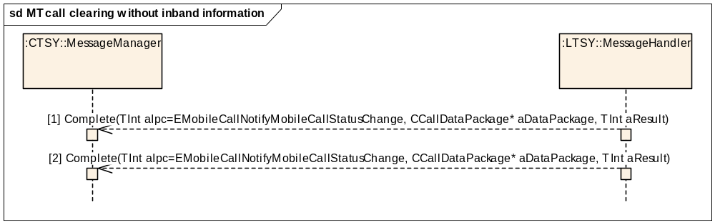
Figure 3.17 MT call clearing without inband information
Parameters:
[1] aDataPackage.iCallId: Call ID X.
aDataPackage.iCallMode: RMobilePhone::TMobileService = RMobilePhone::EVoiceService
aDataPackage.iPtr1: RMobileCall::TMobileCallStatus* = RMobileCall::EStatusDisconnecting
aResult: A Symbian error value
[2] aDataPackage.iCallId: Call ID X.
aDataPackage.iCallMode: RMobilePhone::TMobileService = RMobilePhone::EVoiceService
aDataPackage.Ptr1: RMobileCall::TMobileCallStatus* = RMobileCall::EStatusIdle
aResult: A Symbian error value

Holding a voice call

Holding a call
Precondition: One voice call is in the state RMobileCall::EStatusConnected.
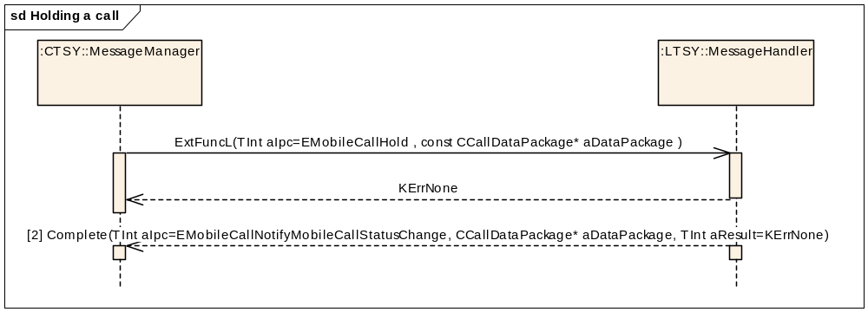
Figure 3.18 Holding a call
Parameters:
[1] aDataPackage.iCallId: X, the call ID of the connected call.
aDataPackage.iCallMode: RMobilePhone::TMobileService = MobilePhone::EVoiceService
[2] aDataPackage.iCallId: X (the same call ID as in the Hold request)
aDataPackage.iCallMode: RMobilePhone::TMobileService = RMobilePhone::EVoiceService
aDataPackage.iPtr1: RMobileCall::TMobileCallStatus* = RMobileCall::EStatusHold.

Autohold while making a voice call
Precondition: A voice call (Call ID = Y) is in the Connected state.
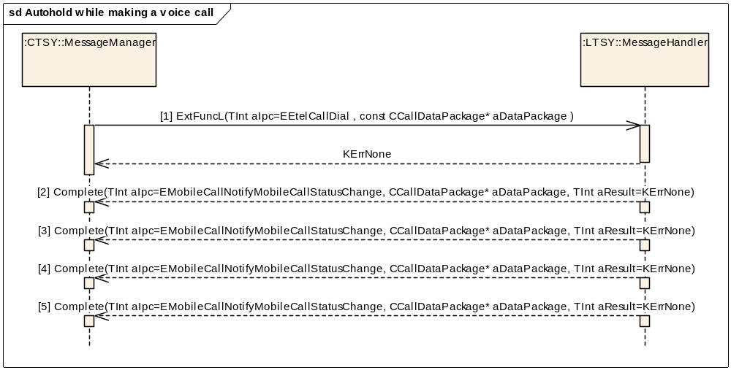
Figure 3.19 Autohold while making a voice call
Parameters:

[1] aDataPackage.iCallId: 0
aDataPackage.iCallMode: RMobilePhone::TMobileService = RMobilePhone::EVoiceService
aDataPackage.iPtr1: RMobileCall::TMobileCallParamsV1Pckg* callParams
aDataPackage.iPtr2: RMobileCall::TMobileCallInfoV1* callInfo
[2] aDataPackage.iCallId: Call ID Y.
aDataPackage.iCallMode: RMobilePhone::TMobileService = RMobilePhone::EVoiceService
aDataPackage.Ptr1: RMobileCall::TMobileCallStatus* = RMobileCall::EStatusHold.
[3] aDataPackage.iCallId: Call ID X allocated by the Licensee TSY layer or Baseband (possible values for X = 1-7 and the same value will be shown in the UI).
aDataPackage.iCallMode: RMobilePhone::TMobileService = RMobilePhone::EVoiceService
aDataPackage.iPtr1: RMobileCall::TMobileCallStatus* = RMobileCall::EStatusDialling.
[4] aDataPackage.iCallId: Call ID X.
aDataPackage.iCallMode: RMobilePhone::TMobileService = RMobilePhone::EVoiceService
aDataPackage.Ptr1: RMobileCall::TMobileCallStatus* = RMobileCall::EStatusConnecting.
[5] aDataPackage.iCallId: Call ID X.
aDataPackage.iCallMode: RMobilePhone::TMobileService = RMobilePhone::EVoiceService
aDataPackage.Ptr1: RMobileCall::TMobileCallStatus* = RMobileCall::EStatusConnected.

Resuming a call
Precondition: One voice call is in the state RMobileCall::EStatusHold.
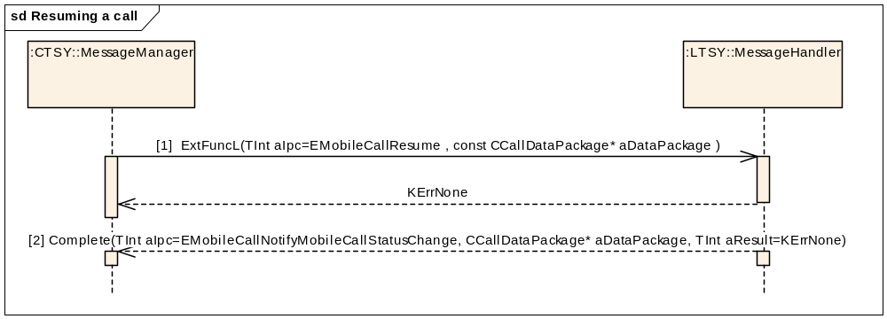
Figure 3.20 Resuming a call
Parameters:
[1] aDataPackage.iCallId: X, the call ID of the held call.
aDataPackage.iCallMode: RMobilePhone::TMobileService = MobilePhone::EVoiceService
[2] aDataPackage.iCallId: X (the same call ID as in the Resume request)
aDataPackage.iCallMode: RMobilePhone::TMobileService = RMobilePhone::EVoiceService
aDataPackage.iPtr1: RMobileCall::TMobileCallStatus* = RMobileCall::EstatusConnected

Swapping active and held voice calls
Precondition: One voice call is in the state RMobileCall::EStatusHold (Call ID=X) and one in the RMobileCall::EStatusConnected (Call ID=Y) state.
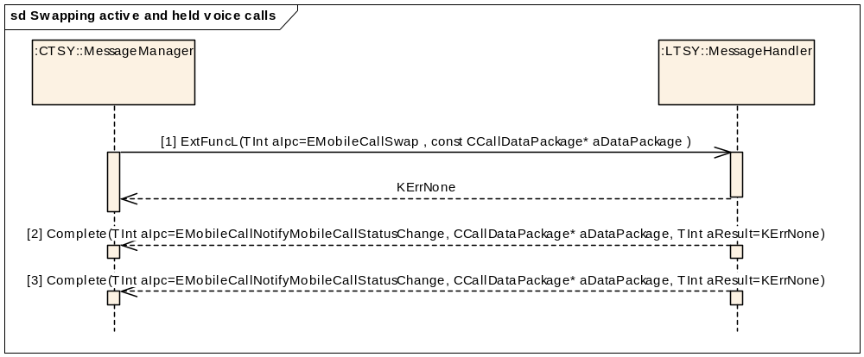
Figure 3.21 Swapping active and held voice calls
Parameters:
[1] aDataPackage.iCallId: X or Y, the call ID of the held or connected call.
aDataPackage.iCallMode: RMobilePhone::TMobileService = MobilePhone::EVoiceService
[2] aDataPackage.iCallId: X #
aDataPackage.iCallMode: RMobilePhone::TMobileService = RMobilePhone::EVoiceService
aDataPackage.iPtr1: RMobileCall::TMobileCallStatus* = RMobileCall::EStatusConnected
[3] aDataPackage.iCallId: Y #
aDataPackage.iCallMode: RMobilePhone::TMobileService = RMobilePhone::EVoiceService
aDataPackage.iPtr1: RMobileCall::TMobileCallStatus* = RMobileCall::EStatusHold
# Indications [2] and [3] can also be completed in the opposite order ([3] before [2]).

Call transfering
Transfer of one active and one held voice call. For more information about Transferring calls refer [R1].
Precondition: One voice call is in the state RMobileCall::EStatusHold (Call ID=X) and one in the RMobileCall::EStatusConnected (Call ID=Y) state.
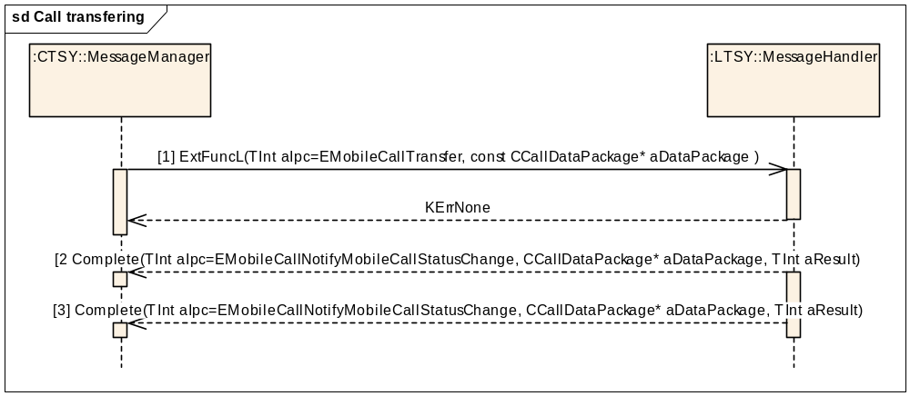
Figure 3.22 Call transfering

Parameters:
[1] aDataPackage.iCallId: X or Y, the call ID of the held or connected call.
aDataPackage.iCallMode: RMobilePhone::TMobileService = MobilePhone::EvoiceService
[2] aDataPackage.iCallId: X #
aDataPackage.iCallMode: RMobilePhone::TMobileService = RMobilePhone::EVoiceService
aDataPackage.iPtr1: RMobileCall::TMobileCallStatus* = RMobileCall::EstatusIdle
[3] aDataPackage.iCallId: Y #
aDataPackage.iCallMode: RMobilePhone::TMobileService = RMobilePhone::EVoiceService
aDataPackage.iPtr1: RMobileCall::TMobileCallStatus* = RMobileCall::EStatusIdle
# Indications [2] and [3] can also be Completed in the opposite order ([3] before [2]).

Blacklist clearing
Blacklist is used to prevent applications from blocking a remote phone number by continuously making calls to the number. The functionality forces some waiting time between calls. Phone UI does not use the blacklist because manual dialing always causes some idle time between calls. Blacklist is cleared every time before Phone UI makes a call.
This functionality exists both on ETel Custom API and ETel MM API, Symbian Phone Engine uses the Custom API functionality.
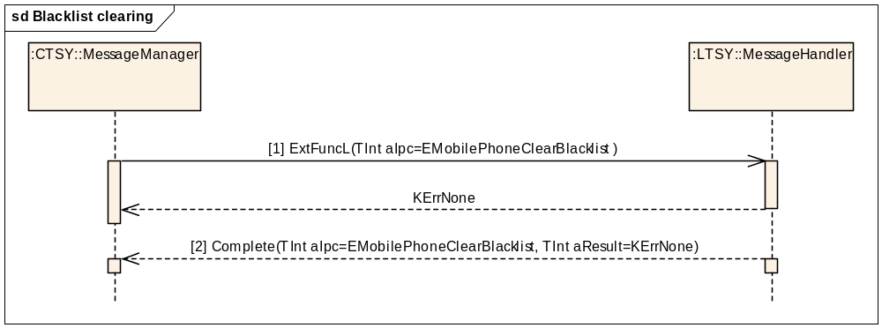
Figure 3.23 Blacklist clearing
Parameters:
[1] aDataPackage.iCallId: X, the call ID of the connected call.
aDataPackage.iCallMode: RMobilePhone::TMobileService = MobilePhone::EvoiceService
[2] None.
This method is a Custom ETel API method, see reference document [R4] for more information.

Remote call event
Remote call event notification:
Precondition: Any number of voice calls is in the Connected or Held state.
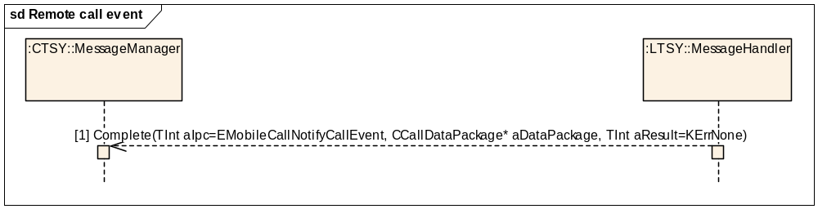
Figure 3.24 Remote call event
Parameters:
[1] aDataPackage.iCallId: X, the call ID of the call to which the event happened.
aDataPackage.iCallMode: RMobilePhone::TMobileService = MobilePhone::EVoiceService
aDataPackage.iPtr1: RMobileCall::TMobileCallEvent*
The events that must be notified are:
- RMobileCall::ERemoteHold
- RMobileCall::ERemoteResume
- RMobileCall::ERemoteTerminated
- RMobileCall::ERemoteConferenceCreate
- RMobileCall::ERemoteTransferring
- RMobileCall::ERemoteTransferAlerting

Common TSY handles local call events.

Activate the User-To-User Signalling service
Activate the User-To-User Signalling service. User-To-User Signalling (UUS) is a service that allows a subscriber to send and receive a limited amount of subscriber-generated User-To-User Information (UUI) to/from another user in association with a call to the user. The UUS service can be used before a call has started (UUS1 and UUS2) or during a call (for UUS3 only). Current implementation only supports the implicit UUS1 service request.
Precondition: MS is in the Idle state and connected to a network. There are no other calls (UUS1).
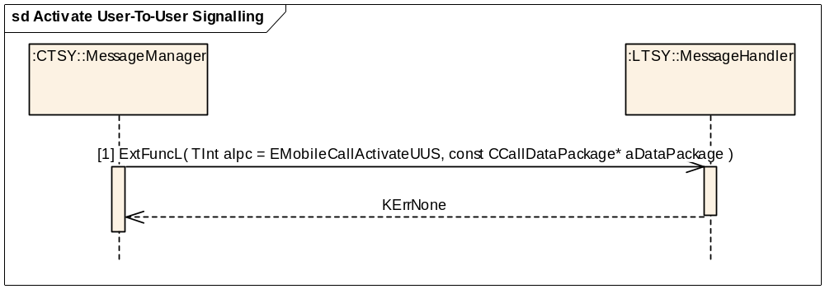
Figure 3.25 Activate User-To-User Signalling
Parameters:
[1] aDataPackage.iCallId: X, the call ID of the call that should activate the UUS service (for UUS1 and UUS2 requests call ID is 0)
aDataPackage.iCallMode: RMobilePhone::TMobileService = MobilePhone::EVoiceService
aDataPackage.iPtr1: RMobileCall::TMobileCallUUSRequestV1*
If UUS Service 1 is being requested, then the iUUI field of TMobileCallUUSRequestV1 contains any UUI data to send with the call set-up message.

Receive User-To-User Information
Receive the next incoming User-To-User Information.
Precondition: MS is connected to a network and at least one call object is created (call ID = X).
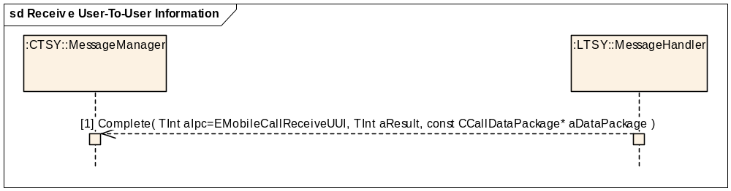
Figure 3.26 Receive User-To-User Information
Parameters:
[1] aDataPackage.iCallId: X
aDataPackage.iCallMode: RMobilePhone::TMobileService = MobilePhone::EVoiceService
aDataPackage.iPtr1: RMobileCall::TMobileCallUUI*

Phone interface

Sending DTMF tones
The string contains no 'w'.
‘w’ stops sending tones, and asks the user if sending should be continued. In Symbian Platform, the UI takes care of this logic.
Precondition: The dynamic capabilities of the MS contain KCapsSendDTMFString (that is, a voice call is active).
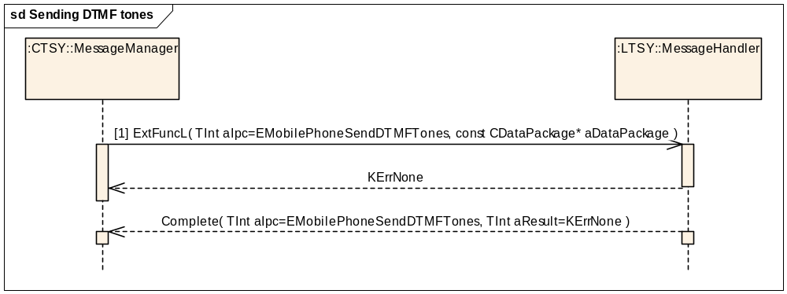
Figure 3.27 Sending DTMF tones
[1] aDataPackage.iPtr1: TDesC* aTones
aTones contains the tones to be sent, without a 'w' character.
If the string is empty or longer than KDtmfStringMaxLength (from MmTSY_NokiaDefs.h), the return value is KErrArgument.

Starting and stopping a DTMF tone
Starting and stopping follows the same sequence, only the parameters differ.

Starting a DTMF tone
Precondition: The dynamic capabilities of the MS contain KCapsStartDTMFTone (that is, a voice call is active).

Stopping a DTMF tone
Precondition: None.
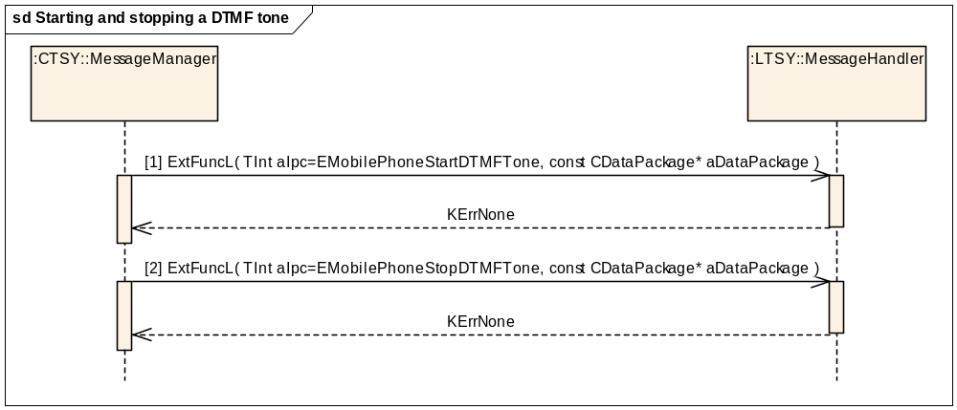
Figure 3.28 Starting and stopping a DTMF tone
[1] aDataPackage.iPtr1: TChar aTone (aTone contains the digit to be sent).
[2] aDataPackage is empty.

Conference call interface

Creating a conference
Precondition: Voice call X is in the EStatusConnected state and voice call Y in the EStatusHold state.
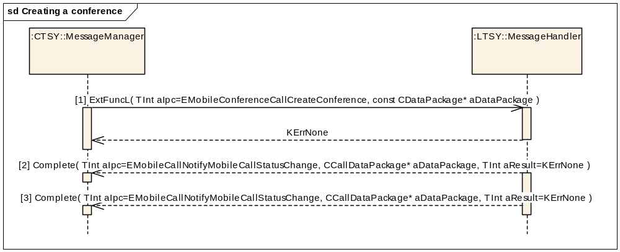
Figure 3.29 Creating a conference
Parameters:
[1] aDataPackage is empty.
[2] aDataPackage.iCallId == x.
aDataPackage.iCallStatus == EStatusConnected.
[3] aDataPackage.iCallId == y.
aDataPackage.iCallStatus == EStatusConnected.

Adding a call to a conference
Precondition: A conference with two calls x and y is in the EConferenceHold state and voice call z is in the EStatusConnected state, or a conference with two calls x and y is in the EConferenceActive state and voice call z is in the EStatusHold state.
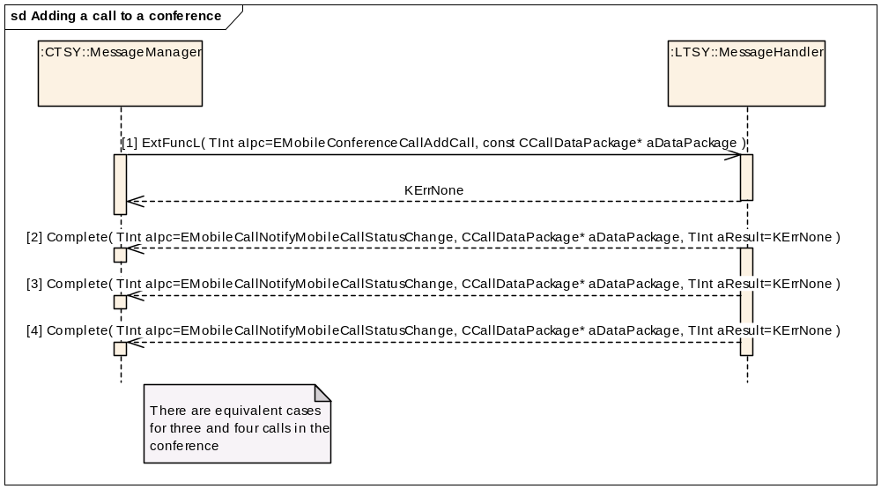
Figure 3.30 Adding a call to a conference
Parameters:
[1] aDataPackage.iCallId = z
[2] aDataPackage.iCallId = x
aDataPackage.iCallStatus = EStatusConnected
[3] aDataPackage.iCallId = y
aDataPackage.iCallStatus = EStatusConnected
[4] aDataPackage.iCallId = z
aDataPackage.iCallStatus = EStatusConnected

Swapping conference

Swapping a conference while there are no other voice calls
Precondition: A conference with two calls x and y is in the EConferenceActive state and there are no other voice calls.
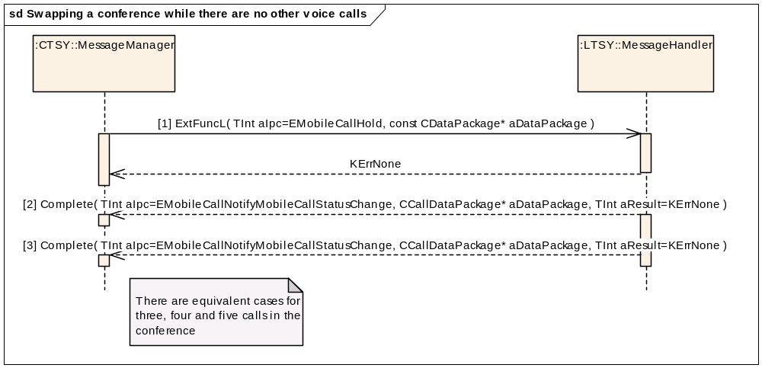
Figure 3.31 Swapping a conference while there are no other voice calls
Parameters:
[1] aDataPackage.iCallId == x or y (arbitrary)
[2] aDataPackage.iCallId == x
aDataPackage.iCallStatus == EStatusHold
[3] aDataPackage.iCallId == y
aDataPackage.iCallStatus == EStatusHold

Swapping a conference while another voice call is on hold
Precondition: A conference with two calls x and y is in the EConferenceActive state, voice call z is in the EStatusHold state.
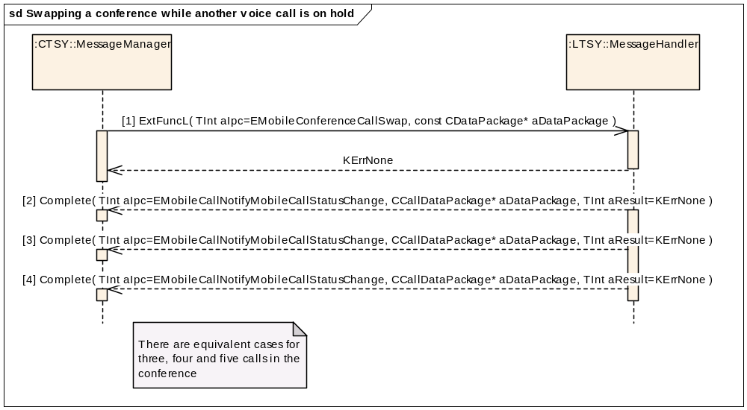
Figure 3.32 Swapping a conference while another voice call is on hold
Parameters:
[1] aDataPackage is empty.
[2] aDataPackage.iCallId == x
aDataPackage.iCallStatus == EStatusHold
[3] aDataPackage.iCallId == y
aDataPackage.iCallStatus == EStatusHold
[4] aDataPackage.iCallId == z
aDataPackage.iCallStatus == EStatusConnected

Swapping a conference while the conference is on hold
Precondition: A conference with two calls x and y is in the EConferenceHold state and there are no other voice calls.
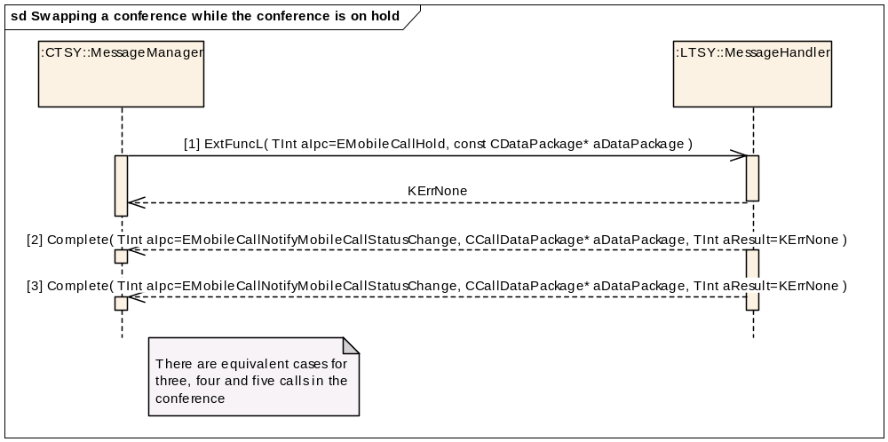
Figure 3.33 Swapping a conference while the conference is on hold
Parameters:
[1] aDataPackage.iCallId == x or y (arbitrary)
[2] aDataPackage.iCallId == x
aDataPackage.iCallStatus == EStatusConnected
[3] aDataPackage.iCallId == y
aDataPackage.iCallStatus == EStatusConnected

Swapping a conference while the conference is on hold and another voice call is connected
Precondition: A conference with two calls x and y is in the EConferenceHold state, voice call z is in the EStatusConnected state.
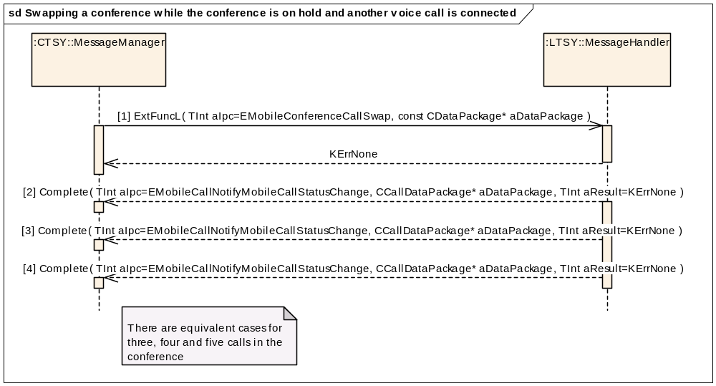
Figure 3.34 Swapping a conference while the conference is on hold and another voice call is connected
Parameters:
[1] aDataPackage is empty.
[2] aDataPackage.iCallId == x
aDataPackage.iCallStatus == EStatusConnected
[3] aDataPackage.iCallId == y
aDataPackage.iCallStatus == EstatusConnected
[4] aDataPackage.iCallId == z
aDataPackage.iCallStatus == EStatusHold

Hanging up a conference
Precondition: A conference with two calls x and y is in the EConferenceActive or EConferenceHold state.
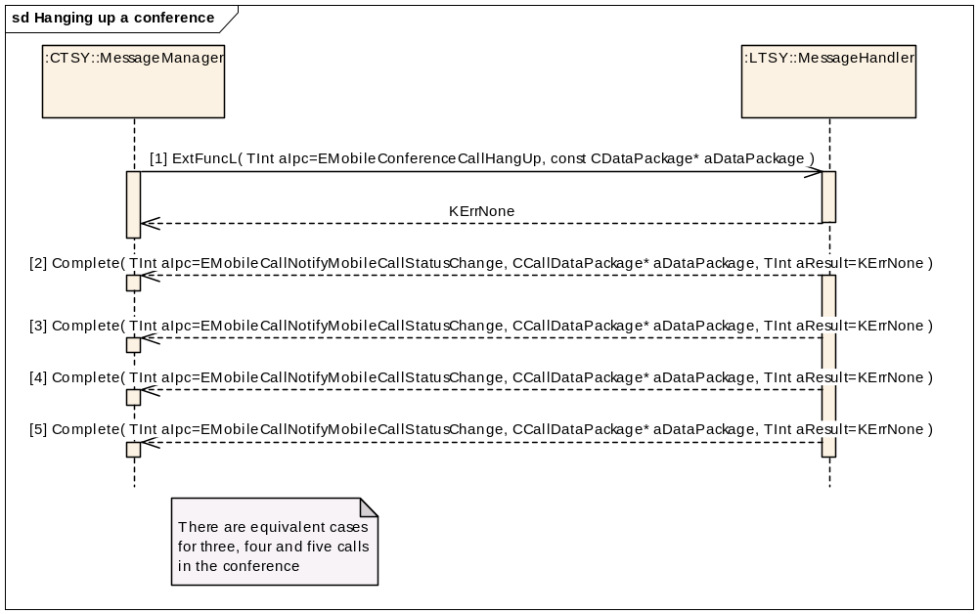
Figure 3.35 Hanging up a conference
Parameters:
[1] aDataPackage is empty.
[2] aDataPackage.iCallId == x
aDataPackage.iCallStatus == EStatusDisconnecting
[3] aDataPackage.iCallId == x
aDataPackage.iCallStatus == EStatusIdle
[4] aDataPackage.iCallId == y
aDataPackage.iCallStatus == EStatusDisconnecting
[5] aDataPackage.iCallId == y
aDataPackage.iCallStatus == EStatusIdle

Going one-to-one with one party
Requests a private communication to the remote party of one call within a conference call.

Going one-to-one while there are three calls in the conference
Precondition: A conference with three calls x, y, z is in the EConferenceActive state and there are no other voice calls.
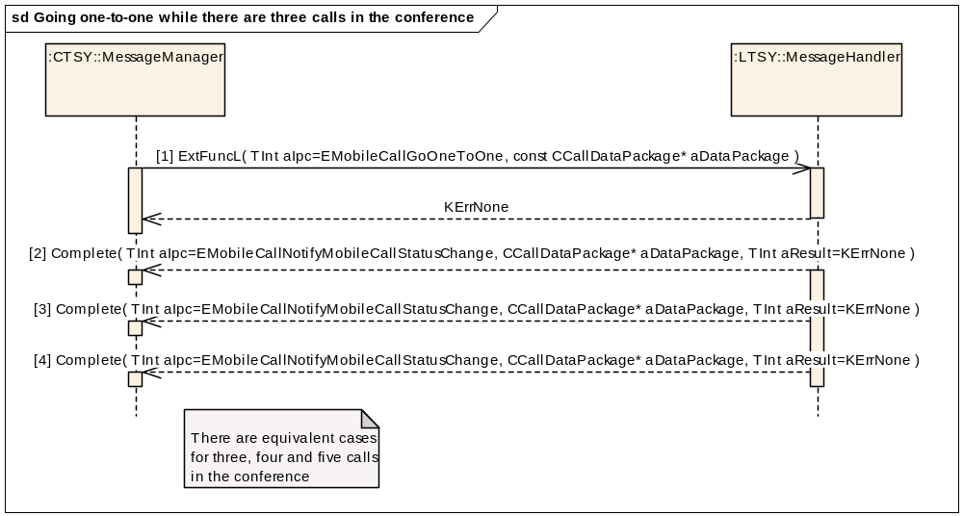
Figure 3.36 Going one-to-one while there are three calls in the conference
Parameters:
[1] aDataPackage.iCallId = z
[2] aDataPackage.iCallId == x
aDataPackage.iCallStatus == EStatusHold
[3] aDataPackage.iCallId == y
aDataPackage.iCallStatus == EStatusHold
[4] aDataPackage.iCallId == z
aDataPackage.iCallStatus == EStatusConnected

Going one-to-one while there are two calls in the conference
Precondition: A conference with two calls x and y is in the EConferenceActive state and there are no other voice calls.
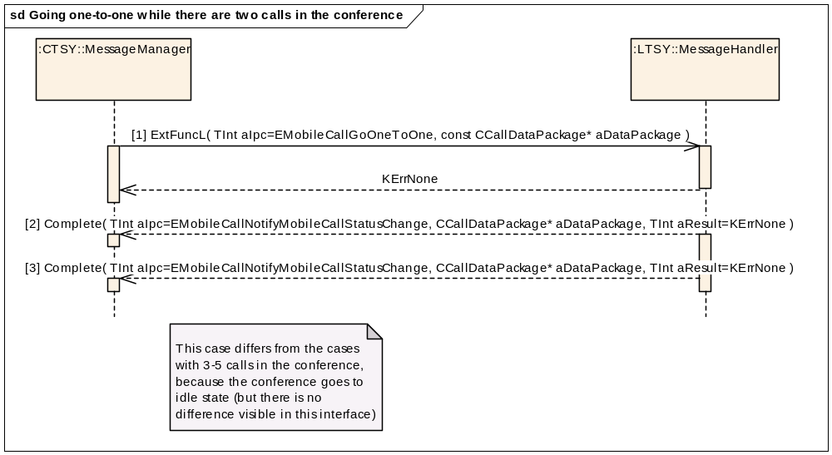
Figure 3.37 Going one-to-one while there are two calls in the conference
Parameters:
[1] aDataPackage.iCallId = y
[2] aDataPackage.iCallId == x
aDataPackage.iCallStatus == EStatusHold
[3] aDataPackage.iCallId == y
aDataPackage.iCallStatus == EStatusConnected

Circuit-switched data interface

Notify modem detected
Precondition: Dataport successfully opened.
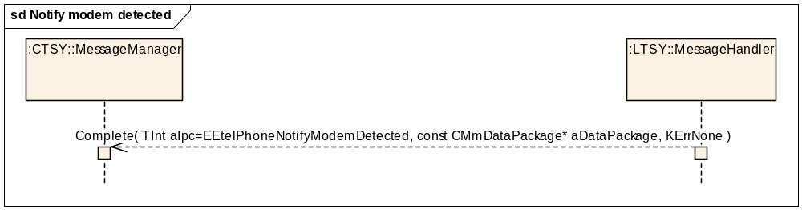
Figure 3.38 Notify modem detected
Parameters:
aDataPackage.iPtr1: RPhone::TStatus (modem status: RPhone::EDetectedPresent, RPhone::EModeIdle)

Notifying of HSCSD information change
Precondition: HSCSD information is changed (new information is received).
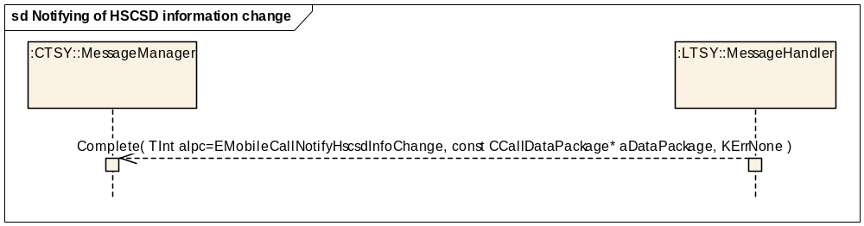
Figure 3.39 Notifying of HSCSD information change
Parameters:
aDataPackage.iCallId = x
aDataPackage.iCallMode = RMobilePhone::EcircuitDataService
aDataPackage.iPtr1: RMobileCall::TMobileCallHscsdInfoV1 (HSCSD settings)
aDataPackage.iPtr2: RMobileCall::TMobileCallDataCapsV1 (CSD call capabilities)

Notifying of mobile data call caps change
Precondition: Mobile data call capabilities are changed (new information is received).
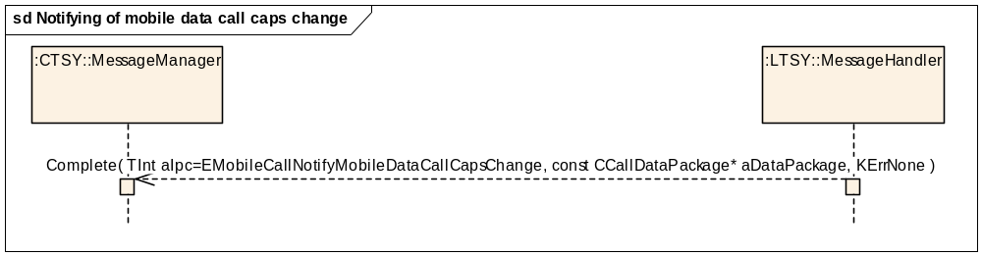
Figure 3.40 Notifying of mobile data call capabilities change

Parameters:
aDataPackage.iCallId = x
aDataPackage.iCallMode = RMobilePhone::EcircuitDataService
aDataPackage.iPtr1: RMobileCall::TMobileCallDataCapsV1 (CSD call capabilities)

Notifying of multimedia data rate change
Precondition: Multimedia call x is active and the data rate has changed.
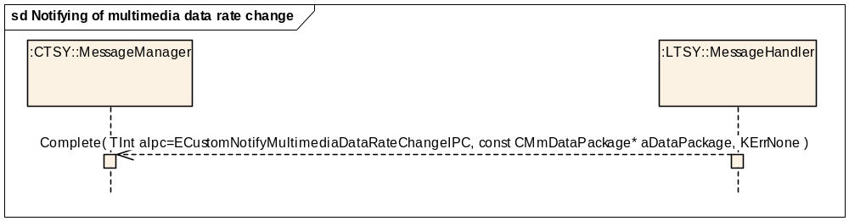
Figure 3.41 Notifying of multimedia data rate change
Parameters:
aDataPackage.iPtr1: TUint32 (the data rate in bits/s)

Setting dynamic HSCSD parameters
Precondition: HSCSD call x is opened from data line and it is in the Idle state (before call setup) or it is in the Connected state (during call connection).
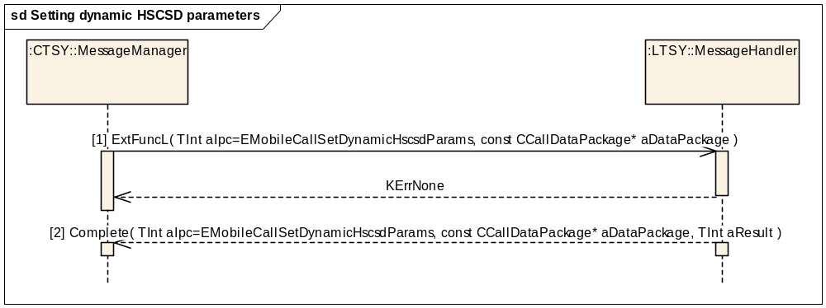
Figure 3.42 Setting dynamic HSCSD parameters
Parameters:
[1] aDataPackage.iCallId = x, aDataPackage.iCallMode = RMobilePhone::ECircuitDataService, aDataPackage.iPtr1: RMobileCall::TMobileHscsdCallParamsV1* (call parameters for HSCSD)
[2] aDataPackage.iCallId = x, aDataPackage.iCallMode = RMobilePhone::ECircuitDataService
In case of a successful request, (aResult == KErrNone).
In case of an unsuccessful request, (aResult != KErrNone).

Getting call parameters
Precondition: Data call parameters changed (new information received).
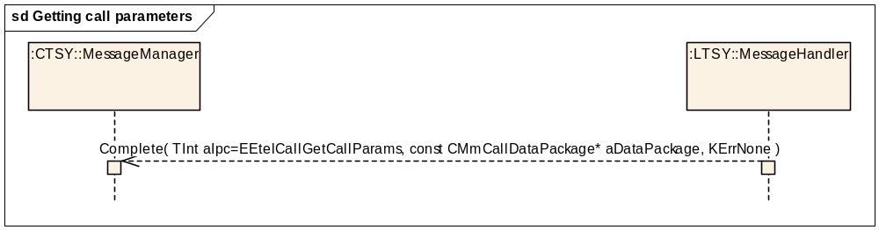
Figure 3.43 Getting call parameters
Parameters:
[1] aDataPackage.iCallId = x, aDataPackage.iCallMode = RMobilePhone::ECircuitDataService, aDataPackage.iPtr1: RMobileCall::TMobileDataCallParamsV1Pckg (data call parameters package)

Getting bearer service information
Precondition: bearer service information changed (new information received).
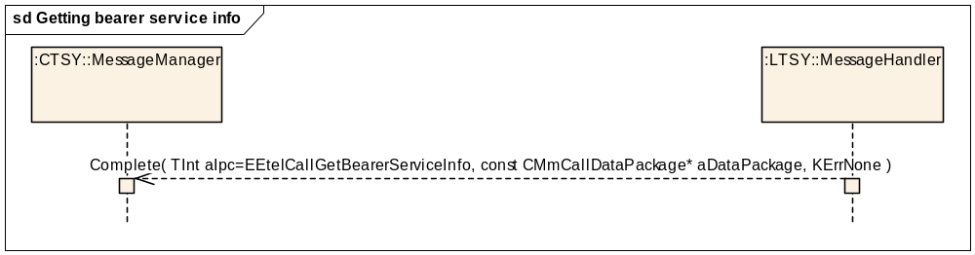
Figure 3.44 Getting bearer service info
Parameters:
[1] aDataPackage.iCallId = x, aDataPackage.iCallMode = RMobilePhone::ECircuitDataService, aDataPackage.iPtr1: RCall::TBearerService (bearer service information)

Loaning data port
Precondition: CSD/HSCSD/Video call x is opened from data line and it is in the Idle state (before call set-up) or it is in Connected state (during call connection).
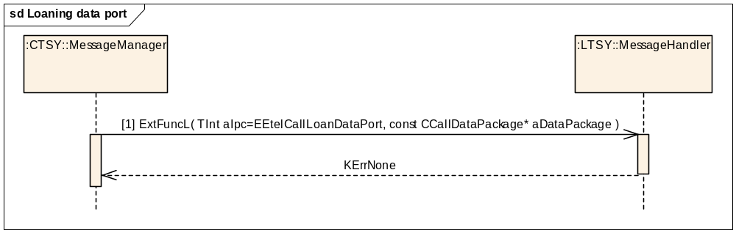
Figure 3.45 Loaning data port
Parameters:
[1] aDataPackage.iCallId = x, aDataPackage.iCallMode = RMobilePhone::ECircuitDataService, aDataPackage.iPtr1: RCall::TCommPort* (dataport to be loaned)
In case of a successful request (aResult == KErrNone).
In case of an unsuccessful request (aResult != KErrNone).

Recovering data port
Precondition: Client does not need dataport anymore or call x is to be disconnected or is disconnecting.
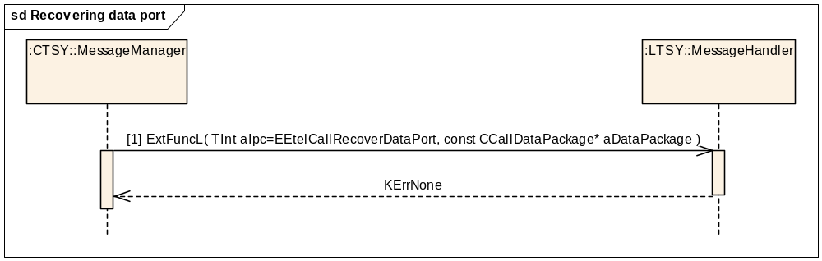
Figure 3.46 Recovering data port
Parameters:
[1] aDataPackage.iCallId = x, aDataPackage.iCallMode = RMobilePhone::ECircuitDataService, aDataPackage.iPtr1: RCall::TCommPort (dataport to be recovered)
In case of a successful request (aResult == KErrNone).
In case of an unsuccessful request (aResult != KErrNone).

Generic sequences for all data call requests

Mobile data call information change
Mobile call information change sequence is common for all voice call & conference use cases. Mobile call information should be delivered to the Common TSY before status change information.
Precondition: A data call is in any state and the mobile call information related to that call changes.
Refer to Section 3.2.1.

Creating a data call
Precondition: MS is in the Idle state and connected to a network. No other calls.
Dataport has been successfully initialised by TSY module.
Refer to Section 3.2.2.

Incoming data call

Incoming data call while no other call
Refer to Section 3.2.5.1.

Incoming data call as waiting call
Refer to Section 3.2.5.2.

Mobile originated data call clearing
Precondition: MS is connected to a network and one data call is in connected state.
Refer to Section 3.2.6.

Mobile terminated data call clearing
Mobile terminating data call clearing is shown in two ways here. When inband is used, the network sends the "busy tones" to the phone and then disconnects. When inband is not used, the network just disconnects and the phone must play the "busy tones" locally.

MT data call clearing with inband information
Precondition: MS is connected to a network and one data call is in connected state.
Refer to Section 3.2.7.1.

MT data call clearing without inband information
Precondition: MS is connected to a network and one data call is in connected state.
Refer to Section 3.2.7.2.

Networking interface

Get home network
Precondition: Baseband is ready to access the SIM.
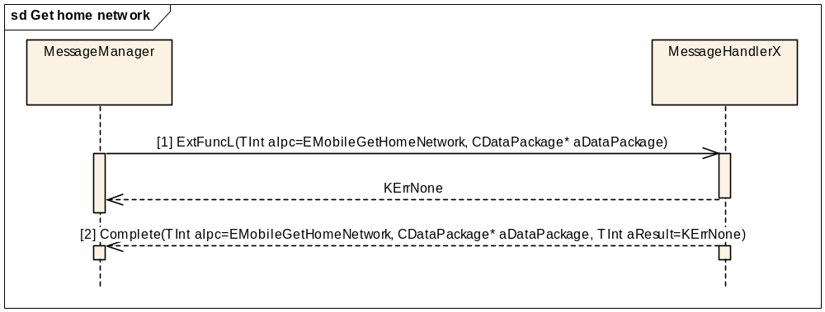
Figure 3.47 Get home network
Parameters:

[1] aDataPackage is empty
[2] aDataPackage.iPtr1: RMobilePhone::TMobilePhoneNetworkInfoV8*

Get network registration status
Get registered network info and status.
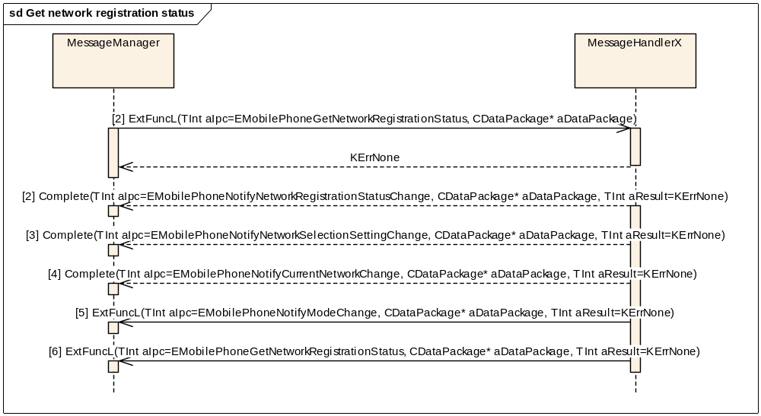
Figure 3.48 Get network registration status
Parameters:
[1] aDataPackage is empty
[2] aDataPackage.iPtr1: RMobilePhone::TMobilePhoneRegistrationStatus*
aDataPackage.iPtr2: RMobilePhone::TMobilePhoneNetworkStatus*
[3] aDataPackage.iPtr1: RMobilePhone::TMobilePhoneNetworkSelectionV1*
[4] aDataPackage.iPtr1: RMobilePhone::TMobilePhoneNetworkInfoV8*
aDataPackage.iPtr2: RMobilePhone::TMobilePhoneLocationAreaV1*
[5] aDataPackage.iPtr1:RMobilePhone::TMobilePhoneNetworkMode*
[6] aDataPackage is empty

Indication of current network change
Precondition: MS is registered into network.
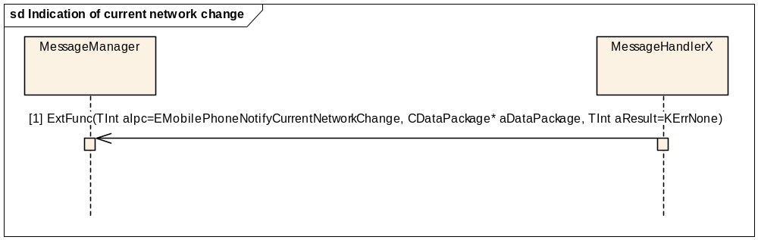
Figure 3.49 Indication of current network change
Parameters:
[1] aDataPackage.iPtr1: RMobilePhone::TMobilePhoneNetworkInfoV8*
aDataPackage.iPtr2: RMobilePhone::TMobilePhoneLocationAreaV1*

Indication of network mode
Precondition: MS is registered into network.
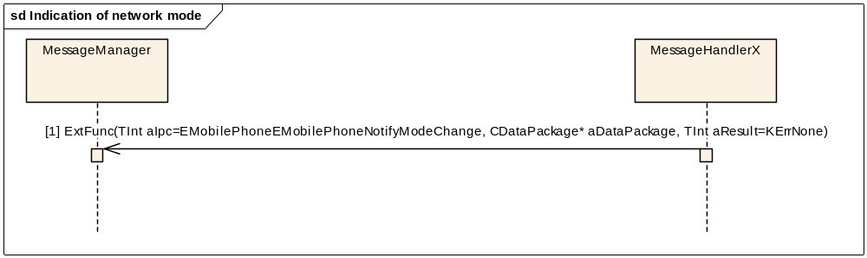
Figure 3.50 Indication of network mode
Parameters:
[1] aDataPackage.iPtr1:RMobilePhone::TMobilePhoneNetworkMode*

Indication of network registration
Precondition: MS is registered into a network.
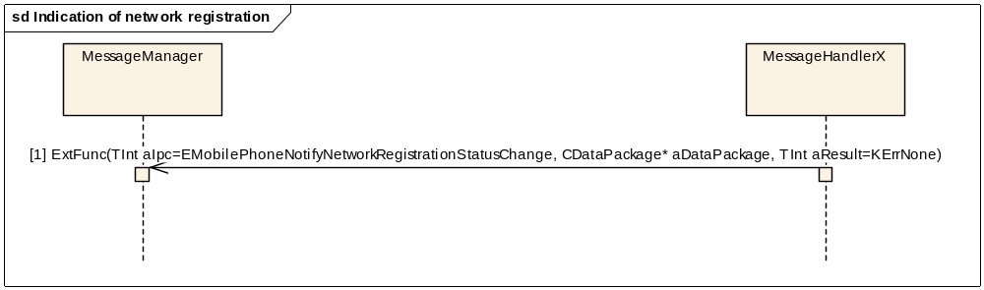
Figure 3.51 Indication of network registration
Parameters:
[1] aDataPackage.iPtr1: RMobilePhone::TMobilePhoneRegistrationStatus*
aDataPackage.iPtr2: RMobilePhone::TMobilePhoneNetworkStatus*

Indication of network selection setting change
Precondition: MS is registered into network.
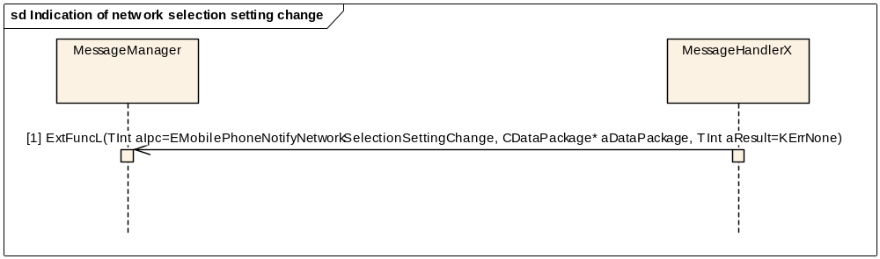
Figure 3.52 Indication of network selection setting change
Parameters:
[1] aDataPackage.iPtr1: RMobilePhone::TMobilePhoneNetworkSelectionV1*

Indication of time and zone information
Precondition: MS is registered into network.
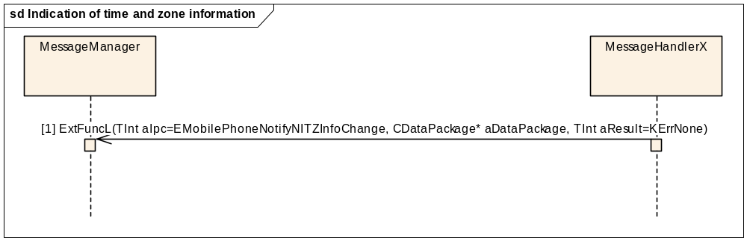
Figure 3.53 Indication of time and zone information
Parameters:
[1] aDataPackage.iPtr1: RMobilePhone::TMobilePhoneNITZ*

Indication of signal strength
Precondition: MS is registered into network.
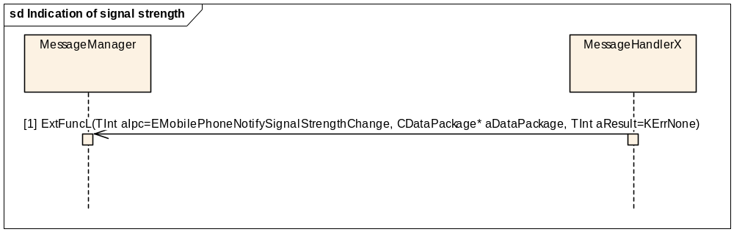
Figure 3.54 Indication of signal strength
Parameters:
[1] aDataPackage.iPtr1: TInt8 (Signal bars)
aDataPackage.iPtr2: TInt32 (Signal strength)

Manual network selection
Automatic selection follows the same sequence.
Precondition: User has made a network search and has a list of networks from which to choose.
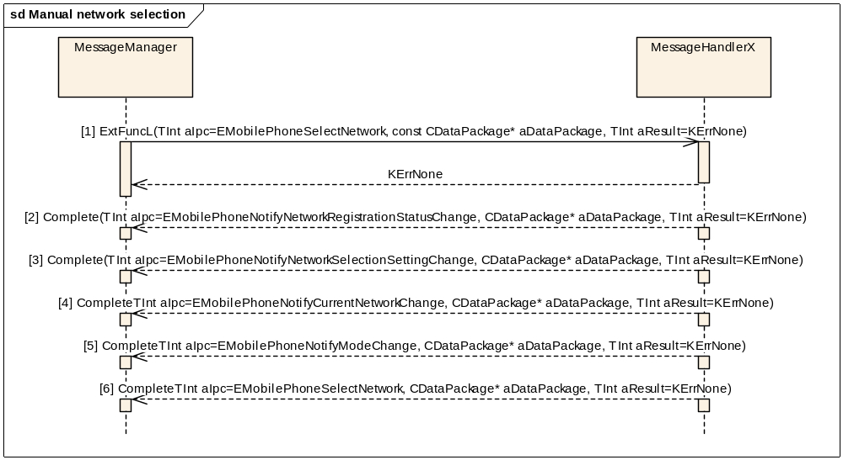
Figure 3.55 Manual network selection

Parameters of manual network selection:
[1] aDataPackage.iPtr1: TBool* = ETrue
aDataPackage.iPtr2: RMobilePhone::TMobilePhoneNetworkManualSelection*
[2] aDataPackage.iPtr1: RMobilePhone::TMobilePhoneRegistrationStatus*
aDataPackage.iPtr2: RMobilePhone::TMobilePhoneNetworkStatus*
[3] aDataPackage.iPtr1: RMobilePhone::TMobilePhoneNetworkSelectionV1*
[4] aDataPackage.iPtr1: RMobilePhone::TMobilePhoneNetworkInfoV8*
aDataPackage.iPtr2: RMobilePhone::TMobilePhoneLocationAreaV1*
[5] aDataPackage.iPtr1:RMobilePhone::TMobilePhoneNetworkMode*
[6]aDataPackage is empty

Manual network selection cancel
Precondition: Manual network selection is ongoing.
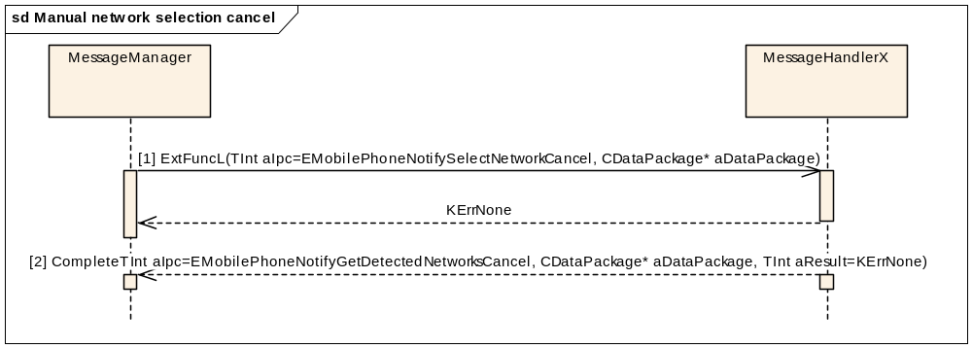
Figure 3.56 Manual network selection cancel
Parameters:

[1] aDataPackage is empty
[2] aDataPackage is empty

Manual network search
Precondition: MS is registered into network.
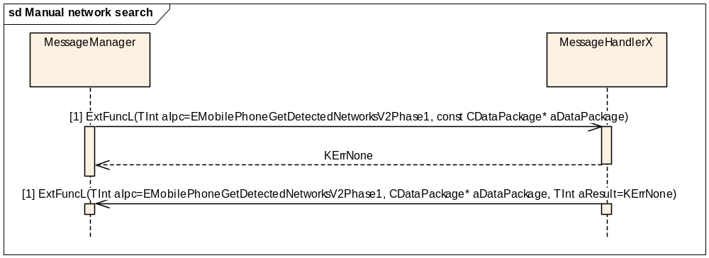
Figure 3.57 Manual network search
Parameters:
[1] aDataPackage is empty.

[2] aDataPackage.iPtr1: CMobilePhoneNetworkListV2*

Manual network search cancel
Precondition: Manual network search is ongoing.
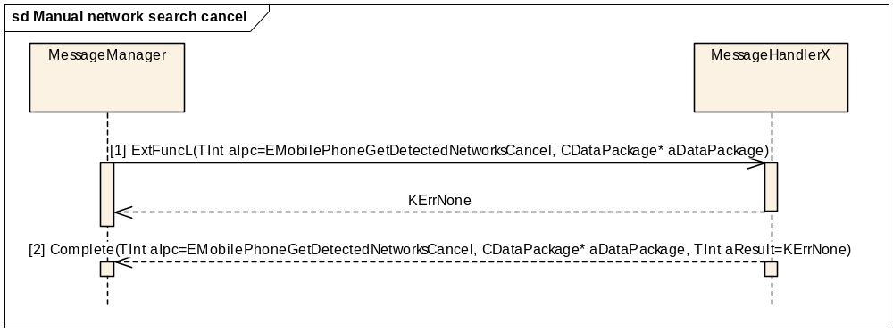
Figure 3.58 Manual network search cancel
Parameters:

[1] aDataPackage is empty
[2] aDataPackage is empty

Set network selection setting
The new selection setting is different from the previous one. If selection setting is the same, the Common TSY completes immediately without involving Licensee TSY.
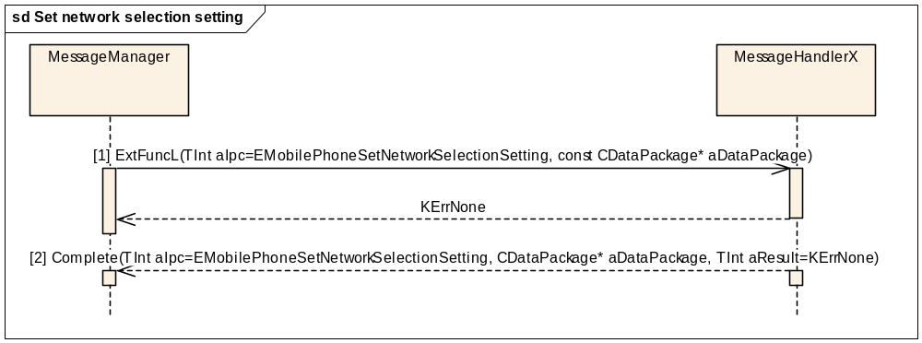
Figure 3.59 Set network selection setting
Parameters:
[1] aDataPackage.iPtr1= RMobilePhone::TMobilePhoneNetworkSelectionV1*

[2] aDataPackage is empty

Get ciphering indicator status
Precondition: This feature is used to indicate whether ciphering is used during radio connections or not.
sd Get ciphering indicator status
MessageManager
MessageHandlerX
[1] ExtFuncL(TInt aIpc=EMobilePhoneGetCipheringIndicatorStatus, CDataPackage* aDataPackage)
KErrNone
[2] Complete(TInt aIpc=EMobilePhoneGetCipheringIndicatorStatus, CDataPackage* aDataPackage, TInt aResult=KErrNone)
Figure 3.60 Get ciphering indicator status
Parameters:
[1] aDataPackage is empty.
[2] aDataPackage.iPtr1: RMobilePhone::TMobileCallCipheringIndicator*

Indication of network security level change
This indication will be sent every time the ciphering status changes.
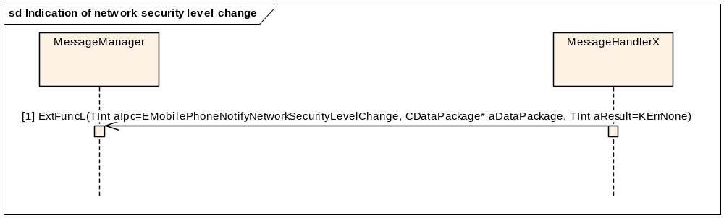
Figure 3.61 Indication of network security level change
Parameters:
[1] aDataPackage.iPtr1: RMobilePhone::TMobilePhoneNetworkSecurity*

Custom get ciphering information
This is used to query if a ciphering indicator must be displayed in the UI or not.
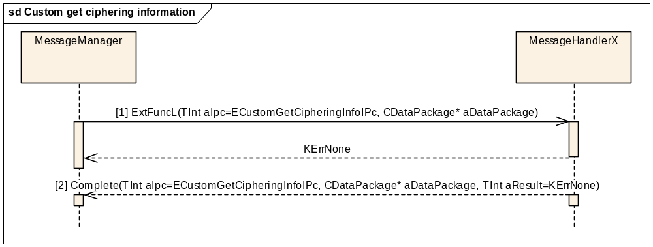
Figure 3.62 Custom get ciphering information
Parameters:

[1] aDataPackage is empty
[2] aDataPackage.iPtr1: TBool (status of the ciphering indicator)

Custom net wakeup information
With this method one can wake up the cellular side from no service power save state i.e currently not listening to any cell.
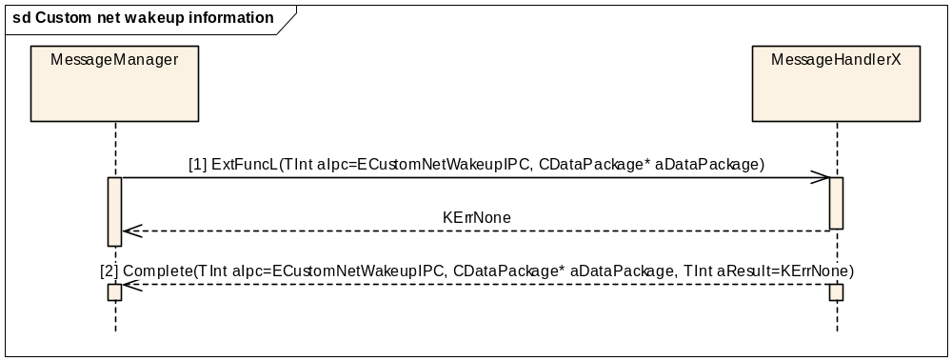
Figure 3.63 Custom net wakeup information
Parameters:
[1] aDataPackage is empty
[2] aDataPackage is empty

Custom get operator name
Precondition: This feature gets the operator name from the current network.
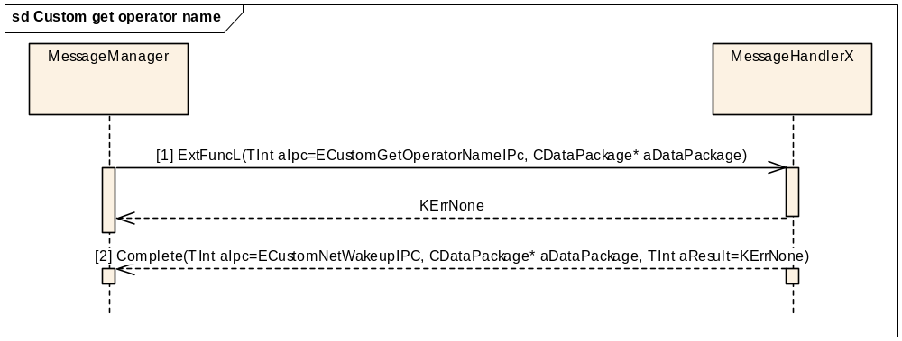
Figure 3.64 Custom get operator name
Parameters:

[1] aDataPackage is empty
[2] aDataPackage.iPtr1: RMmCustomAPI::TOperatorNameInfo

Custom reset network registration status
Precondition: This function resets cellular side synchronously to the previous registered network. This method is used to set the previous registration state in cellular side when the user does not select a network from the list of networks found in a search manually.
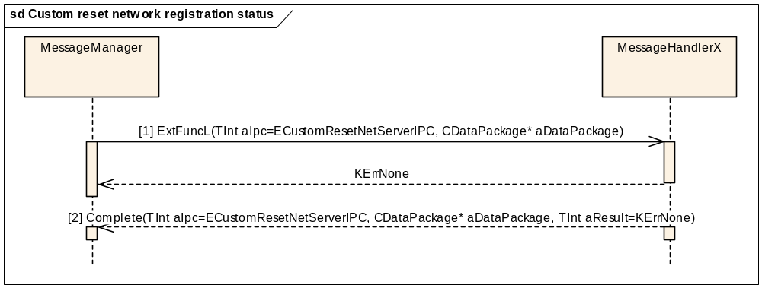
Figure 3.65 Custom reset network registration status
Parameters:

[1] aDataPackage is empty
[2] aDataPackage is empty

Indication of custom network connection failure
Precondition: This notification is completed when network connection is failed in such a way that a note is shown to the user. The failure is so severe that the only way to recover is to restart the phone.
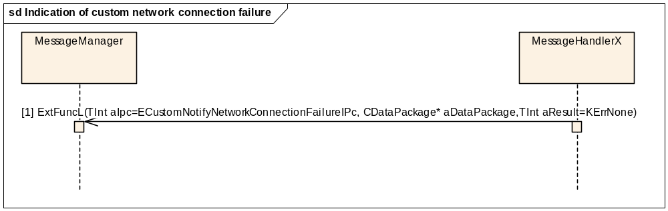
Figure 3.66 Indication of custom network connection failure
Parameters:

[1] aDataPackage is empty

Custom get system network modes
Precondition: This feature gets system network modes.
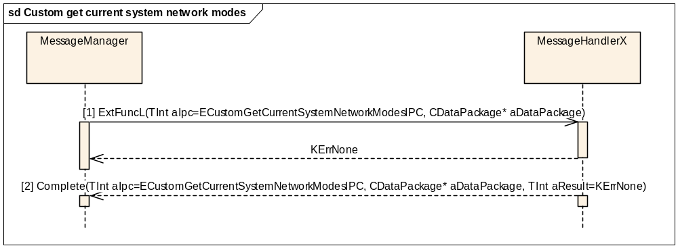
Figure 3.67 Custom get system network modes

Parameters:
[1] aDataPackage.iPtr1: TBool

[2] aDataPackage.iPtr1: TUint32, only one value is valid at the same time (KCapsNetworkModeGsm or KCapsNetworkModeUmts or KCapsNetworkModeDual)

Custom set system network mode
Precondition: This feature is used to indicate whether ciphering is used during radio connections or not.
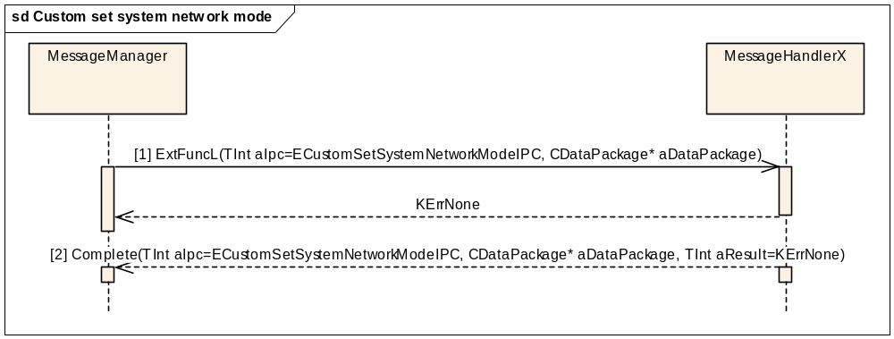
Figure 3.68 Custom set system network mode
Parameters:
[1] aDataPackage.iPtr1: RMmCustomAPI::TNetworkModeCaps

[2] aDataPackage is empty

Custom get current system network modes
Precondition: This method is used by General Settings. This method sets network system
mode synchronously.
Figure 3.69 Custom get current system network modes
Parameters:

[1] aDataPackage is empty
[2] aDataPackage.iPtr1: TUint32, only one value is valid at the same time (KCapsNetworkModeGsm or KCapsNetworkModeUmts or KCapsNetworkModeDual)

Custom read HSUPA/HSDPA Status
Precondition: This feature is used to indicate whether HSUPA/HSDPA Status is disabled or enabled.
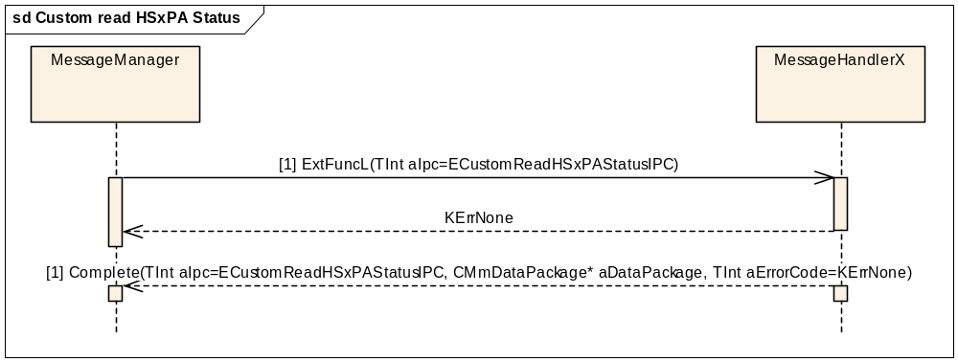
Figure 3.70 Custom read HSxPA Status

Parameters:
[1] aDataPackage.iPtr1: RMmCustomAPI::THSxPAStatus

Custom write HSUPA/HSDPA Status
Precondition: This feature is used to set HSUPA/HSDPA Status.
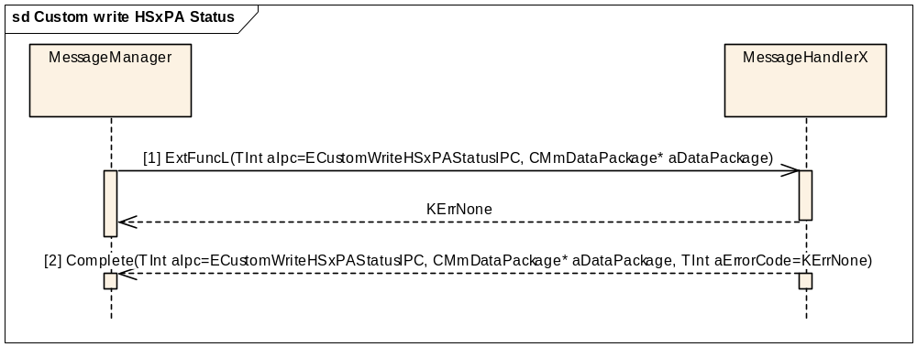
Figure 3.71 Custom write HSxPA Status

Parameters:
[1] aDataPackage.iPtr1: RMmCustomAPI::THSxPAStatus
[2] aDataPackage is empty

Indication of custom HSUPA/HSDPA Status change
Precondition: This notification is completed when HSUPA/HSDPA Status has changed.
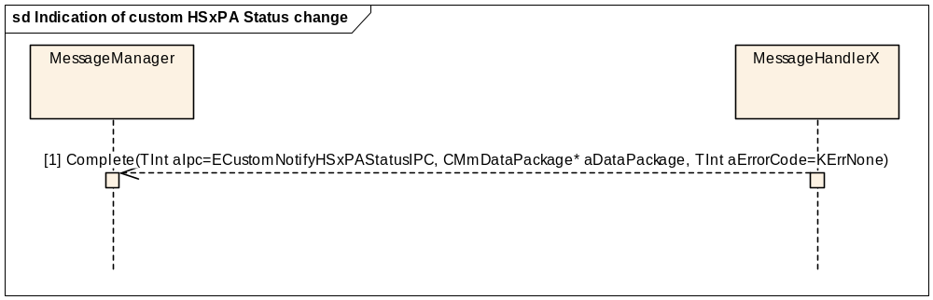
Figure 3.72 Indication of custom HSxPA Status change

Parameters:
[1] aDataPackage.iPtr1: RMmCustomAPI::THSxPAStatus

Custom get cell info
Precondition: This feature gets GSM/WCDMA cell(s) information.
sd Custom get cell info
MessageManager
MessageHandlerX
[1] ExtFunL(TInt aIpc=ECustomGetCellInfoIPC, CMmDataPackage* aDataPackage)
KErrNone
[2] Complete(TInt aIpc=ECustomGetCellInfoIPC, CMmDataPackage* aDataPackage, TInt aErrorValue=KErrNone)
Figure 3.73 Custom get cell info

Parameters:
[1] aDataPackage.iPtr1: TDes8* aCellInfoPckg
[2] aDataPackage.iPtr1: RMmCustomAPI::TMmCellInfo

Indication of custom cell info change
Precondition: This notification is completed when cell information has changed.
sd Indication of custom cell info change
MessageManager
MessageHandlerX
[1] Complete(TInt aIpc=ECustomNotifyCellInfoChangeIPC, CMmDataPackage* aDataPackage, TInt aErrorCode=KErrNone)
Figure 3.74 Indication of custom cell info change

Parameters:
[1] aDataPackage.iPtr1: TDes8* aCellInfoPckg

Get cell info
Precondition: This feature gets GSM/WCDMA cell(s) information.
sd get cell info
MessageManager
MessageHandlerX
ExtFunL(TInt aIpc= ECtsyPhoneCellInfoReq)
KErrNone
[1] Complete(TInt aIpc= ECtsyPhoneCellInfoComp, CMmDataPackage* aDataPackage, TInt aErrorValue=KErrNone)
Figure 3.75 get cell info

Parameters:
[1] aDataPackage.iPtr1: TDes8* aCellInfoPckg (RMobilePhone::TMobilePhoneCellInfoV9)

Register for indication of cell info change
Precondition: This notification is completed when cell information has changed.
sd Indication of cell info change

MessageManager
MessageHandlerX
ExtFunL(TInt aIpc= ECtsyPhoneCellInfoIndReq)
KErrNone
[1] Complete(TInt aIpc= ECtsyPhoneCellInfoComp, TInt aErrorValue)
Figure 3.76 Registration for indication of cell info change

Parameters:
[1] aErrorValue = KErrNone, if registration was successful.

Indication of cell info change
Precondition: This feature asks for notification when GSM/WCDMA cell(s) information.
sd Indication of cell info change
MessageManager
MessageHandlerX
[1] Complete(TInt aIpc= ECtsyPhoneCellInfoComp, CMmDataPackage* aDataPackage, TInt aErrorCode=KErrNone)
Figure 3.77 Indication of cell info change

Parameters:
[1] aDataPackage.iPtr1: TDes8* aCellInfoPckg

Packet data interface

Packet service initialisation
Packet service initialisation is done when the client opens a packet data session.
Precondition: Licensee TSY is created, and communication channel(s) between Licensee TSY and Baseband are ready.
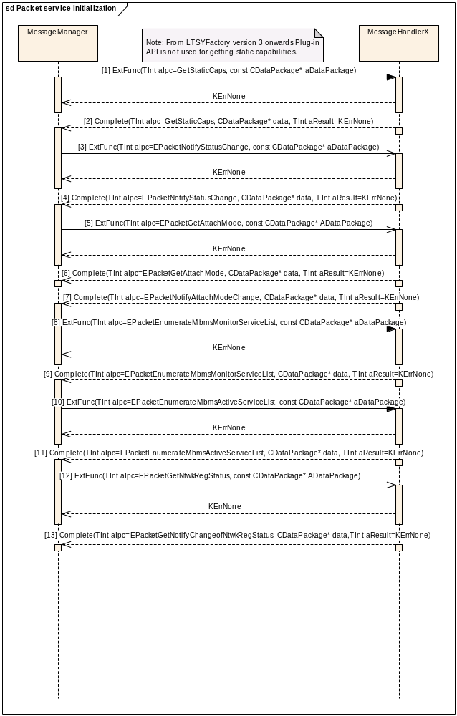Figure 3.78 Packet service initialisation
Parameters:
[1] CDataPackage is empty.
[2] aDataPackage.Ptr1: RPacketService::TStaticMiscCaps staticCaps
aDataPackage.Ptr2 is empty.
[3] CDataPackage is empty.
[4] aDataPackage.Ptr1: RPacketService::TStatus attachModeForCompletion
aDataPackage.Ptr2: TBool* resumed
[5] CDataPackage is empty.
[6] aDataPackage.Ptr1: RPacketService::TPreferredBearer bearer
aDataPackage.Ptr2 is empty.
[7] aDataPackage.Ptr1: RPacketService::TPreferredBearer bearer
aDataPackage.Ptr2 is empty.
[8] CDataPackage is empty.
[9] aDataPackage.Ptr1: TInt maxMonitorValue
aDataPackage.Ptr2 is empty.
[10] CDataPackage is empty.
[11] aDataPackage.Ptr1: TInt MaxActiveServices
aDataPackage.Ptr2 is empty.

[12] CDataPackage is empty.
TInt Result: RPacketService::TRegistrationStatus regStatusClient (mapped to int)
[13] aDataPackage.Ptr1: TRegistrationStatus regStatus
aDataPackage.Ptr2 is empty.
Note: EPacketNotifyAttachModeChange [call 5] should be completed in boot-up to initialise the preferred bearer.
Note2: EPacketEnumerateMbmsMonitorServiceList[call 8] and EPacketEnumerateMbmsActiveServiceList [call 10] should be completed only in boot-up to initiliase the MBMS related lists.

Packet service, PDP context and QoS activation and deactivation
A packet connection in TSY consists of three objects: the packet service, packet context and quality of service. Service is the main object, via which all internal context objects are opened. The Service creates the Context list and uses TSY-defined IPC EPacketInitProxies for initialisation. One context object opens a QoS object for itself when created. Basic actions of attach and detach are shown in Figure 3.79 below.
By requesting EPacketContextInitialiseContextIPC, Common TSY asks Licensee TSY to communicate to the lower level about the context being created and to perform some initialisation so that further phases (configuration, activation, etc.) can be done.
By requesting EPacketInitProxiesIPC, Common TSY asks Licensee TSY to initialise packet data specific message handlers in boot-up. Also in return CMmPacketContextList::InitAttributesAndListsL gets a positive initialisation value for channels, which is used later in the contexts' names.
Precondition: The MS is in the Idle state and registered to a network.
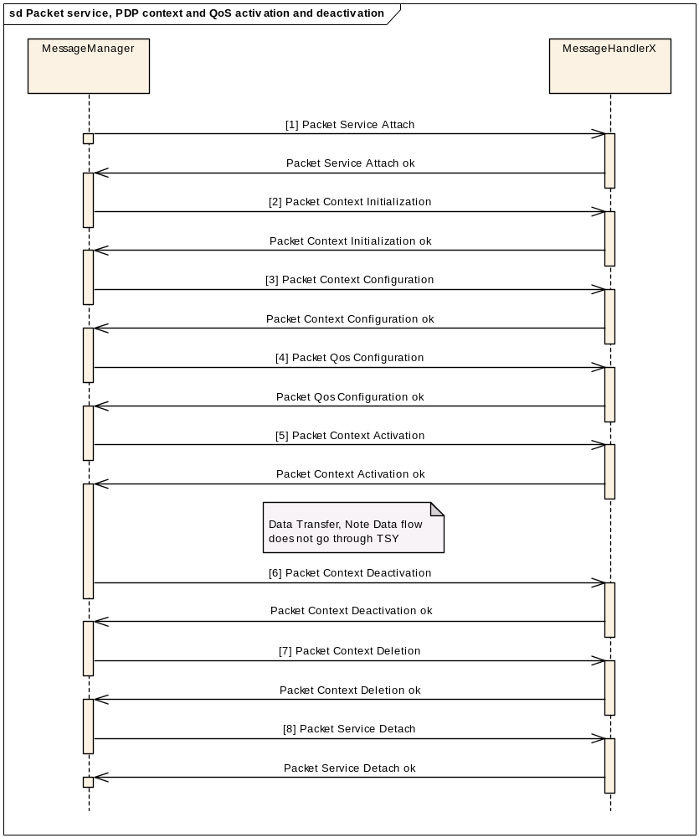
Figure 3.79 Packet service, PDP context and QoS activation and deactivation
The phases Packet service attach [1] and Packet service detach [8] are shown in detail in the following Sections.

Packet service, MBMS context activation and deactivation
A MBMS connection in TSY consists of two objects: the packet service and mbms context. Service is the main object, via which all MBMS context objects are opened. The Service creates the MBMS Context list and uses IPC EPacketEnumerateMbmsActiveServiceList, asked in boot-up, for managing the maximum amount of services. Basic actions of attach and detach are shown in Figure 3.79 below. It is notable that the MBMS contexts concepts is here considered as support for MBMS broadcast and thus contexts are considered as “local” contexts, which mean they don’t establish a connection to network.
Precondition: The MS is in the Idle state and registered to a network.

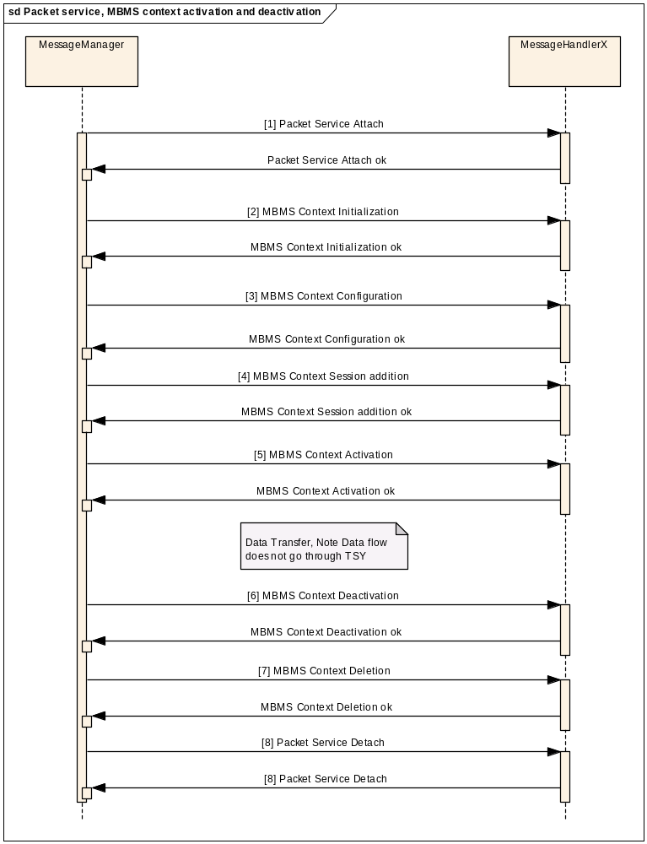
Figure 3.76 Packet Service, MBMS context activation and deactivation
Note. Session addition [call 4] is optional.

Packet service attach
Precondition: MS is in the Idle state and connected to a network.
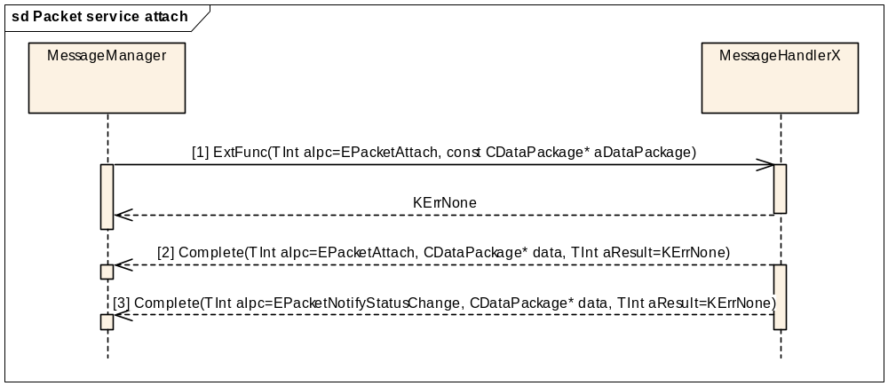
Figure 3.80 Packet service attach
Parameters:
[1] CDataPackage is empty.
[2] CDataPackage is empty.
[3] aDataPackage.Ptr1: RPacketService::Tstatus* status
aDataPackage.Ptr2: TBool resumed

Packet service detach
Precondition: MS is attached to a network.
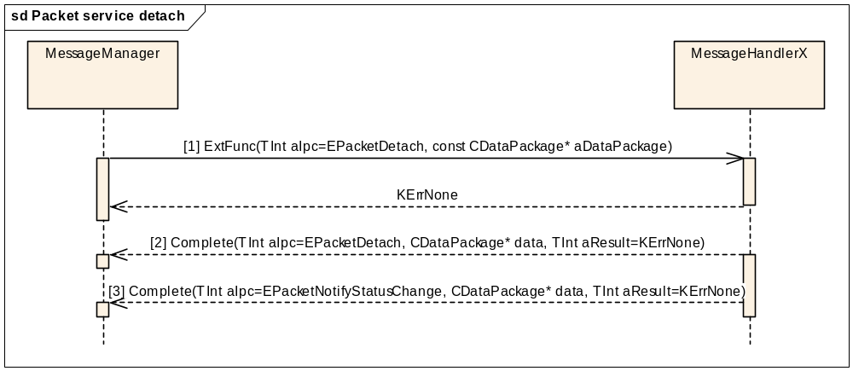
Figure 3.81 Packet service detach
Parameters:
[1] CDataPackage is empty.
[2] CDataPackage is empty.
[3] aDataPackage.Ptr1: RPacketService::Tstatus* status
aDataPackage.Ptr2: TBool resumed

Packet service GetNetworkRegistrationStatus
Precondition: MS is in the Idle state and connected to a network.
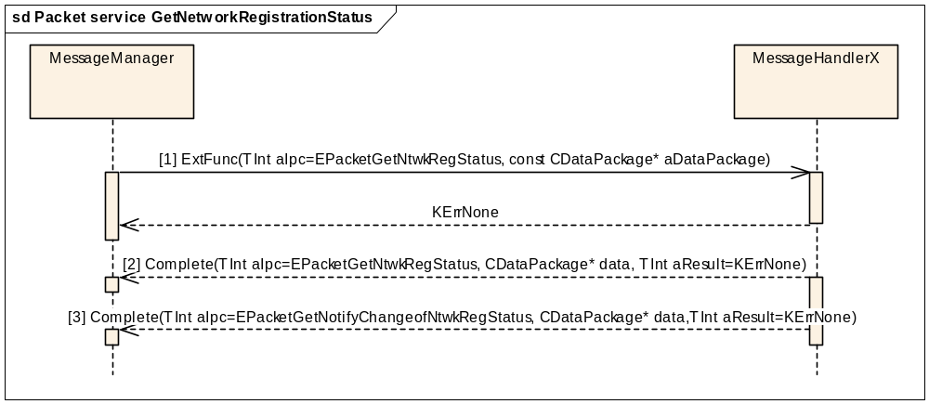
Figure 3.82 Packet service GetNetworkRegistrationStatus
Parameters:
[1] CDataPackage is empty.
[2] CDataPackage is empty.
[3] CDataPackage is empty.
TInt Result: RpacketService::TRegistrationStatus regStatusClient (Mapped to int).

Packet service RejectActivationRequested
Precondition: MS is in the Idle state and connected to a network.
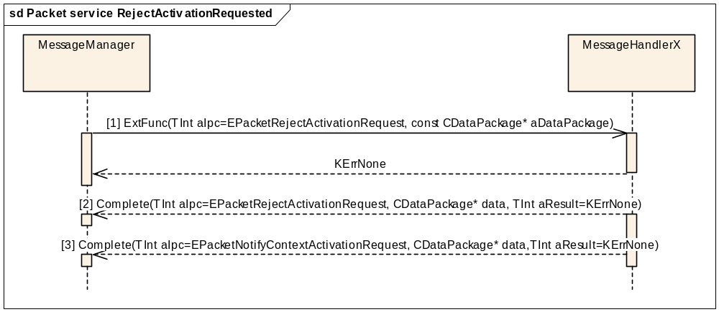
Figure 3.80 Packet service RejectActivationRequested
Parameters:
[1] CDataPackage is empty.
[2] CDataPackage is empty.
[3] aCDataPackage.Ptr1: RpacketContext::TContextConfigGPRS completeNotifyContextActivationReq
aCDataPackage.Ptr2 is empty.

Packet service SetAttachMode
Precondition: MS is in the Idle state and connected to a network.
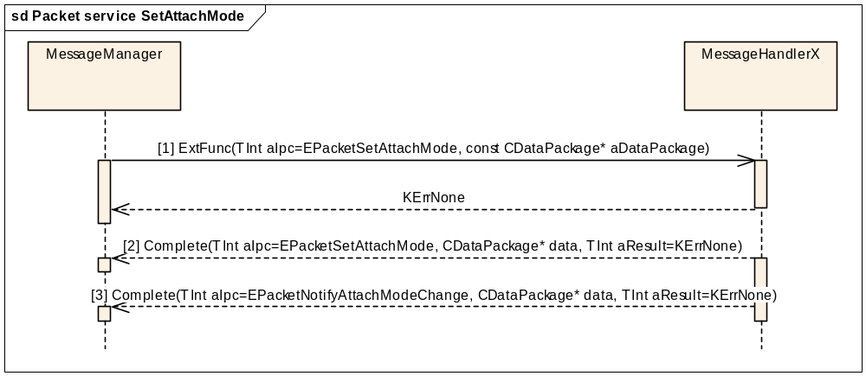
Figure 3.81 Packet service SetAttachMode
Parameters:
[1] aDataPackage.Ptr1: RPacketService::TattachMode* dataPtr
aDataPackage.Ptr2 is empty.
[2] aDataPackage.Ptr1 is empty.
[3] aDataPackage.Ptr1: RpacketService::TPreferredBearer bearer
aDataPackage.Ptr2 is empty.

Packet service GetAttachMode
Precondition: MS is in the Idle state and connected to a network.
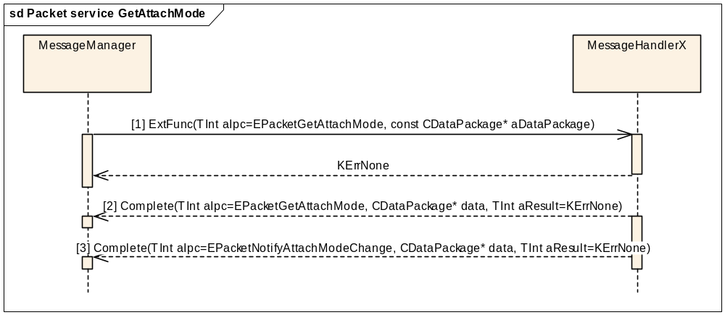
Figure 3.82 Packet service GetAttachMode
Parameters:
[1] aDataPackage is empty.
[2] aDataPackage.Ptr1: RpacketService::TattachMode attachModeForCompletion
aDataPackage.Ptr2 is empty.
[3] aDataPackage.Ptr1: RpacketService::TPreferredBearer bearer
aDataPackage.Ptr2 is empty.
Note: This is completed only at boot-up phase.

Packet service SetDefaultContextParameters
Precondition: MS is in the Idle state and connected to a network.
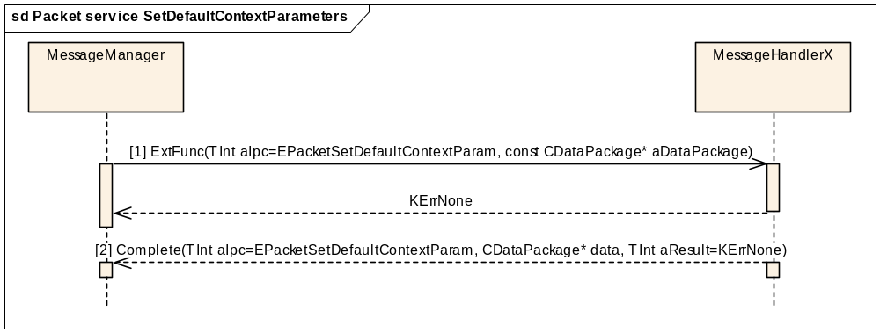
Figure 3.83 Packet service SetDefaultContextParameters
Parameters:

[1] aDataPackage.Ptr1: TpacketDataConfigBase* dataPtr
aDataPackage.Ptr2 is empty.
[2] CDataPackage is empty.

Packet service SetPreferredBearer
Precondition: MS is in the Idle state and connected to a network.
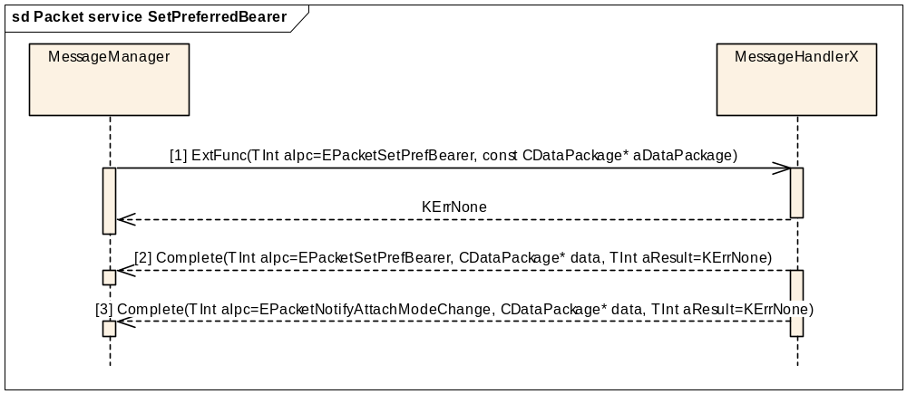
Figure 3.84 Packet service SetPreferredBearer
Parameters:
[1] aDataPackage.Ptr1: RpacketService::TPreferredBearer* abearer
aDataPackage.Ptr2 is empty.
[2] CDataPackage is empty.
[3] aDataPackage.Ptr1: RpacketService::TPreferredBearer* bearer
aDataPackage.Ptr2 is empty.
Note: aIPC = EpacketNotifyAttachModeChange is used because it does not have a specific preferred bearer notify IPC defined in ETel (pcktcs.h).

Packet service get static capabilities
Precondition: This is done only in boot-up.

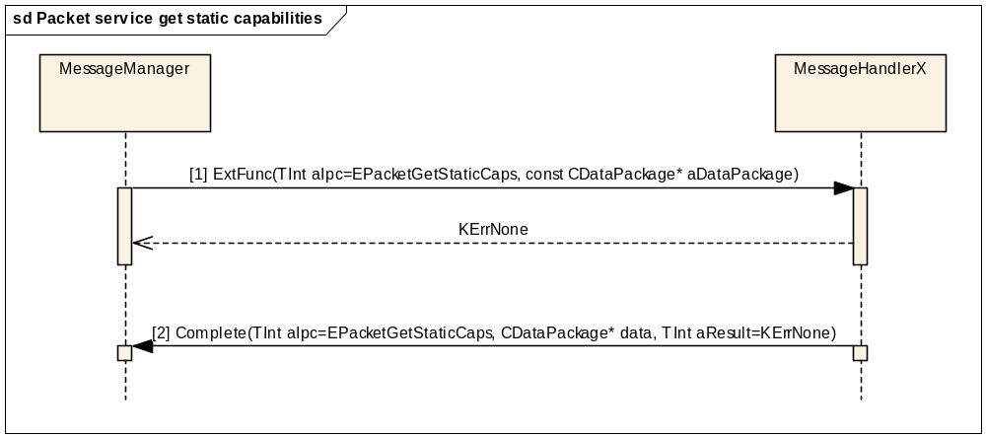
Figure 3.85 Packet service get static capabilities
Parameters:
[1] aDataPackage.Ptr1 is empty
aDataPackage.Ptr2 is empty.
[2] aDataPackage.Ptr1: RPacketService::TStaticMiscCaps aCaps

Packet service get Mbms network service status
Precondition: MS is in the Idle state and connected to a network.
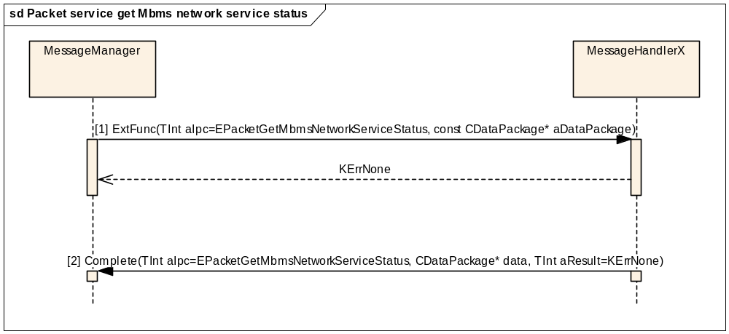
Figure 3.86 Packet service get Mbms network service status

Parameters:
[1] aDataPackage.Ptr1: TBool aAttemptAttach
aDataPackage.Ptr2 is empty.
[2] aDataPackage.Ptr1: RPacketService::TMbmsNetworkServiceStatus aServiceStatus
aDataPackage.Ptr2 is empty.

Packet service notify Mbms network service status change
Precondition: MS is in the Idle state and connected to a network.

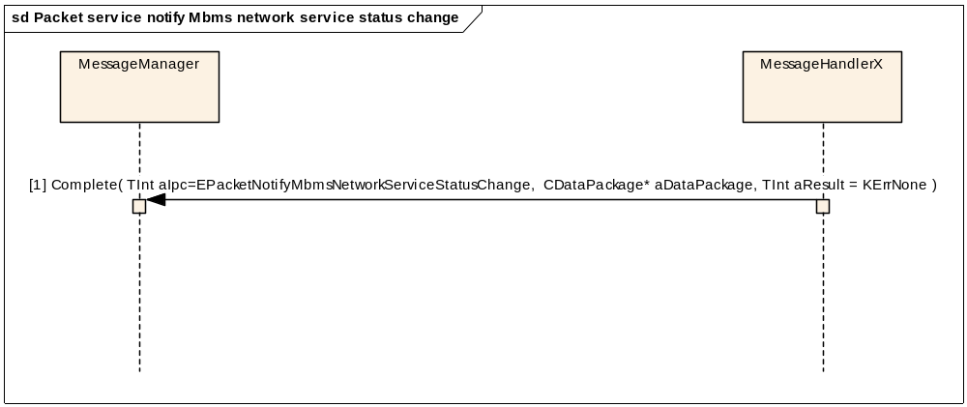
Figure 3.87 Packet service notify Mbms network service status change
Parameters:
[1] aDataPackage.Ptr1: RPacketService::TMbmsNetworkServiceStatus aServiceStatus
aDataPackage.Ptr2 is empty.

Packet service update Mbms monitor service list
Precondition: MS is in the Idle state and connected to a network.

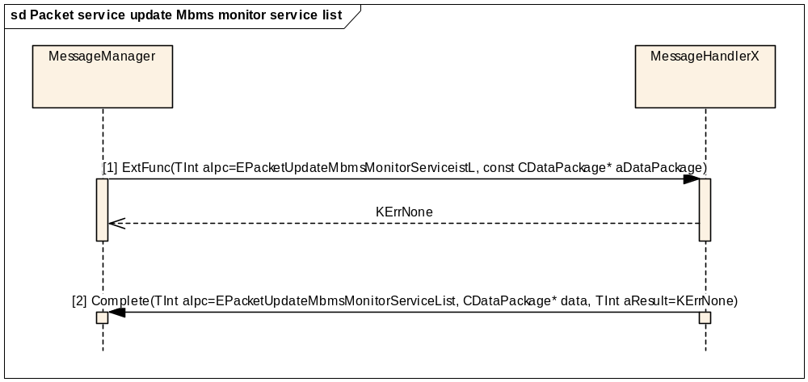
Figure 3.88 Packet service update Mbms monitor service list
Parameters:
[1] aDataPackage.Ptr1: TMmMbmsMonitorServiceListParams aMbmsMonitoredListData
aDataPackage.Ptr2 is empty.
[2] aDataPackage.Ptr1: CPcktMbmsMonitoredServiceList* failedMonitorEntries
aDataPackage.Ptr2 is empty.

Packet service notify Mbms service availability change
Precondition: MS is in the Idle state and connected to a network.

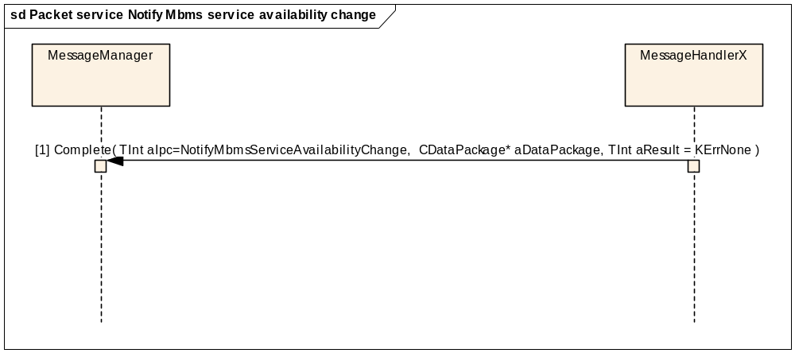
Figure 3.89 Packet service notify Mbms service availability change
Parameters:
[1] aDataPackage.Ptr1: CPcktMBMSMonitoredServicesList* aAvailableMonitorServices
aDataPackage.Ptr2 is empty.

Packet service enumerate Mbms monitor service list
Precondition: This is done only in boot-up.

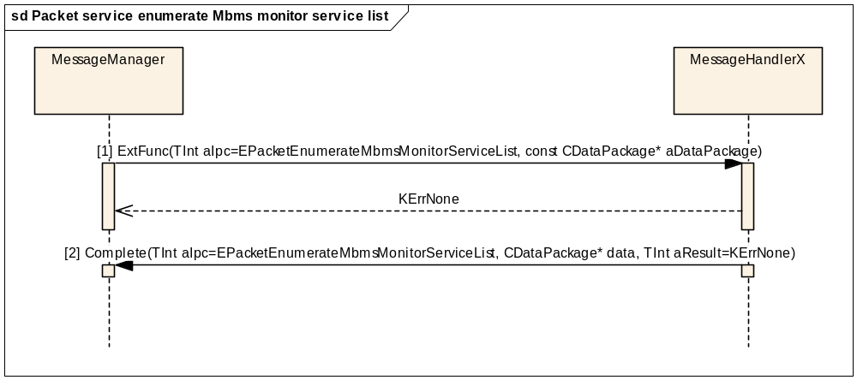
Figure 3.90 Packet service enumerate Mbms monitor service list
Parameters:
[1] aDataPackage.Ptr1 is empty
aDataPackage.Ptr2 is empty.
[2] aDataPackage.Ptr1: TInt maxMonitorValue

Packet service enumerate Mbms active service list
Precondition: This is done only in boot-up.

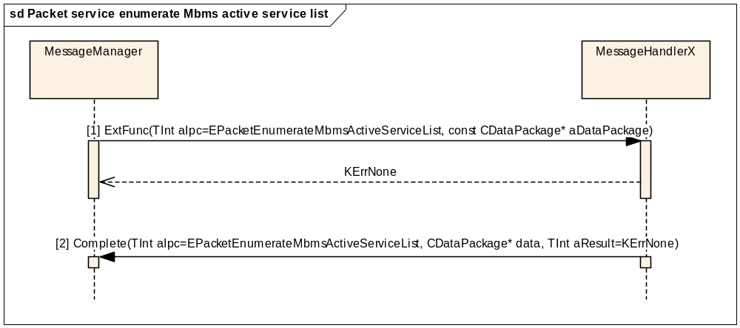
Figure 3.91 Packet service enumerate Mbms active service list
Parameters:
[1] aDataPackage.Ptr1 is empty
aDataPackage.Ptr2 is empty.
[2] aDataPackage.Ptr1: TInt aMaxActiveServices

Packet context initialisation
Precondition: MS is in the Idle state and connected to a network. A context is active.
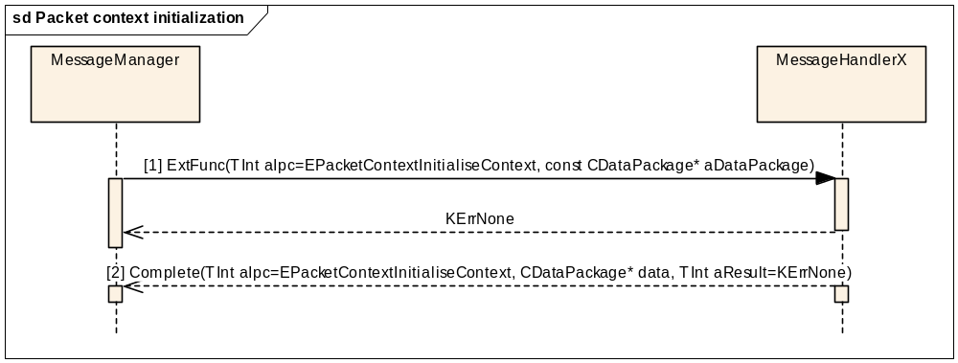
Figure 3.92 Packet context initialisation
Parameters:
[1] aDataPackage.Ptr1: TInfoName* aContextName
[2] aDataPackage.Ptr1: TInfoName* aContextName

Packet context configuration
Precondition: MS is in the Idle state and connected to a network. A context is active.
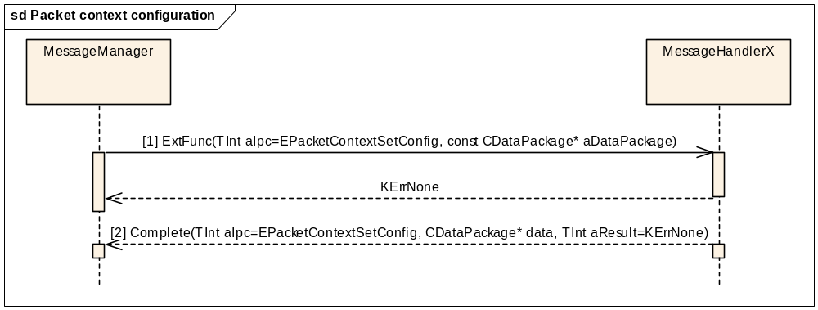
Figure 3.93 Packet context configuration
Parameters:

[1] aDataPackage.Ptr1: TPacketDataConfigBase* aConfig
aDataPackage.Ptr2: TInfoName* aContextName
[2] aDataPackage.Ptr1: TInfoName* aContextName

Packet context activation
Precondition: MS is in the Idle state and connected to a network. A context is active.
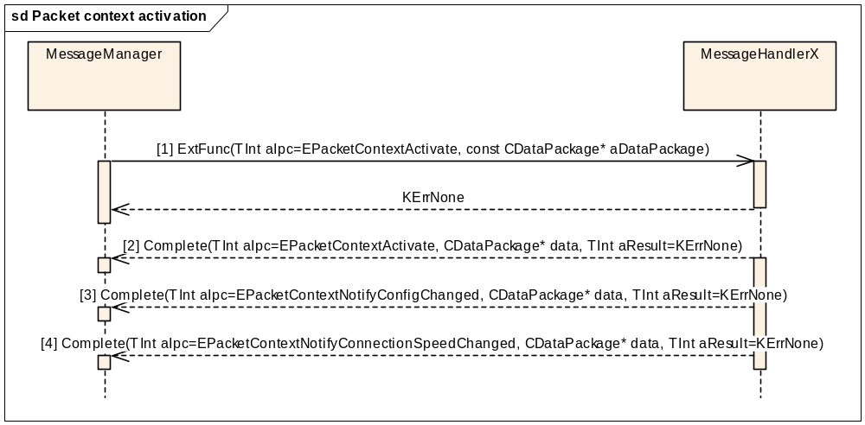
Figure 3.94 Packet context activation
Parameters:
[1] aDataPackage.Ptr1: TInfoName* aContextName
[2] aDataPackage.Ptr1: TInfoName* aContextName
aDataPackage.Ptr2: RPacketContext::TContextConfigGPRS* aConfig
[3] aDataPackage.Ptr1: TInfoName* aContextName
aDataPackage.Ptr2: RpacketContext::TContextConfigGPRS* aConfig
[4] aDataPackage.Ptr1: TInfoName* aContextName
aDataPackage.Ptr2: TInt aConnectionSpeed

Packet context deactivation
Precondition: MS is in the Idle state and connected to a network. A context is active.
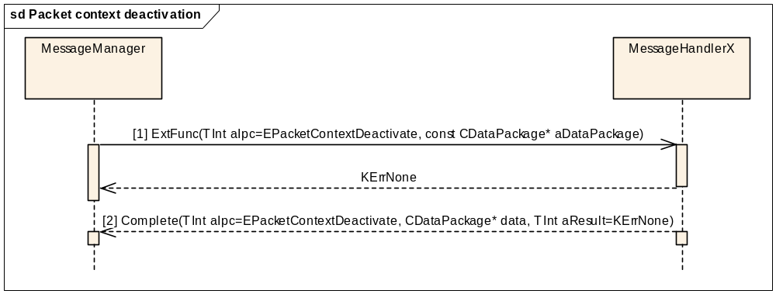
Figure 3.95 Packet context deactivation

Parameters:
[1] aDataPackage.Ptr1: TInfoName* aContextName
[2] aDataPackage.Ptr1: TInfoName* aContextName

Packet context deletion
Precondition: MS is in the Idle state and connected to a network. A context is active.
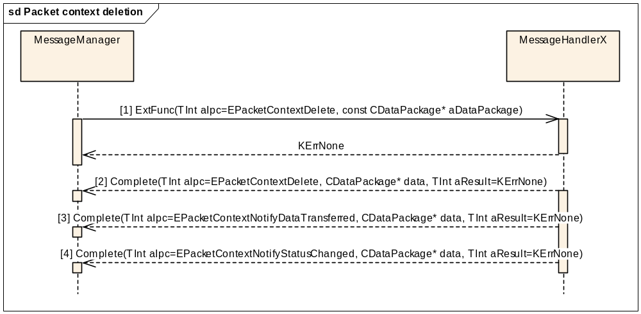
Figure 3.96 Packet context deletion
Parameters:
[1] aDataPackage.Ptr1: TInfoName* aContextName
[2] aDataPackage.Ptr1: TInfoName* aContextName
[3] aDataPackage.Ptr1: TInfoName* aContextName
aDataPackage.Ptr2: RPacketContext::TDataVolume* aDataVolume
[4] aDataPackage.Ptr1: TInfoName* aContextName
aResult: RPacketContext::EstatusDeleted

Packet context GetDataVolumeTransferred
Precondition: The MS is in the Idle state and connected to a network. A context is initialised.
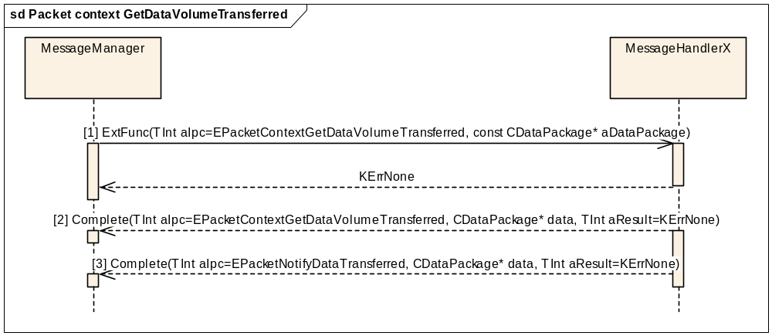
Figure 3.97 Packet context GetDataVolumeTransferred
Parameters:
[1] aDataPackage.Ptr1: TInfoName* aContextName
[2] aDataPackage.Ptr1: TInfoName* aContextName
aDataPackage.Ptr2: RPacketContext::TDataVolume* aDataVolume
[3] aDataPackage.Ptr1: TInfoName* aContextName
aDataPackage.Ptr2: RPacketContext::TDataVolume* aDataVolume

Packet context Set QoS profile parameters
Precondition: The MS has at least one context that needs QoS parameters and the context has been initialised.
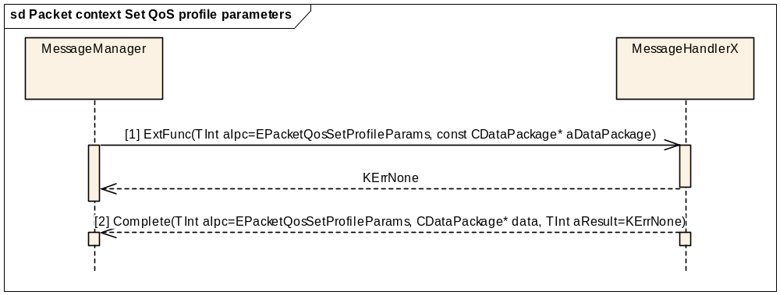
Figure 3.98 Packet context Set QoS profile parameters
Parameters:

[1] aDataPackage.Ptr1: TContextParams aContextParams
aDataPackage.Ptr2: TDes8* aProfile
[2] CDataPackage is empty.

Packet context Add packet filters
Precondition: A secondary context is created and initialised. Before activation, the secondary context must have at least one packet filter added.
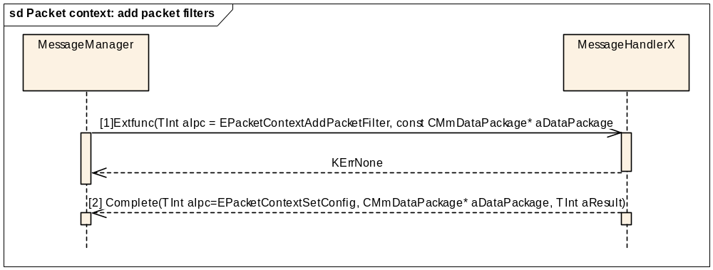
Figure 3.99 Packet context: add packet filters
Parameters:

[1] aDataPackage.Ptr1: TInfoName contextName
aDataPackage.Ptr2: CArrayFixFlat<RPacketContext::TPacketFilterV2>* iFilterTemporaryArray
[3] CDataPackage: TInfoName contextName
Note: In case one aDataPackage type is CMmPacketDataPackage, which inherits from the class CMmDataPackage, using the CMmPacketDataPackage class provides a way to transfer more than two parameters through the interface between Common TSY and Licensee TSY.

Packet context Remove packet filters
Preconditions: A secondary context has been created and packet filters have been added.
The removal of packet filters is done by using the Common TSY method RemovePacketFilter. The TFT filter is removed by an ID given in the function call. The removal takes place by calling the Common TSY method ModifyActiveContextL after calling the method RemovePacketFilter.

Packet context Add media authorization parameters
Preconditions: A secondary context has been created and initialised and the context state is inactive or unknown. Otherwise, the request goes through ModifyActiveContextL to Licensee TSY by calling the Common TSY method AddMediaAuthorizationL and after this ModifyActiveContextL. More info about media authorization can be found in reference document [R3].
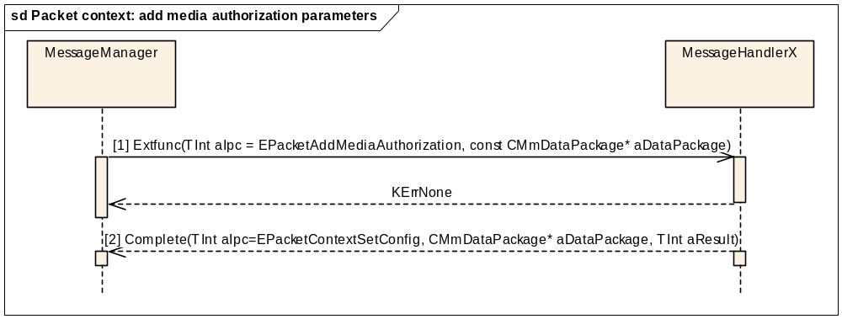
Figure 3.100 Packet context: add media authorization parameters
Parameters:

[1] aDataPackage.Ptr1: TInfoName contextName
aDataPackage.Ptr2: RPacketContext::CTFTMediaAuthorizationV3* const aMediaAuthorization
[3] CDataPackage: TInfoName contextName

Packet context Remove media authorization parameters
Preconditions: A secondary context has been created and media authorization parameters have been added.
The removal of media authorization parameters is done by using the Common TSY method RemoveMediaAuthorization. An authorization token is removed by the token given in the function call. The removal takes place when the Common TSY method ModifyActiveContextL is called.

Packet service NotifyTransferCaps
Precondition: The MS is in the Idle state and connected to a network.
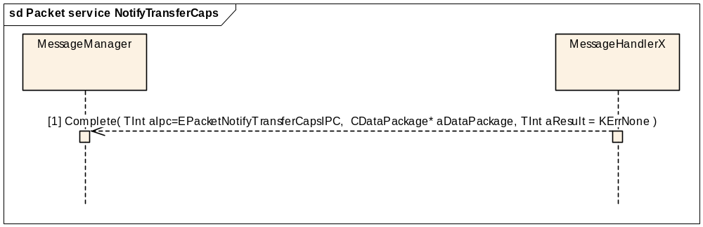
Figure 3.101 Packet service NotifyTransferCaps
Parameters:
[1] aDataPackage.Ptr1: TDynamicTransferCapsFlags containing valid TDynamicTransferCaps
aDataPackage.Ptr2 is empty.

Packet service Custom Set Always On
Successful case
Precondition: MS is on and connected to network. This method is used to set always on mode to network.
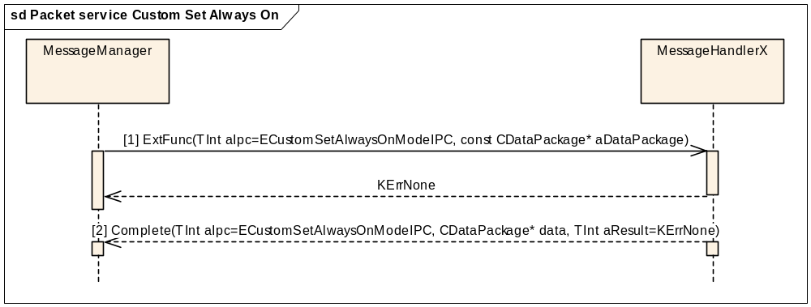
Figure 3.102 Packet service Custom Set Always On

Paremeters:
[1] aDataPackage.iPtr1: RMmCustomAPI::TSetAlwaysOn

Packet service Custom Notify Rau Event
Precondition: MS is on and connected to network, client has requested this notification. Notify is completed when RAU (routing area update) event occurs.
Figure 3.103 Packet service Custom Notify Rau Event

Parameters:
[1] aDataPackage.iPtr1: RMmCustomAPI::TRauEventStatus

MBMS context initialisation
Precondition: MS is in the Idle state and connected to a network.
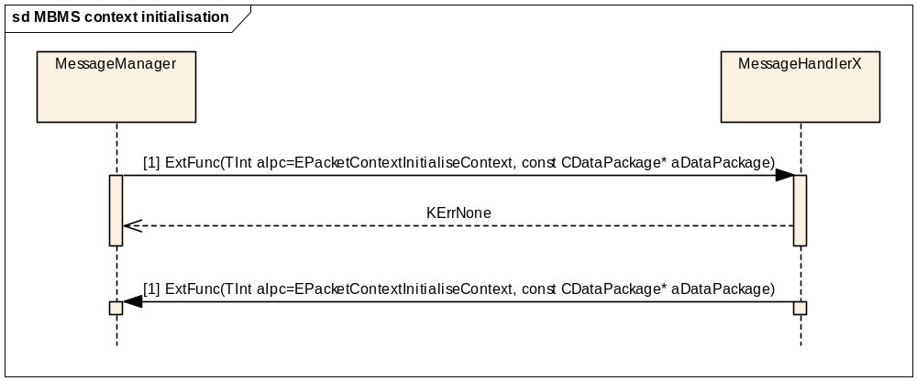
Figure 3.104 MBMS context initialisation
Parameters:

[1] aDataPackage.Ptr1: TInfoName* aContextName
aDataPackage.Ptr2: RPacketContext :: aDataChannelV2* aChannel

[2] aDataPackage.Ptr1: TInfoName* aContextName
aDataPackage.Ptr2: RPacketContext :: aDataChannelV2* aChannel

MBMS context configuration
Precondition: MS is in the Idle state and connected to a network. A context is initialised.
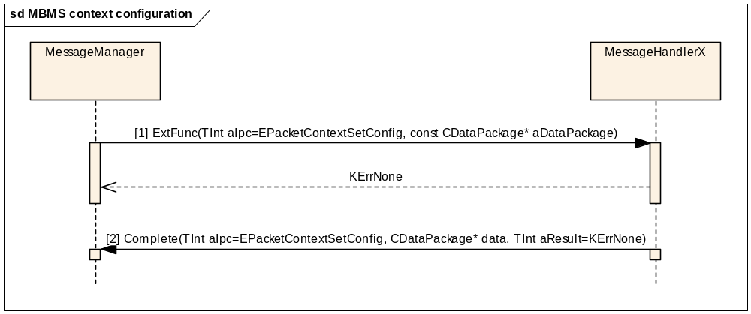
Figure 3.105 MBMS context configuration
Parameters:

[1] aDataPackage.Ptr1: TPacketDataConfigBase* aConfig
aDataPackage.Ptr2: TInfoName* aContextName
[2] aDataPackage.Ptr1: TInfoName* aContextName

MBMS context session update
Precondition: MS is in the Idle state and connected to a network. A context is configured.

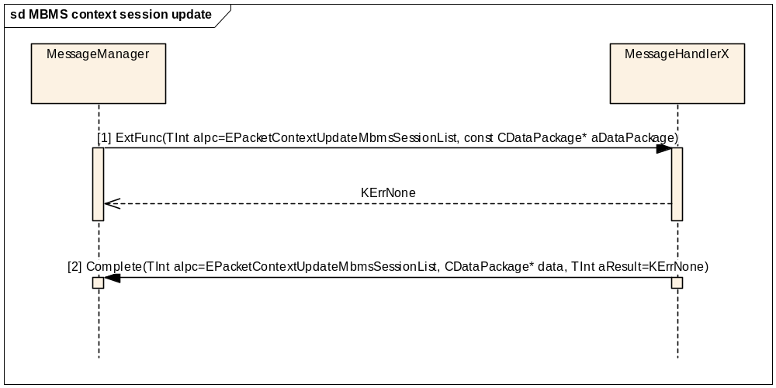
Figure 3.106 MBMS context session update
Parameters:

[1] aDataPackage.Ptr1: TInfoName* aContextName

aDataPackage.Ptr2: TMmMbmsActiveServiceListParams aActiveServiceList
[2] aDataPackage.Ptr1: TInfoName* aContextName

MBMS context activation
Precondition: MS is in the Idle state and connected to a network. A context is configured.
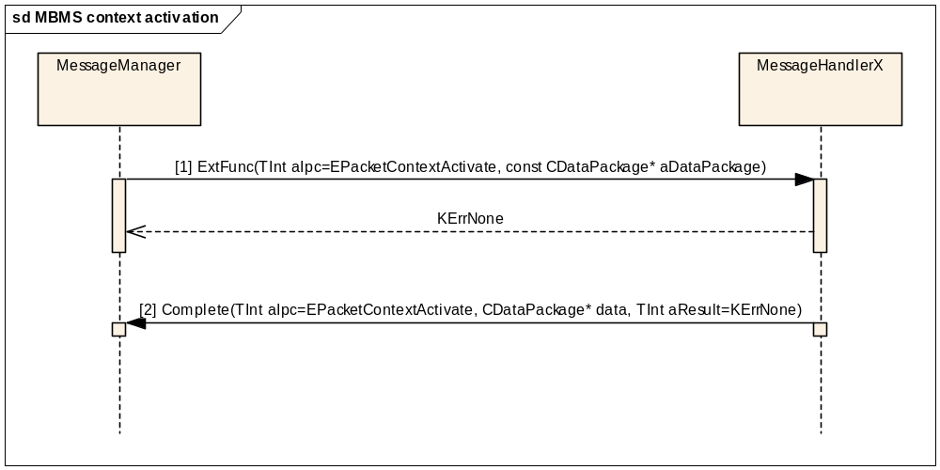
Figure 3.107 MBMS context activation
Parameters:
[1] aDataPackage.Ptr1: TInfoName* aContextName
[2] aDataPackage.Ptr1: TInfoName* aContextName

MBMS context deactivation
Precondition: MS is in the Idle state and connected to a network. A context is active.
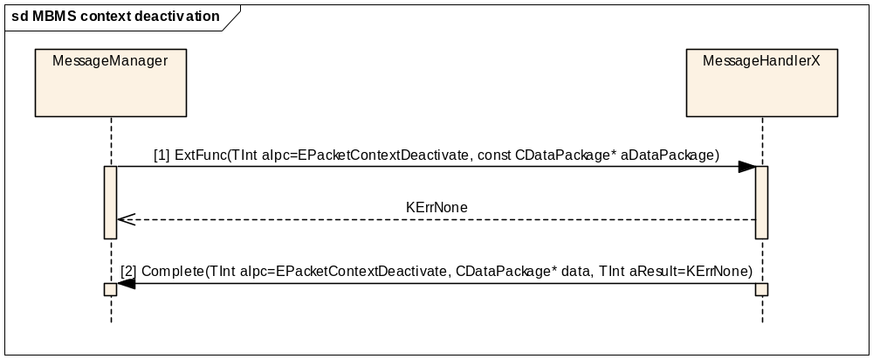
Figure 3.107 MBMS context deactivation

Parameters:
[1] aDataPackage.Ptr1: TInfoName* aContextName
aDataPackage.Ptr2: RPacketMbmsContext::CmbmsSession* iServicesArray
[2] aDataPackage.Ptr1: TInfoName* aContextName
aDataPackage.Ptr2: RPacketMbmsContext::CmbmsSession* listOfFailedEntries

MBMS context deletion
Precondition: MS is in the Idle state and connected to a network.
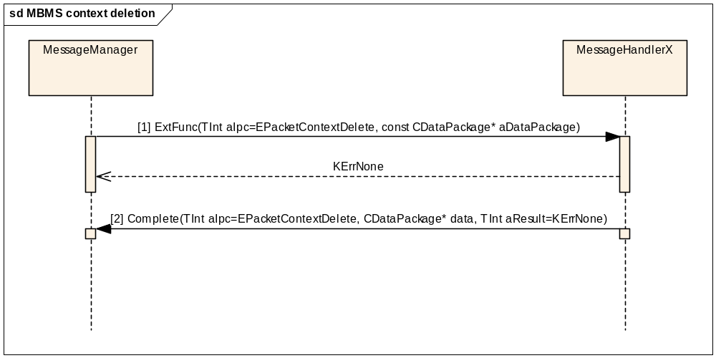
Figure 3.108 MBMS context deletion
Parameters:
[1] aDataPackage.Ptr1: TInfoName* aContextName
[2] aDataPackage.Ptr1: TInfoName* aContextName

Packet Context - GetConnectionInfo
This method simply returns the cache value of the connection info. No call is actually made to the LTSY.
The cache value is updated by the LTSY by it calling CompleteNotifyConnectionInfoChange with the new data. See NotifyConnectionInfoChange below.

Packet Context – NotifyConnectionInfoChange
This method is called by the LTSY in order to notify the CTSY of an update to the ConnectionInfo cache data. If there is a change in the data, the cache is updated.
If there is an outstanding client request, the client request will be completed with the new cache value.
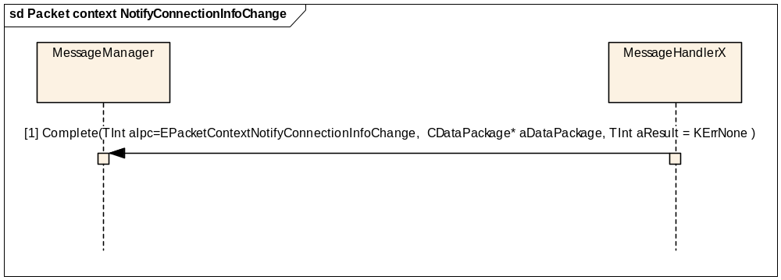
Figure 3.109 Packet context NotifyConnectionInfoChange
Parameters:
[1] aDataPackage.Ptr1: TInfoName* aContextName
aDataPackage.Ptr2: TConnectionInfoBase* aConnectionInfoBase

Supplementary services interface

Getting the call barring status
Precondition: The MS is connected to a network. It can be either in the Idle state or have an active call.
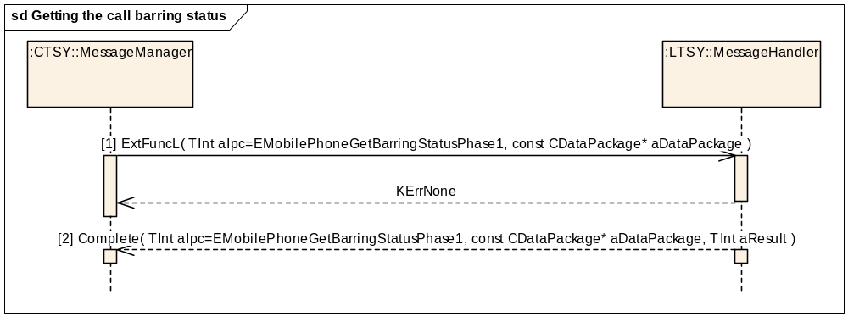
Figure 3.83 Getting the call barring status
Parameters:
[1] aDataPackage.iPtr1: TMobilePhoneCBCondition (one of {EBarAllIncoming, EBarIncomingRoaming, EBarAllOutgoing, EBarOutgoingInternational, EBarOutgoingInternationalExHC})
[2] aDataPackage.iPtr1: CMobilePhoneCBList* (list of TMobilePhoneCBInfoEntryV1 entries)
In case of a successful request (aResult == KErrNone), the list always contains at least one entry (also in the case that the requested service is not active).
In case of an unsuccessful request (aResult != KErrNone), the list is empty.

Getting the call forwarding status
Precondition: MS is connected to a network. It can be either in the Idle state or have an active call.
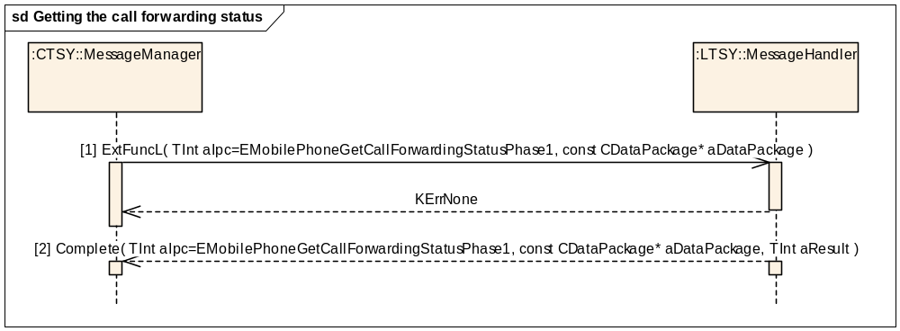
Figure 3.84 Getting the call forwarding status
Parameters:
[1] aDataPackage.iPtr1: TMobilePhoneCFCondition (one of {ECallForwardingUnconditional, EcallForwardingBusy, ECallForwardingNoReply or ECallForwardingNotReachable})
aDataPackage.iPtr2: TMobileService serviceGroup (any service group)
[2] aDataPackage.iPtr1: CMobilePhoneCFList* (a list of TMobilePhoneCFInfoEntryV1 entries)
In case of a successful request (aResult == KErrNone), the list always contains at least one entry (also in the case that the requested service is not active).
In case of an unsuccessful request (aResult != KErrNone), the list is empty.

Getting the call waiting status
Precondition: MS is connected to a network. It can be either in the Idle state or have an active call.
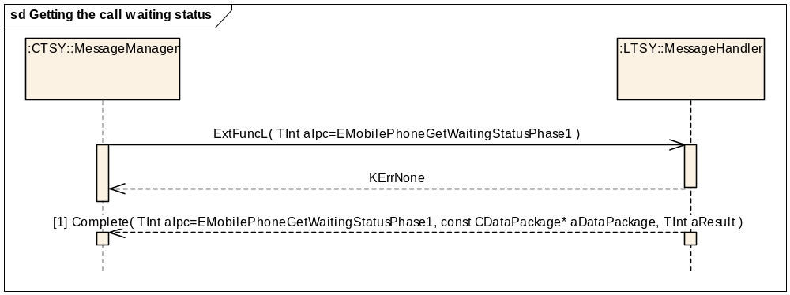
Figure 3.85 Getting the call waiting status
Parameters:
[1] aDataPackage.iPtr1: CMobilePhoneCWList* (a list of TMobilePhoneCWInfoEntryV1 entries)
In case of a successful request (aResult == KErrNone), the list always contains at least one entry (also in the case that the requested service is not active).
In case of an unsuccessful request (aResult != KErrNone), the list is empty.

Getting the identity service status
Precondition: The MS is connected to a network. It can be either in the Idle state or have an active call.
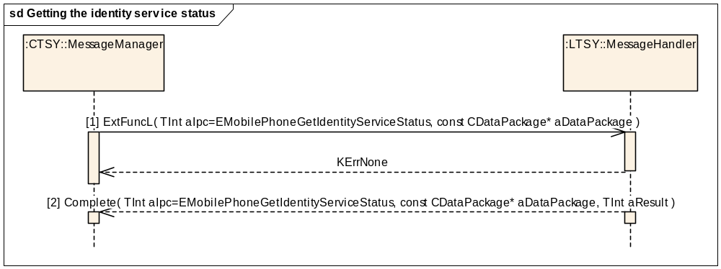
Figure 3.86 Getting the identity service status
Parameters:
[1] aDataPackage.iPtr1: TMobilePhoneIdService (any of {EIdServiceCallerPresentation, EIdServiceCallerRestriction, EIdServiceConnectedPresentation, EIdServiceConnectedRestriction or EIdServiceCallerName})
[2] aDataPackage.iPtr1: TMobilePhoneIdServiceStatus (the status of the requested service)
In case of a successful request (aResult == KErrNone), the service status is one of {EIdServiceActivePermanent, EIdServiceActiveDefaultRestricted, EIdServiceActiveDefaultAllowed, EIdServiceNotProvisioned}.
In case of an unsuccessful request (aResult != KErrNone), the service status is EIdServiceUnknown.

Setting the call barring status

Setting the call barring status: success
Precondition: MS is connected to a network. It can be either in the Idle state or have an active call.
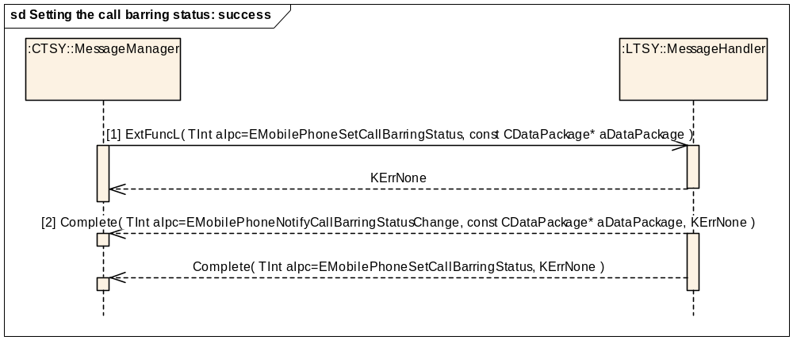
Figure 3.87 Setting the call barring status: success
Parameters:

[1] aIpc: EMobilePhoneSetCallBarringStatus
aDataPackage.iPtr1: TMobilePhoneCBCondition (any)
aDataPackage.iPtr2: TMobilePhoneCBChangeV1* (with iAction one of {EServiceActionRegister, EServiceActionActivate, EServiceActionDeactivate, EServiceActionErase})
The conditions EBarAllCases, EBarAllOutgoingServices, EBarAllIncomingServices are only possible in conjunction with the actions EServiceActionDeactivate and EServiceActionErase.
[2] aDataPackage.iPtr1: TMobilePhoneCBCondition (the condition which might have changed. Because there is no cache of the statuses, this is always triggered in case of a successful request).

Setting the call barring status: failure
Precondition: The MS is connected to a network. It can be either in the Idle state or have an active call.
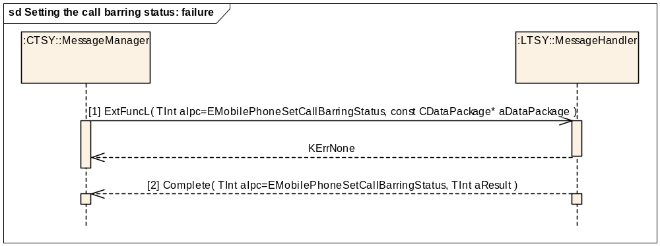
Figure 3.88 Setting the call barring status: failure
Parameters:
[1] As in a successful case, see Section 3.8.5.1.
[2] aResult: An error code (!= KErrNone)

Setting the call forwarding status

Setting the call forwarding status: success
Precondition: The MS is connected to a network. It can be either in the Idle state or have an active call.
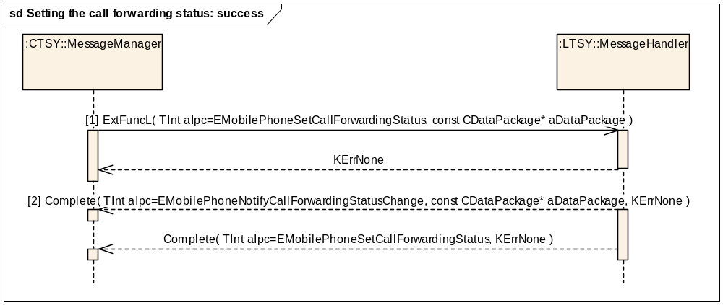
Figure 3.89 Setting the call forwarding status: success
Parameters:
[1] aDataPackage.iPtr1: TMobilePhoneCFCondition (any)
aDataPackage.iPtr2: TMobilePhoneCFChangeV1* (with iAction one of {EServiceActionRegister, EServiceActionActivate, EServiceActionDeactivate, EServiceActionErase})
[2] aDataPackage.iPtr1: TMobilePhoneCFCondition (the condition which might have changed. Because there is no cache of the statuses, this notification is always triggered in case of a successful request).

Setting the call forwarding status: failure
Precondition: The MS is connected to a network. It can be either in the Idle state or have an active call.
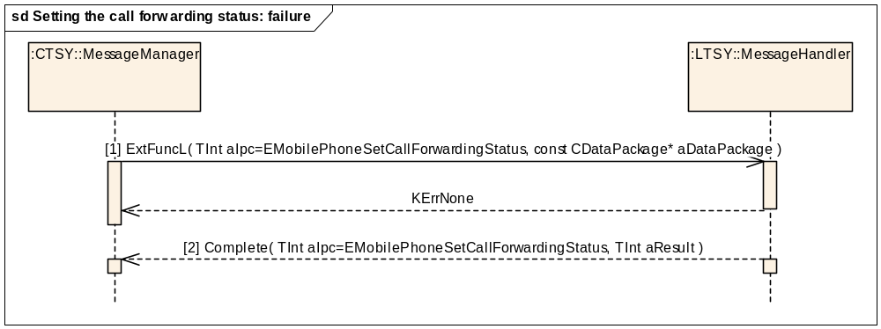
Figure 3.90 Setting the call forwarding status: failure
Parameters:
[1] As in a successful case, see Section 3.8.6.1.
[2] aResult: An error code (!= KErrNone)

Setting the call waiting status

Setting the call waiting status: success
Precondition: The MS is connected to a network. It can be either in the Idle state or have an active call.
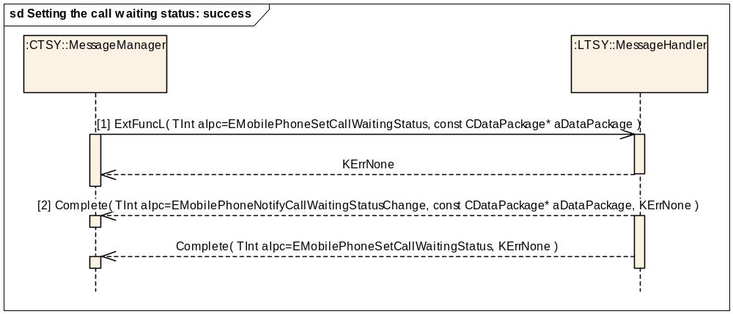
Figure 3.91 Setting the call waiting status: success
Parameters:
[1] aDataPackage.iPtr1: TMobileService (any service group)
aDataPackage.iPtr2: TMobilePhoneServiceAction (one of {EServiceActionActivate, EServiceActionDeactivate})
[2] aDataPackage.iPtr1: TMobilePhoneCWInfoEntryV1 (the changed call waiting status and service group).

Setting the call waiting status: failure
Precondition: The MS is connected to a network. It can be either in the Idle state or have an active call.
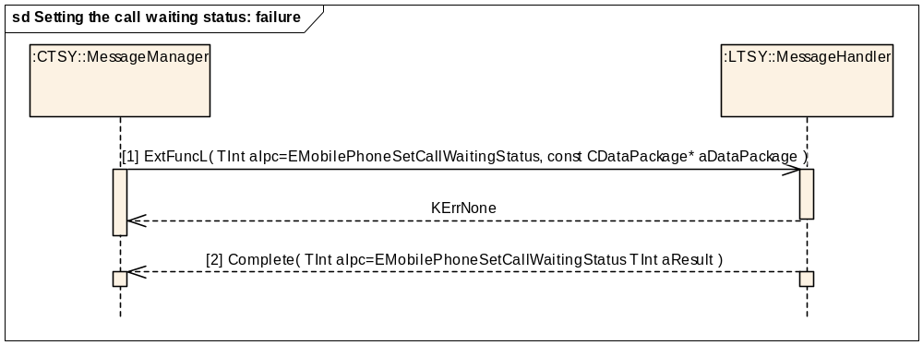
Figure 3.92 Setting the call waiting status: failure
Parameters:
[1] As in a successful case, see Section 3.8.7.1.
[2] aResult: An error code (!= KErrNone)

Setting the supplementary services password
Precondition: The MS is connected to a network. It can be either in the Idle state or have an active call.
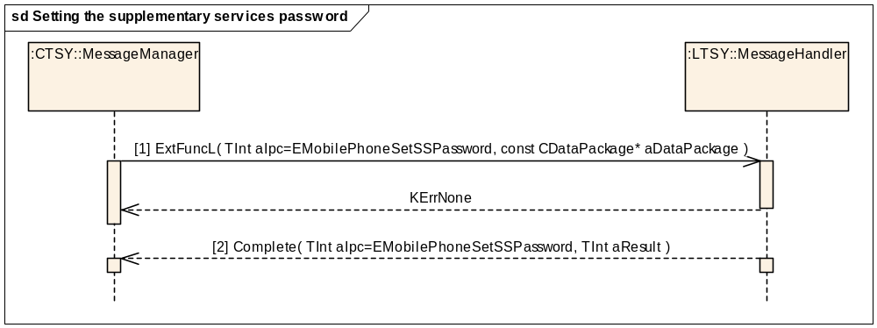
Figure 3.93 Setting the supplementary services password
Parameters:
[1] aDataPackage.iPtr1: TMobilePhonePasswordChangeV2 (containing the old, new and verified passwords)
aDataPackage.iPtr2: TUint16 (the service code, either 0 (all services) or 330 (call barring), the only legal values according to reference document [R6]
[2] aResult: KErrNone or an error code.

Setting ICC Message Waiting Indicators
This function sets the message waiting indicators on the current ICC.
Precondition: Baseband is ready to access the SIM.
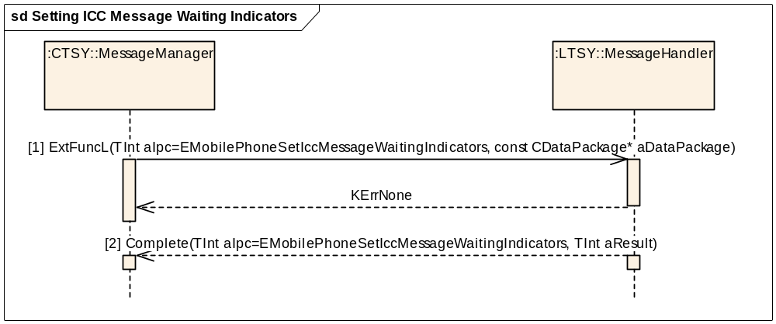
Figure 3.94 Setting ICC Message Waiting Indicators
Parameters:
[1] aDataPackage.iPtr1: TMobilePhoneMessageWaitingV1 (containing the new ICC message waiting indicators).
[2] aResult: KErrNone or an error code, KErrNotSupported if the current ICC does not support message waiting indicators.

Getting ICC Message Waiting Indicators
This function retrieves the set of message waiting indicators from the current ICC.
Precondition: Baseband is ready to access the SIM.
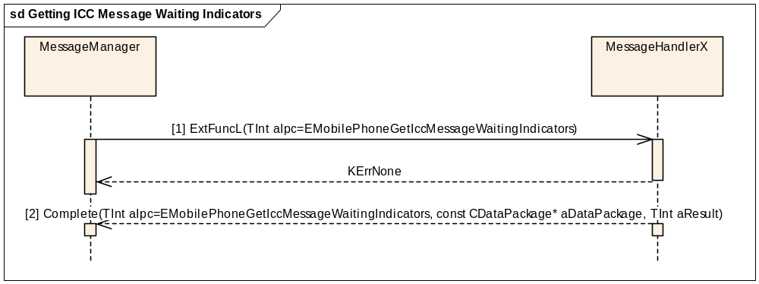
Figure 3.95 Getting ICC Message Waiting Indicators
Parameters:
[1] aDataPackage.iPtr1: TMobilePhoneMessageWaitingV1 (up-to-date information of the ICC message waiting indicators).
aResult: KErrNone or an error code, KErrNotSupported if the current ICC does not support message waiting indicators.

Notify if ICC Message Waiting Indicators are changed
This function notifies the client if the message waiting indicators on the current ICC change. Notification is also called internally if the ICC Message Waiting Indicators information has been changed after the Get or Set methods.
Precondition: Baseband is ready to access the SIM.
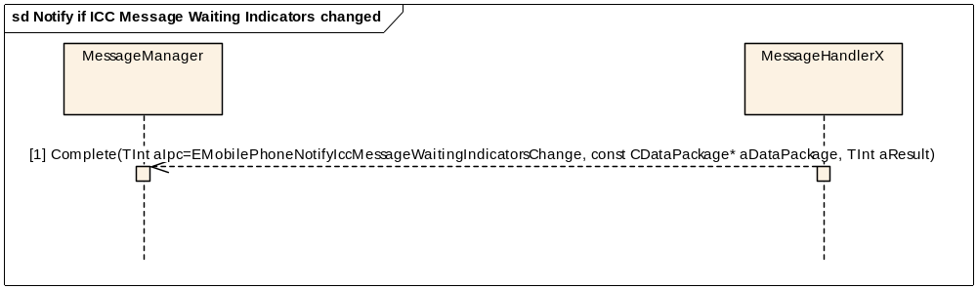
Figure 3.96 Notify if ICC Message Waiting Indicators changed
Parameters:
[1] aDataPackage.iPtr1: TMobilePhoneMessageWaitingV1 (up-to-date information of the ICC message waiting indicators).
aResult: KErrNone or an error code, KErrNotSupported if the current ICC does not support message waiting indicators.

Setting ICC call forwarding status indicator
Precondition: The MS is on and connected to a network.
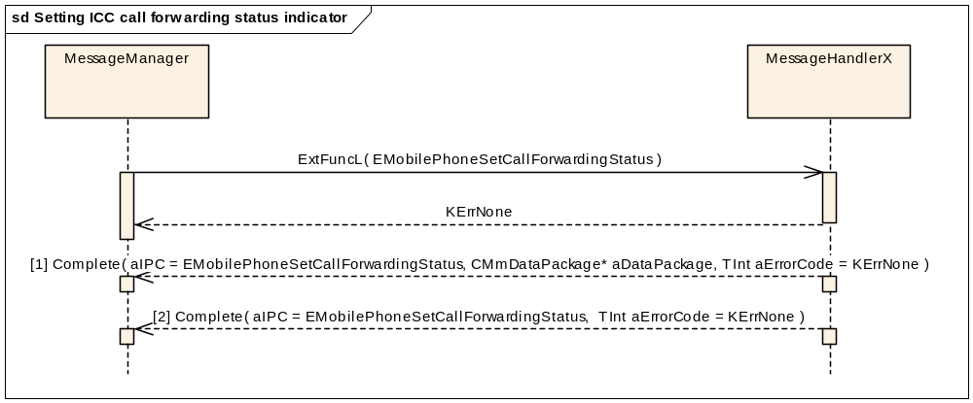
Figure 3.97 Setting ICC call forwarding status indicator
Parameters:
[1] aDataPackage.iPtr1: RMobilePhone::TMobilePhoneCFCondition
aDataPackage.iPtr2: RMobilePhone::TMobilePhoneCFChangeV1
[2] aResult: KErrNone or an error code.

Getting ICC call forwarding status indicator
Precondition: The MS is on and connected to a network.
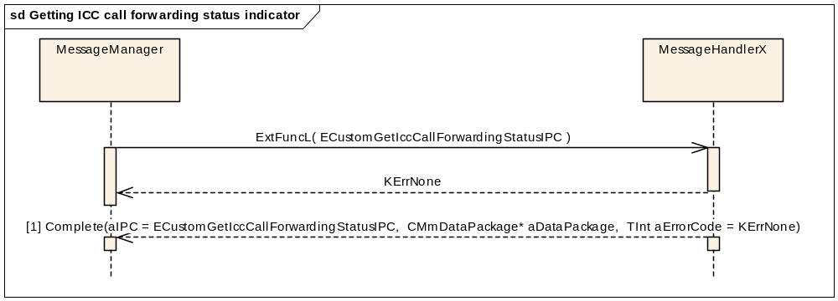
Figure 3.98 Getting ICC call forwarding status indicator
Parameters:
[1] aDataPackage.iPtr1: RMmCustomAPI::TCFIndicators (Class defined in CustomApi containing indicator information)
aDataPackage.iPtr2: Empty

Security interface

Getting the “Is blocked” status
This method checks if PIN1, PIN2, UPIN or Security Code is blocked.
Precondition: The Baseband security component is ready.
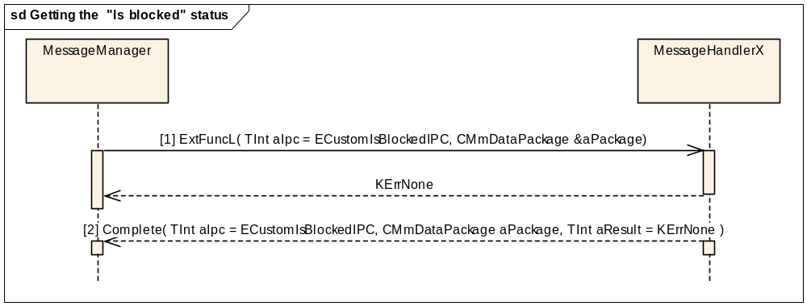
Figure 3.99 Getting the “Is blocked” status
Parameters:
[1] aPackage.iPtr1: TUint8* iCodeID. Possible values for iCodeID are KSecCodePin, KSecCodePin2, KSecCodeUpin or KSecCodeSecurity.
[2] aPackage.iPtr1: TBool
This method is a Custom ETel API method, see reference document [R4] for more information.

Checking the security code
This method activates security code request.
Precondition: The Baseband security component is ready.
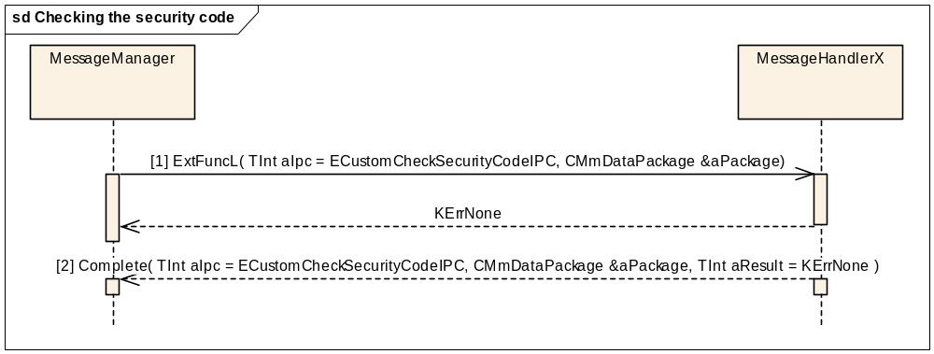
Figure 3.100 Checking the security code
Parameters:
[1] aPackage.iPtr1: TUint8* iCodeID. Possible values for iCodeID are KSecCodePin, KSecCodePin2, KSecCodeUpin or KSecCodeSecurity.
aPackage.iPtr2: RMobilePhone::TmobilePassword* iSecCode
[2] aPackage is empty.
This method is a Custom ETel API method, see reference document [R4] for more information.

Disabling the phone lock
This method disables the phone lock.
Precondition: The Baseband security component is ready and the phone lock is active.
Figure 3.101 Disabling the phone lock
Parameters:
[1] aPackage.iPtr1: RMobilePhone::TMobilePassword* aVerifyCode
[2] aPackage is empty.
This method is a Custom ETel API method, see reference document [R4] for more information.

Getting lock information
This method gets the status and setting of the lock.
Precondition: The Baseband security component is ready.
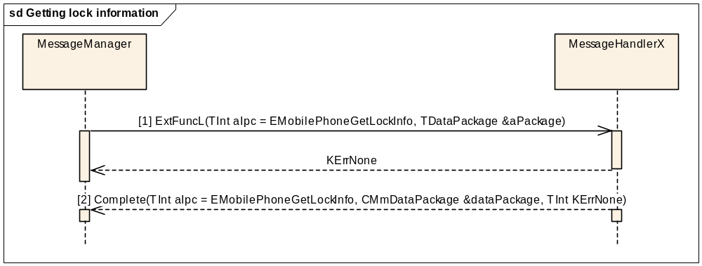
Figure 3.102 Getting lock information

Parameters:
[1] aPackage.iPtr1: RMobilePhone::TmobilePhoneLock*
aPackage.iPtr2: RMobilePhone::TMobilePhoneLockInfoV1*
[2] dataPackage.iPtr1: RMobilePhone::TMobilePhoneLockInfoV1::TMobilePhoneLockStatus*
dataPackage.iPtr2: RMobilePhone::TMobilePhoneLockInfoV1::TMobilePhoneLockSetting*

Changing the security code
This method changes the security code.
Precondition: The Baseband security component is ready.
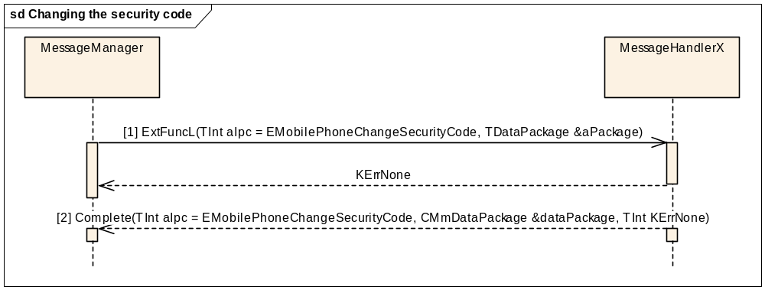
Figure 3.103 Changing the security code
Parameters:
[1] aPackage.iPtr1: RMobilePhone::TmobilePhoneSecurityCode*
aPackage.iPtr2: RMobilePhone::TMobilePhonePasswordChangeV1*
[2] dataPackage is empty.

Aborting an ongoing security related request
This method requests aborting of an ongoing security related request.
Precondition: The Baseband security component is ready.
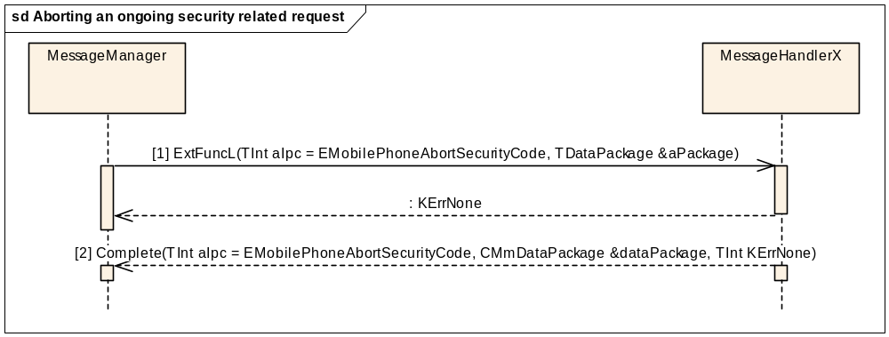
Figure 3.104 Aborting an ongoing security related request
Parameters:
[1] aPackage.iPtr1: RMobilePhone::TMobilePhoneSecurityCode*
[2] dataPackage is empty.

Verifying the security code
This method verifies the given security code.
Precondition: The Baseband security component is ready.
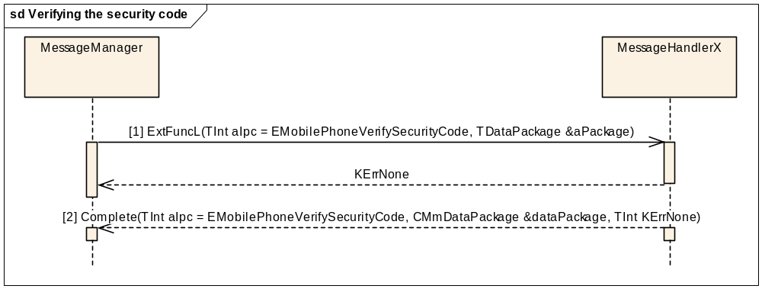
Figure 3.105 Verifying the security code
Parameters:
[1] aPackage.iPtr1: RMobilePhone::TMobilePhoneSecurityCode*
aPackage.iPtr2: RMobilePhone::TCodeAndUnblockCode*
[2] dataPackage is empty.

Setting lock setting
This method changes the setting of a given lock.
Precondition: The Baseband security component is ready.
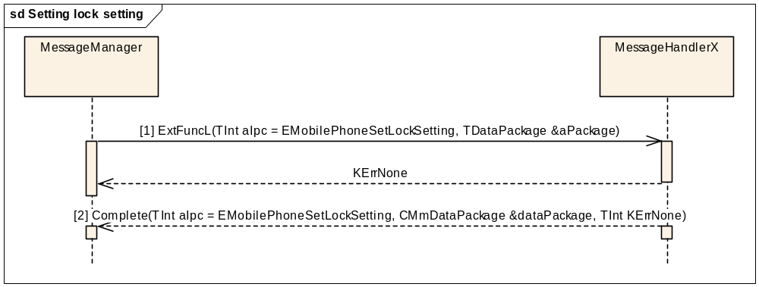
Figure 3.106 Setting lock setting
Parameters:
[1] aPackage.iPtr1: TLockAndSetting*
or
aPackage.iPtr1: TLockAndSetting*
aPackage.iPtr2: RMobilePhone::TMobilePassword*
[2] dataPackage.iPtr1: RMobilePhone::TMobilePhoneLockInfoV1::TMobilePhoneLockStatus*
dataPackage.iPtr2: RMobilePhone::TMobilePhoneLockInfoV1::TMobilePhoneLockSetting*

Notifying security event
This method allows a client to be notified when the phone has detected the occurrence of one of the security related events.
NOTE: This request is completed whenever the right indication is received or certain requirements are met.
Precondition: The Baseband security component is ready. The client has made the EMobilePhoneNotifySecurityEvent request to TSY.
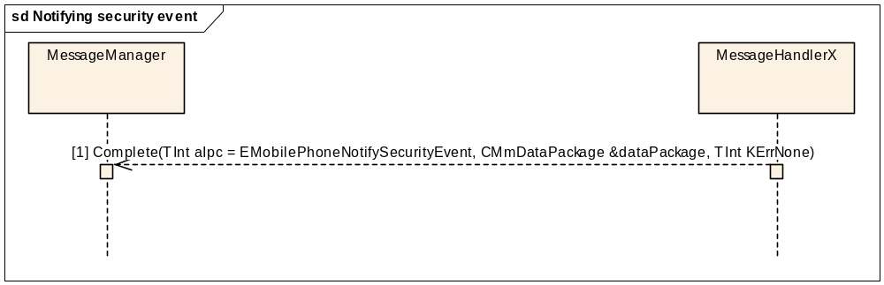
Figure 3.107 Notifying security event
Parameters:
[1] aPackage.iPtr1: RMobilePhone::TMobilePhoneSecurityEvent*

Notifying lock information change
This method allows a client to be notified when any part of the lock information changes.
NOTE: This request is completed whenever right indication is received or certain requirements are met.
Precondition: The Baseband security component is ready. The client has made the EMobilePhoneNotifyLockInfoChange request to TSY.
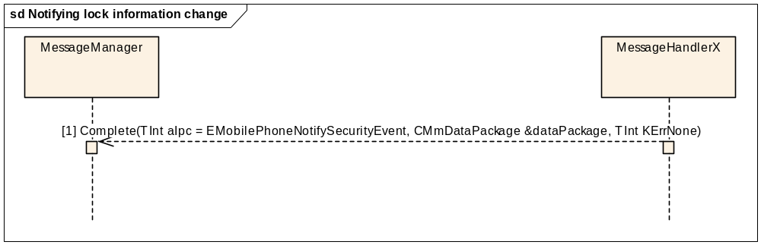
Figure 3.108 Notifying lock information change
Parameters:
[1] dataPackage.iPtr1: RMobilePhone::TMobilePhoneLockInfoV1*
dataPackage.iPtr2: RMobilePhone::TMobilePhoneLock*

Getting active PIN state
This method requests the state of the currently active PIN.
Precondition: The Baseband security component is ready.
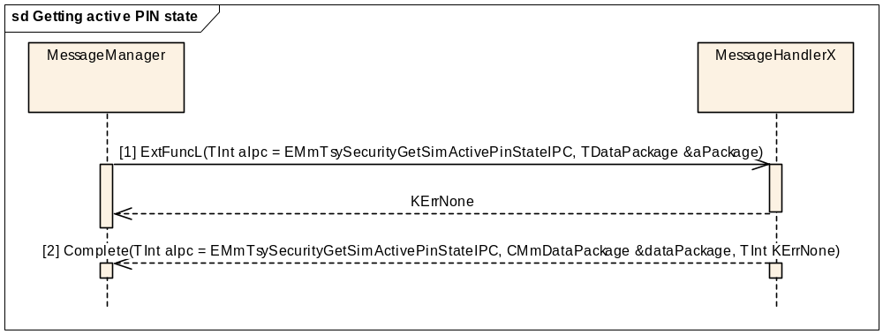
Figure 3.109 Getting active PIN state
Parameters:
[1] aDataPackage is empty.
[2] dataPackage.iPtr1: RMobilePhone::TMobilePhoneSecurityCode*

Cancelling security code check
This method cancels active securitycode query.
Precondition: The Baseband security component is ready.
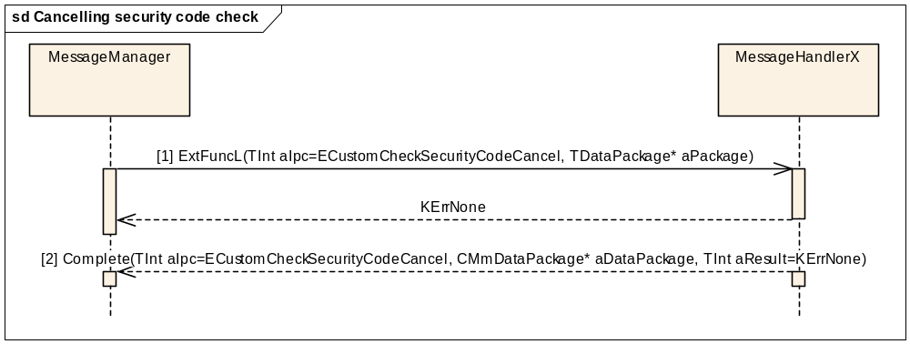
Figure 3.110 Cancelling security code check
Parameters:
[1] aPackage.iPtr1: TBool*
aPackage.iPtr2: TUint8*
[2] dataPackage is empty.

Modem status ready notification on phone boot-up
This completes the modem status ready notification for a client on phone boot-up.
Precondition: Modem status is not ready.
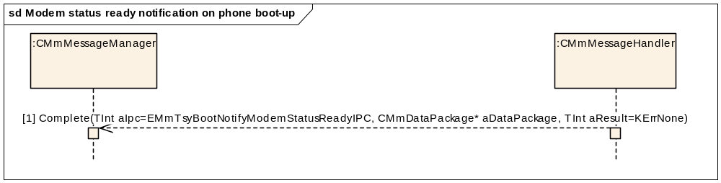
Figure 3.111 Modem status ready notification on phone boot-up
Parameters:

[1] aDataPackage is empty.

SIM status ready notification on phone boot-up
This completes SIM status ready notification for a client on phone boot-up.
Precondition: SIM status is not ready.
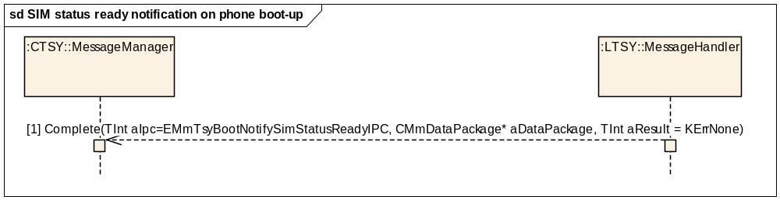
Figure 3.112 SIM status ready notification on phone boot-up
Parameters:

[1] aDataPackage is empty.

Security ready notification on phone boot-up
This completes the Security ready notification for a client on phone boot-up.
Precondition: Security is not ready.
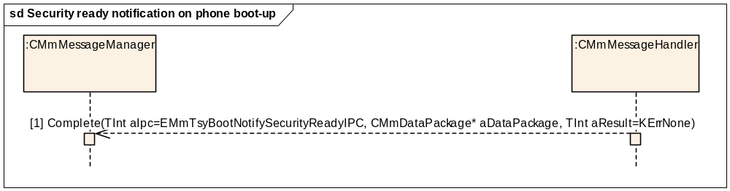
Figure 3.113 Security ready notification on phone boot-up
Parameters:
[1] aDataPackage is empty

Getting RF status on phone boot-up
This method gets RF status for a client on phone boot-up.
Precondition: RF status is unknown.
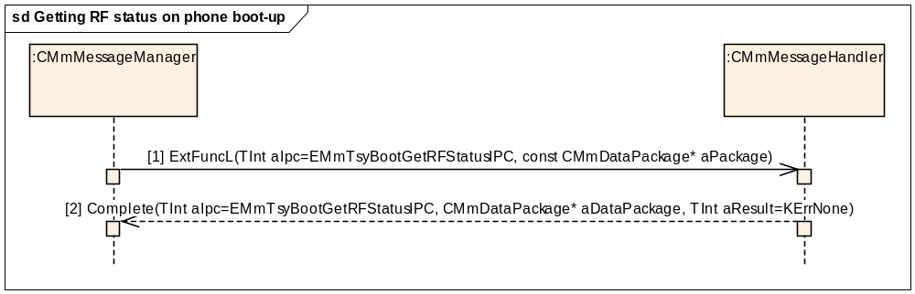
Figure 3.114 Getting RF status on phone boot-up
Parameters:
[1] aDataPackage is empty
[2] aDataPackage.iPtr1: TRfStateInfo* (RF State Info)

Getting the SIM ICC type
This method gets the SIM ICC type.
Precondition: SIM ICC type is unknown.
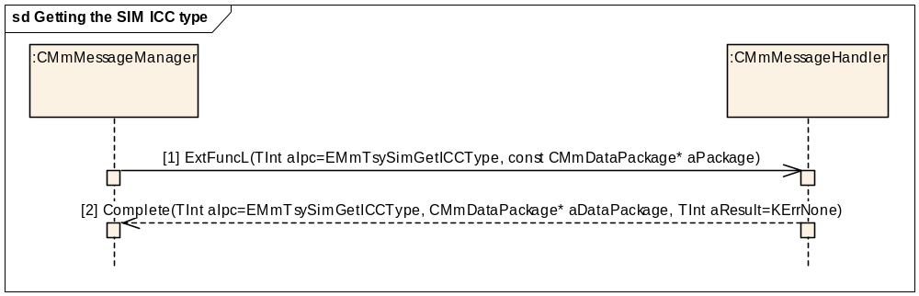
Figure 3.115 Getting the SIM ICC type
Parameters:
[1] aDataPackage is empty
[2] aDataPackage.iPtr1: CMmPhoneGsmWcdmaExt::TICCType* (ICC type)

Delivering the security code
This method delivers security code from CommonTSY to Licencee TSY.
Precondition: Delivered security code must be given.
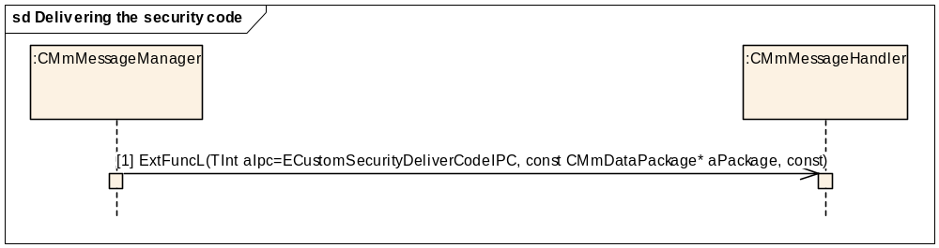
Figure 3.116 Delivering the security code

Parameters:
[1] aDataPackage.iPtr1: RMobilePhone::TCodeAndUnblockCode* (security code)

Getting information of the PIN1 disable support
This method gets information of PIN1 disable support for a client.
Precondition: PIN1 disable support possibility unknown.
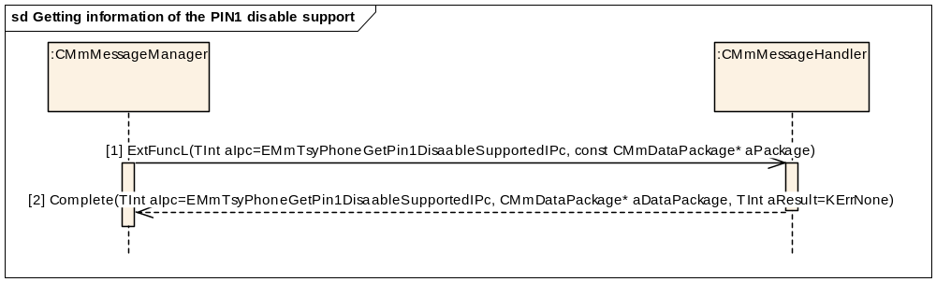
Figure 3.117 Getting information of the PIN1 disable support

Parameters:
[1] aDataPackage is empty
[2] aDataPackage.iPtr1: TBool (PIN1 disable support)

Getting security code information
This method gets the information of remaining entry attempts of a security code.
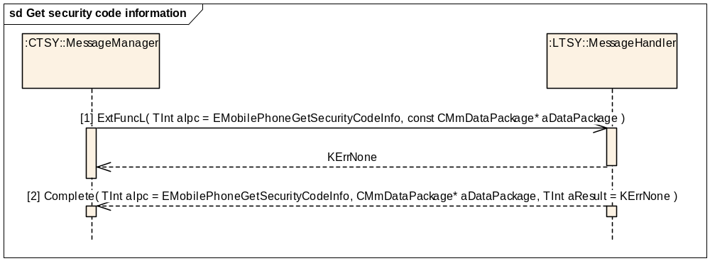
Figure 3.118 Get security code information

Parameters:
[1] aDataPackage.iPtr1: RMobilePhone::TMobilePhoneSecurityCode* (Security code type)
[2] aDataPackage.iPtr1: RMobilePhone::TMobilePhoneSecurityCode* (Security code type)
[2] aDataPackage.iPtr2: RMobilePhone::TMobilePhoneSecurityCodeInfoV5* (Security code information)

Notifying security code information change
This method allows a client to be notified when the security code info has changed.
Precondition: The Baseband security component is ready. The client has made the EMobilePhoneNotifySecurityCodeInfoChange request to TSY.
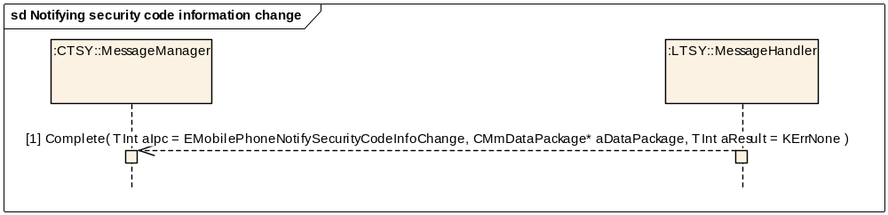
Figure 3.119 Notifying security code information change

Parameters:
[1] aDataPackage.iPtr1: RMobilePhone::TMobilePhoneSecurityCode* (Security code type)
[1] aDataPackage.iPtr2: RMobilePhone::TMobilePhoneSecurityCodeInfoV5* (Security code information)

Messaging interface

USSD

Sending a USSD message
Precondition: MS is connected to a network.
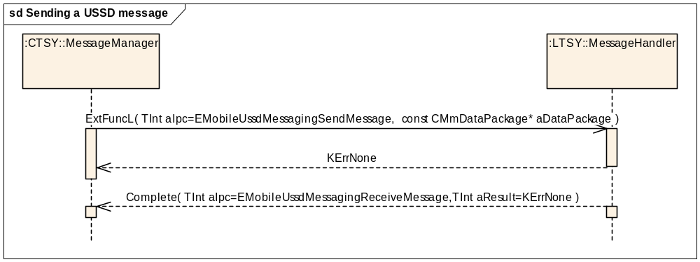
Figure 3.120 Sending a USSD message
Parameters:
aDataPackage.iPtr1: TDes8* (Data)
aDataPackage.iPtr2: TDes8* ( Attributes)

Receiving a USSD message
Precondition: MS is connected to a network and has received a USSD message.
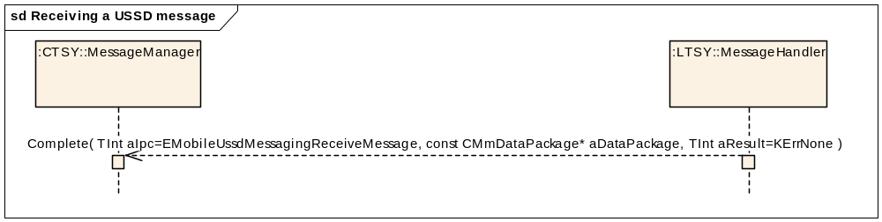
Figure 3.121 Receiving a USSD message
Parameters:
aDataPackage.iPtr1:TBuf8<RMobileUssdMessaging::KGsmUssdDataSize>
aDataPackage.iPtr2:RMobileUssdMessaging::TMobileUssdAttributesV1

Cell broadcast

Notifying that a GSM CBS message has arrived
Precondition: MS is connected to a network and has received a GSM CB message.
Figure 3.122 Notifying that a GSM CBS message has arrived
Parameters:
aDataPackage.iPtr1:TGsmCbsMsg

Sending a CB routing request: receive message
Precondition: MS is connected to a network.
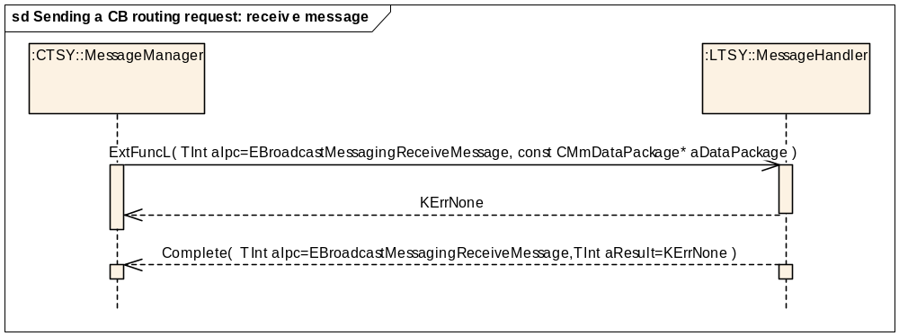
Figure 3.123 Sending a CB routing request: receive message
Parameters:
aDataPacakge.iPtr1:TCbsCbmiAndLangAndFilter

Sending a CB routing request: receive message cancel
Precondition: MS is connected to a network and has received a CB message. Routing is ongoing in Baseband.
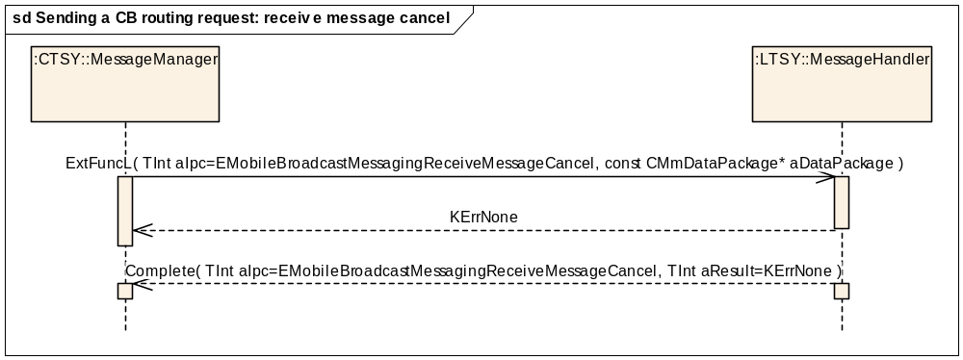
Figure 3.124 Sending a CB routing request: receive message cancel
Parameters:
aDataPacakge.iPtr1:TCbsCbmiAndLangAndFilter

SMS

Writing a SIM SMS
Class 2 SMS messages are written to the SIM.
Precondition: Baseband is ready to access the SIM.
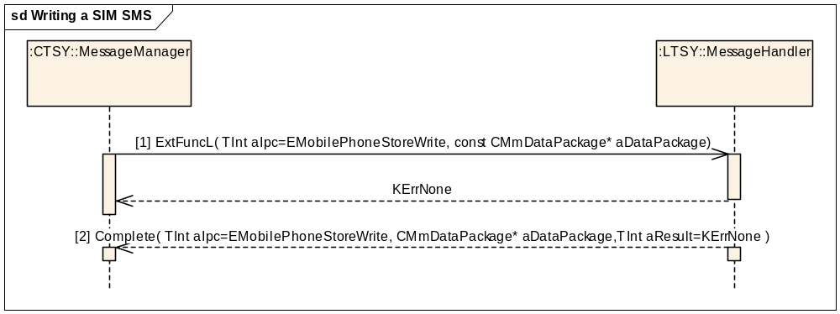
Figure 3.125 Writing a SIM SMS
PhoneStoreWrite is used in writing all kind of data to the SIM.
Parameters:
[1] aDataPackage.iPtr1: TDesC8* (the SMS package)
aDataPackage.iPtr2: TInt (the entry index. The special case index=-1 means that LTSY saves the message to the first free slot.)
[2] aDataPackage.iPtr1: TUint8 (the SMS slot location in the SIM)
aDataPackage.iPtr2: TBool

Acknowledgement: SMS stored
This sequence applies to all SMS messages except for Class 0 messages (i.e. classes 1, 2, 3, unspecified). Class 0 messages have to be acknowledged already by Baseband or LicenceeTSY before passing them to CommonTSY.
Precondition: MS is connected to a network and has received an SMS. Causes a RP-ACK to be sent to the network.
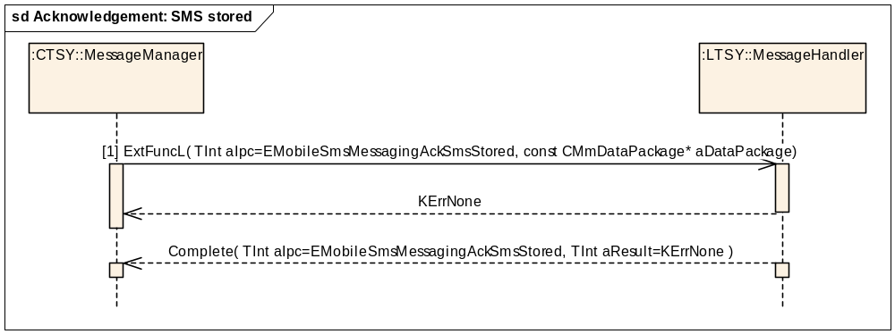
Figure 3.126 Acknowledgement: SMS stored
Parameters:
[1] aDataPackage.iPtr1: TDesC8* (the DELIVER-REPORT TPDU data. Optional, LicenceeTSY has to create a default report if empty.)

Activating SMS routing
This feature allows a client to subscribe routing of SMS messages to be able to receive them. This is called at the boot. See Section 3.1.5 for the boot sequence.
Precondition: MS is connected to a network.
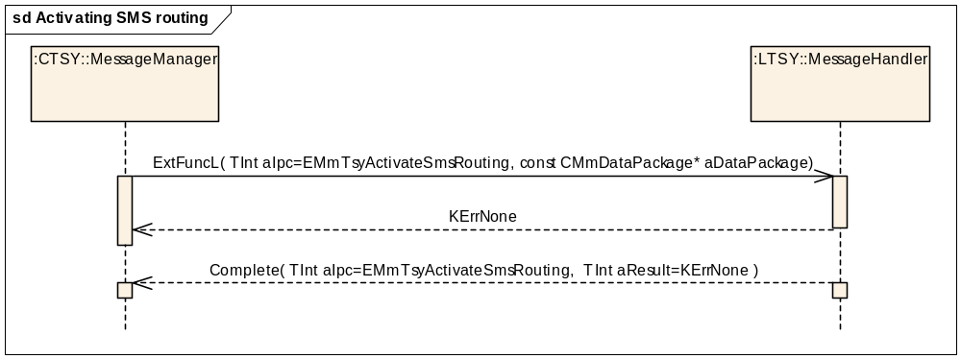
Figure 3.127 Activating SMS routing
Parameters:
aDataPackage is empty.

Deleting all SIM SMS messages
Precondition: Baseband is ready to access the SIM.
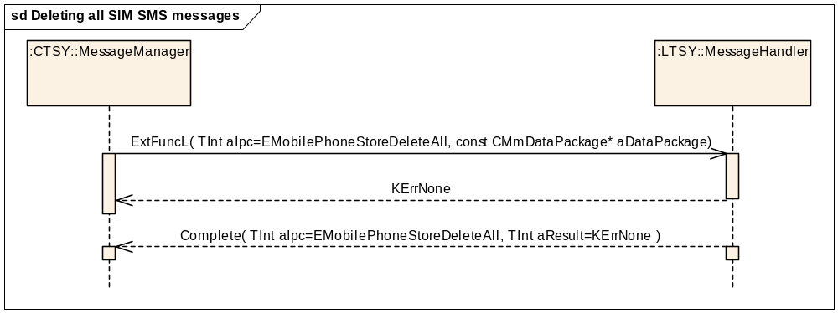
Figure 3.128 Deleting all SIM SMS messages

Parameters:
aDataPackage is empty.

Deleting a SIM SMS
Precondition: Baseband is ready to access the SIM.
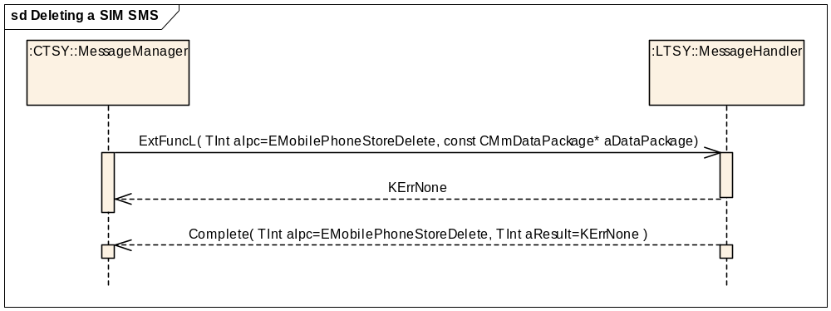
Figure 3.129 Deleting a SIM SMS
Parameters:
aDataPackage.iPtr1: TInt* (index)

Getting message store information
This method is for checking the number of SIM SMS slots and to check how many slots are used.
Precondition: Baseband is ready to access the SIM.
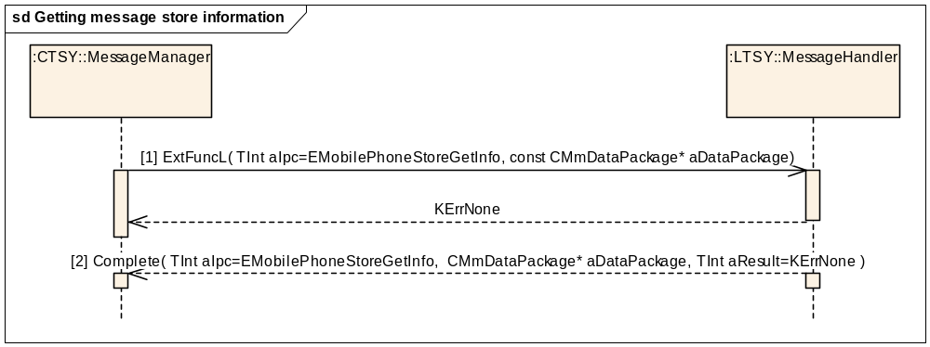
Figure 3.130 Getting message store information
Parameters:
[1] aDataPackage is empty.
[2] aDataPackage.iPtr1: TUint8 (the number of SMS locations)
aDataPackage.iPtr2: TInt (the number of SMS used entries)

Getting the SMS parameters list
In phase 1, TSY retrieves the list and stores it to internal memory. In phase 2, it passes copies of the list to the clients. Phase 2 is done in Common TSY.
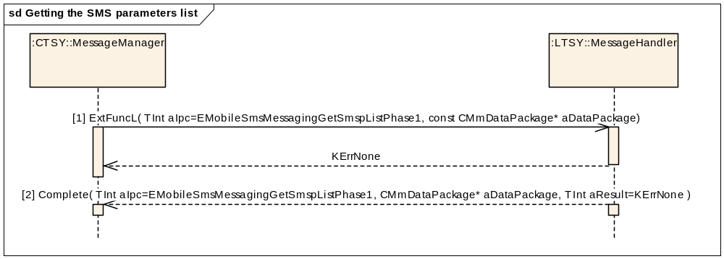
Figure 3.131 Getting the SMS parameters list

Parameters:
[1] aDataPackage is empty.
[2] aDataPackage.iPtr1: CArrayPtrFlat<TSmsParameters>*

Non acknowledgement: SMS stored
This method that is used when storing an SMS is again possible after a failure. A failure in storing a received SMS can happen, for example, because the memory was full. Causes an RP-ERROR to be sent to the network.
Precondition: The MS is connected to a network.
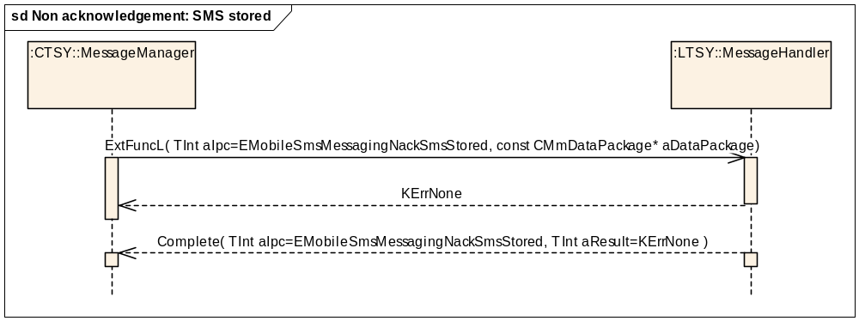
Figure 3.132 Non acknowledgement: SMS stored
Parameters:
[1] aDataPackage.iPtr1: TDes8* (DELIVER-REPORT TPDU data. Optional, LicenceeTSY has to create a default report if empty.)
aDataPackage.iPtr2: TInt (the cause)

Reading all SIM SMS messages
In phase 1, TSY retrieves the list and stores it to internal memory. In phase 2, it passes copies of the list to the clients. Phase 2 is done in Common TSY.
Precondition: Baseband is ready to access the SIM.
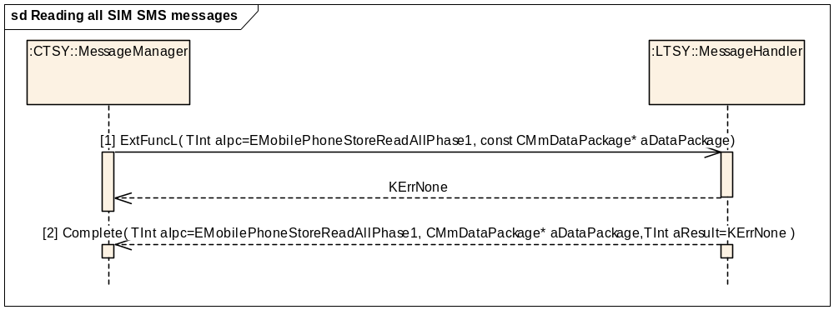
Figure 3.133 Reading all SIM SMS messages
Parameters:
[1] aDataPackage is empty.
[2] aDataPackage.iPtr1: CArrayPtrFlat<TSmsMsg>*
aDataPackage.iPtr2: TBool

Reading a SIM SMS message
Precondition: Baseband is ready to access the SIM.
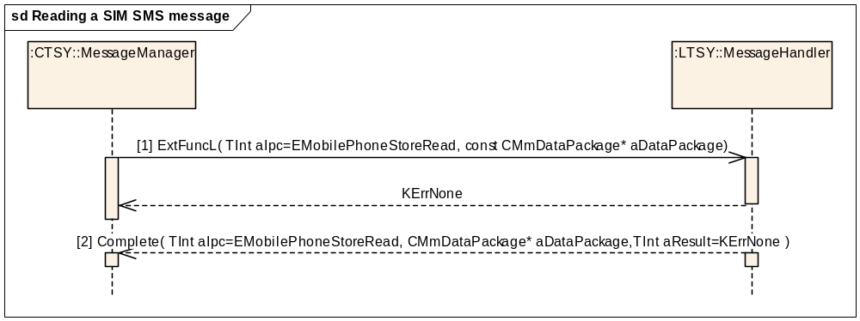
Figure 3.134 Reading a SIM SMS message
Parameters:
[1] aDataPackage.iPtr1: TInt (index)
[2] aDataPackage.iPtr1: TSmsMsg*

Receiving an SMS
Precondition: The MS is connected to a network and has received an SMS. If receiving a class 2 SMS, the message has to be stored in the SIM before calling this method.
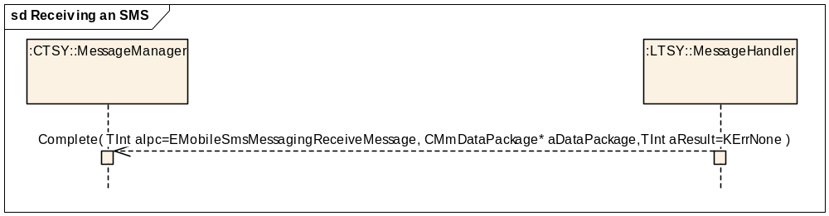
Figure 3.135 Receiving an SMS
Parameters:
aDataPackage.iPtr1: TBool <unused>
aDataPackage.iPtr2: TSmsMsg*

Resuming SMS reception
Precondition: This method is called each time the MS is switched on or when there has been an SMS Memory Full situation and to tell that free memory is again available. Causes an RP-SM-MEMORY-AVAILABLE to be sent to the network.
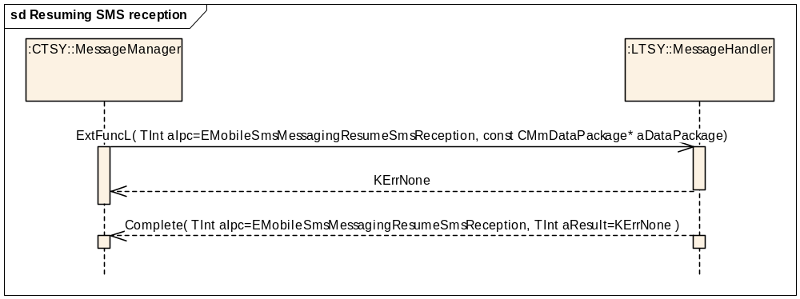
Figure 3.136 Resuming SMS reception
Parameters:
aDataPackage is empty.

Sending a SAT SMS message
Functionally equivalent to “normal” SMS sending with the exception that destination and SC address are not checked against the FDN list.
Precondition: The MS is connected to a network.
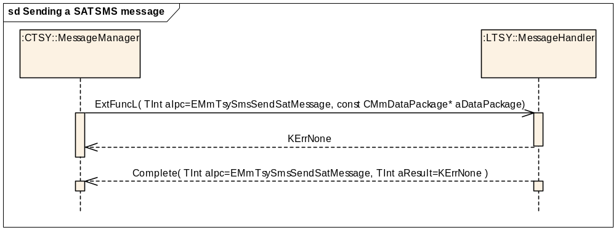
Figure 3.137 Sending a SAT SMS message
Parameters:
aDataPackage.iPtr1:TsendSmsDataAndAttributes

Sending an SMS message
Precondition: The MS is connected to a network.
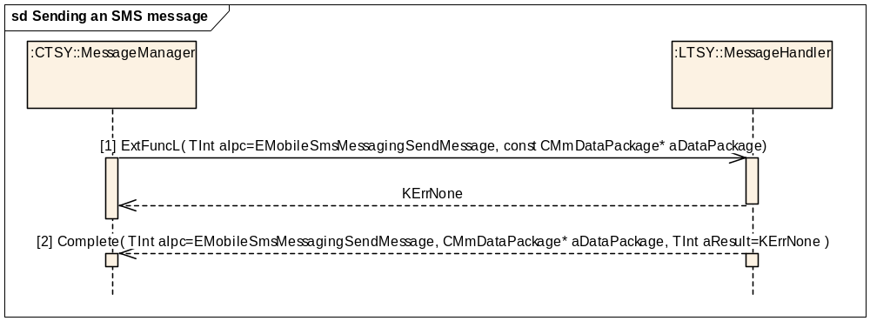
Figure 3.138 Sending an SMS message
Parameters:
[1] aDataPackage.iPtr1: TsendSmsDataAndAttributes
[2] aDataPackage.iPtr1: TUint16 TP-Message-Reference
aDataPackage.iPtr2: TBuf8<RMobileSmsMessaging::KGsmTpduSize>

Storing the SMS parameters list
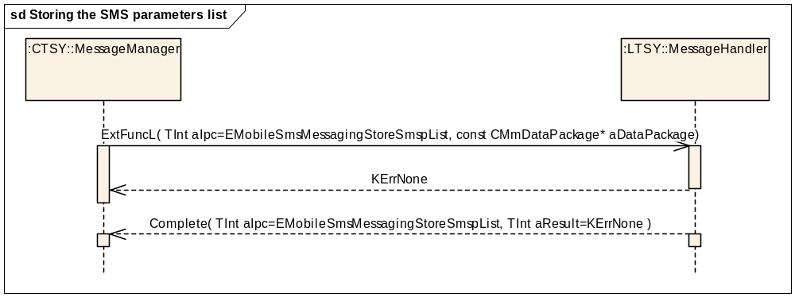
Figure 3.139 Storing the SMS parameters list
Parameters:
aDataPackage.iPtr1: RMobileSmsMessaging::TMobileSmspEntryV1

Getting message store information
Precondition: Baseband is ready to access the SIM.
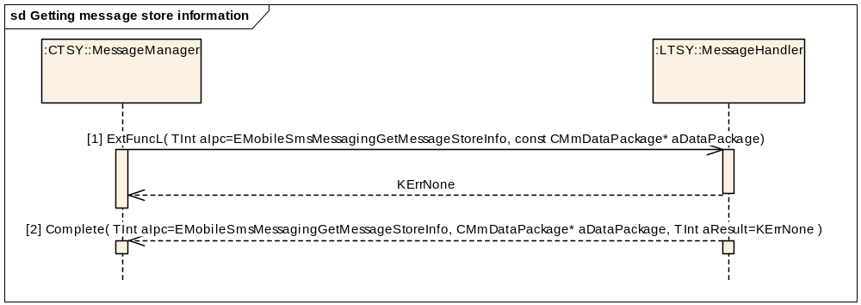
Figure 3.140 Getting message store information
Parameters:
[1] aDataPackage is empty.
[2] aDataPackage.iPtr1: TUint8 (the number of SMS locations)
aDataPackage.iPtr2: TInt (the number of SMS used entries)

Setting Mo SMS Bearer
Precondition: MS is connected to a network.
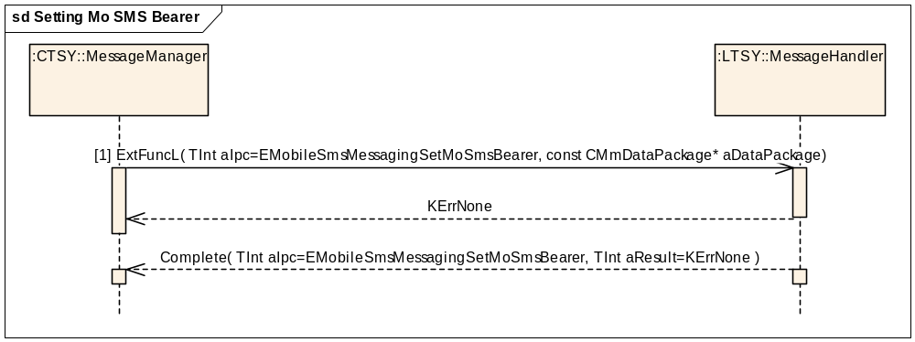
Figure 3.141 Setting Mo SMS Bearer
Parameters:
[1] aDataPackage.iPtr1: RMobileSmsMessaging::TMobileSmsBearer

Phone storage interface

Phonebook initialisation
Precondition: PhoneBookStoreTSY in Common TSY has been opened and SIM initialisation has been established successfully.
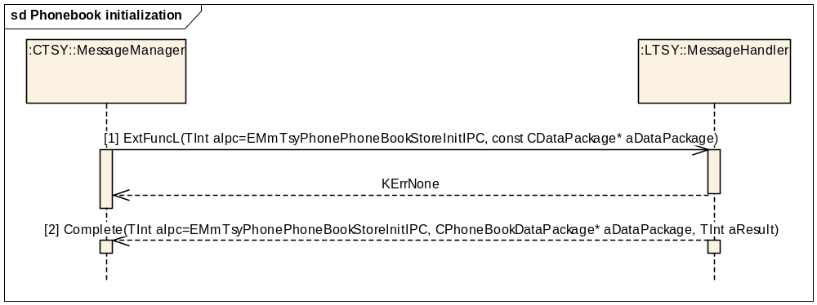
Figure 3.142 Phonebook initialisation
Parameters:
[1] aDataPackage.iPhoneBookName = the current phonebook name
[2] aDataPackage.iPhoneBookName = the current phonebook name
aDataPackage.iPtr1 == CStorageInfoData*, (U)SIM phonebook initialisation information.

Filling the phonebook cache
Precondition: PhoneBookStoreTSY in Common TSY has been opened and (U)SIM phonebook initialisation has been established successfully.
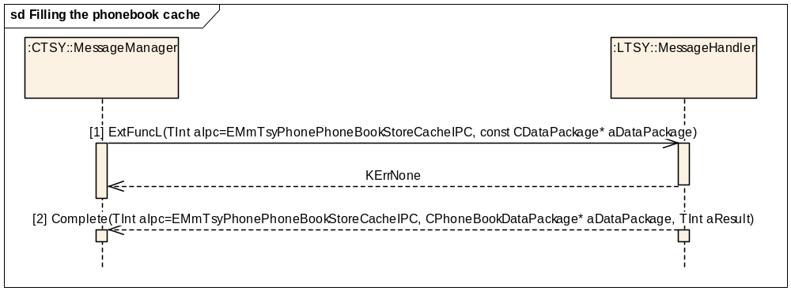
Figure 3.143 Filling the phonebook cache
Parameters:
[1] aDataPackage.iPhoneBookName = the current phonebook name.
aDataPackage.iPtr1 = CArrayPtrSeg<TPhoneBookStoreEntry>*, a pointer to the phonebook entry cache.
[2] aDataPackage.iPhoneBookName = the current phonebook name.
Note: Licensee TSY has to fill the cache before completing the method, this picture does not define the implementation.

Reading entries
Precondition: PhoneBookStoreTSY in Common TSY has been opened and (U)SIM phonebook initialisation has been established successfully.
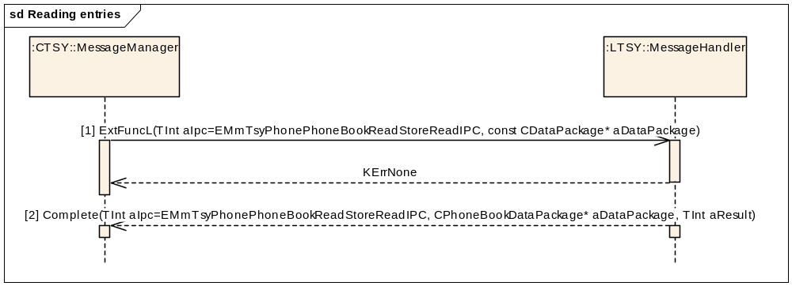
Figure 3.144 Reading entries
Parameters:
[1] aDataPackage.iPhoneBookName = the current phonebook name.
aDataPackage.iPtr1 = RMobilePhoneBookStore::TPBIndexAndNumEntries* a pointer to the index and entries data structure.
aDataPackage.iPtr2 = CArrayPtrSeg<TPhoneBookStoreEntry>* a pointer to the entry array.
[2] aDataPackage.iPhoneBookName = the current phonebook name.
Note: Licensee TSY has to fill the cache before completing the method, this picture does not define the implementation.

Writing an entry
Precondition: PhoneBookStoreTSY in Common TSY has been opened and (U)SIM phonebook initialisation has been established successfully.
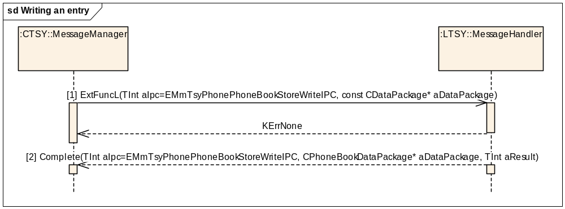
Figure 3.145 Writing an entry
Parameters:
[1] aDataPackage.iPhoneBookName = the current phonebook name.
aDataPackage.iPtr1 = TInt aIndex, the location index.
aDataPackage.iPtr2 = TPhoneBookStoreEntry* aDataToWrite, the entry to be written into (U)SIM.
[2] aDataPackage.iPtr1 = TPBEntryInfo (struct)

TPBEntryInfo.iMaxNumLength
TPBEntryInfo.iLocation
aDataPackage.iPhoneBookName = the current phonebook name.

Deleting an entry
Precondition: PhoneBookStoreTSY in Common TSY has been opened and (U)SIM phonebook initialisation has been established successfully.
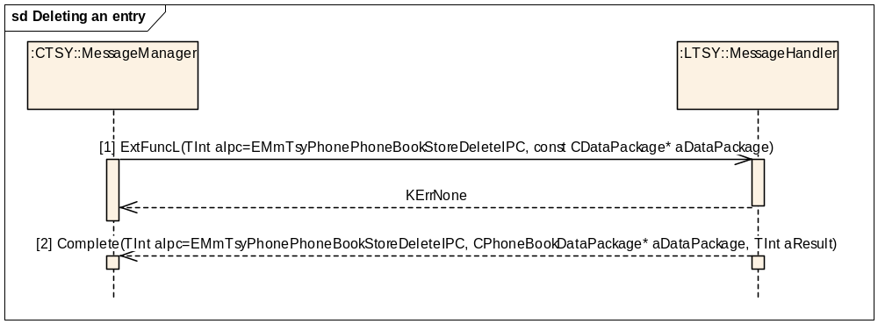
Figure 3.146 Deleting an entry
Parameters:
[1] aDataPackage.iPhoneBookName = the current phonebook name.
aDataPackage.iPtr1 = TInt, the location index.
[2] aDataPackage.iPhoneBookName = the current phonebook name
aDataPackage.iPtr1 = TPBEntryInfo (struct)

TPBEntryInfo.iMaxNumLength
TPBEntryInfo.iLocation
(TPBEntryInfo.iLocation is not used in the Delete case so can be set to 0 here)

Deleting all entries
Precondition: PhoneBookStoreTSY in Common TSY has been opened and (U)SIM phonebook initialisation has been established successfully.
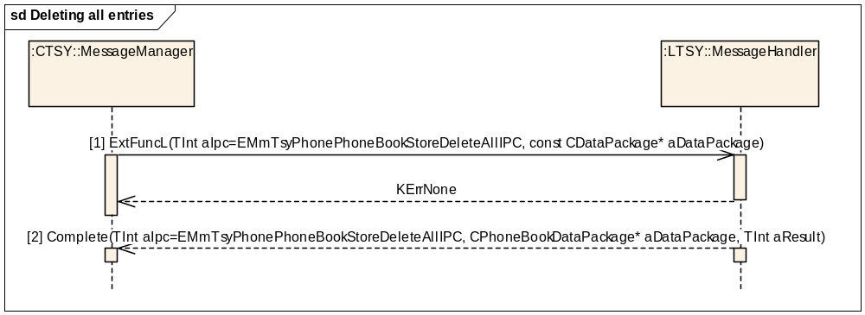
Figure 3.147 Deleting all entries
Parameters:
[1] aDataPackage.iPhoneBookName = the current phonebook name.
[2] aDataPackage.iPhoneBookName = the current phonebook name
aDataPackage.iPtr1 = TPBEntryInfo (struct)

TPBEntryInfo.iMaxNumLength
TPBEntryInfo.iLocation
(TPBEntryInfo.iLocation is not used in the DeleteAll case so can be set to 0 here)

Getting the phonebook storage information
Precondition: PhoneBookStoreTSY in Common TSY has been opened and (U)SIM phonebook initialisation has been established successfully.
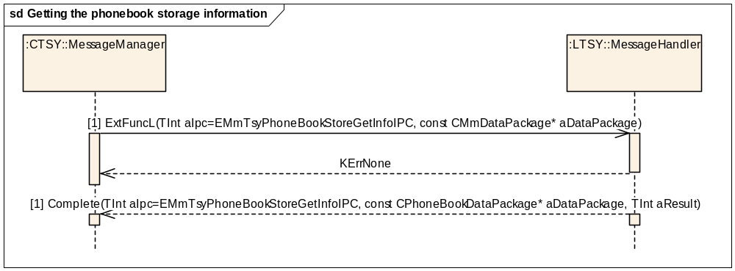
Figure 3.148 Getting the phonebook storage information
Parameters:
[1] aDataPackage.iPhoneBookName = the current phonebook name.
[2] aDataPackage.iPhoneBookName = the current phonebook name
aDataPackage.iPtr1 = TInt, number of used phonebook entries

Resetting the phonebook cache
Precondition: PhoneBookStoreTSY in Common TSY has been opened and (U)SIM phonebook initialisation has been established successfully.
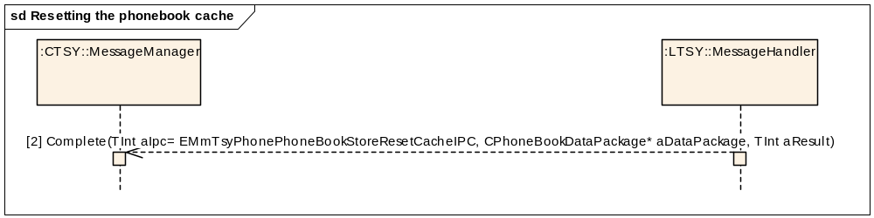
Figure 3.149 Resetting the phonebook cache
Parameters:
aDataPackage.iPhoneBookName = the current phonebook name.

Reading emergency number store (ENstore) entry
Precondition: The MS is on and the SIM is ready.
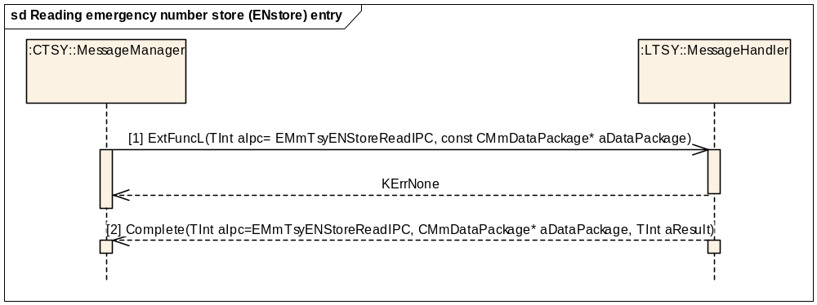
Figure 3.150 Reading emergency number store (ENstore) entry
Parameters:
[1] aDataPackage.iPtr1 = TInt, location index to be read
[2] aDataPackage.iPtr1 = TENStoreResponse (struct)
TENStoreResponse.iLocation
TENStoreResponse.iECCNumber

Reading all emergency number store (ENstore) entries
Precondition: MS is on and the SIM is ready.
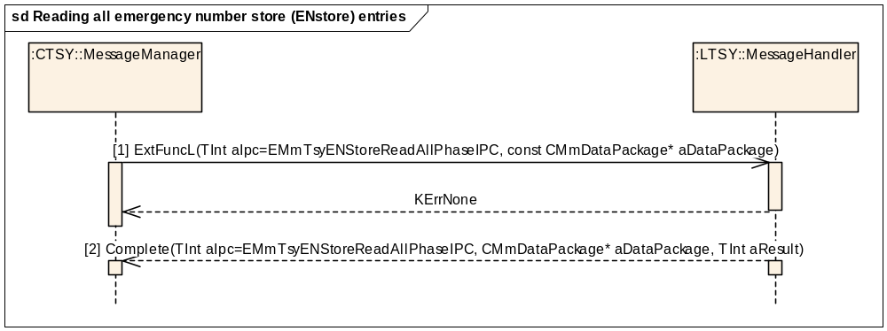
Figure 3.151 Reading all emergency number store (ENstore) entries
Parameters:
[1] aDataPackage.iPtr1 = TInt, location index to be read
[2] aDataPackage.iPtr1 = CArrayPtrFlat<TENStoreResponse>*

Getting the emergency number store (ENstore) information
Precondition: MS is on and the SIM is ready.
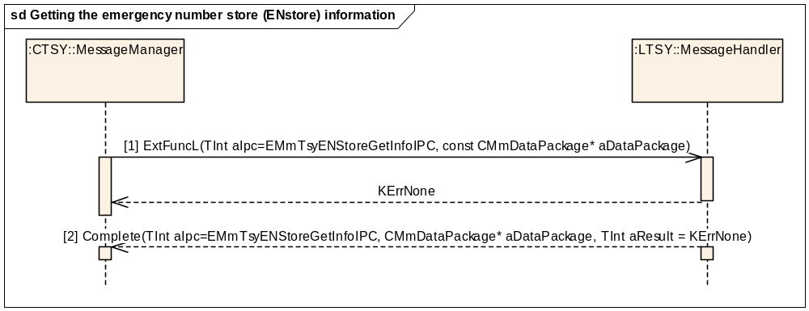
Figure 3.152 Getting the emergency number store (ENstore) information
Parameters:
[1] aDataPackage.iPtr1 = TInt aIndex, location index to be read
[2] aDataPackage.iPtr1 = TInt, number of used ENstore entries

Reading own number store (ONstore) entry
Precondition: MS is on and the SIM is ready.
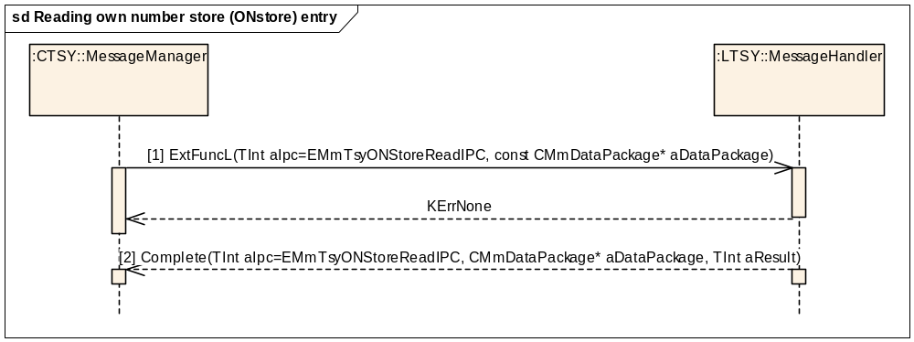
Figure 3.153 Reading own number store (ONstore) entry
Parameters:
[1] aDataPackage.iPtr1 = TInt, location index.
[2] aDataPackage.iPtr1 = TONStoreMsg
TONStoreMsg.iLocation
TONStoreMsg.iName
TONStoreMsg.iTelNumber

Getting the own number store (ONstore) information
Precondition: MS is on and the SIM is ready.
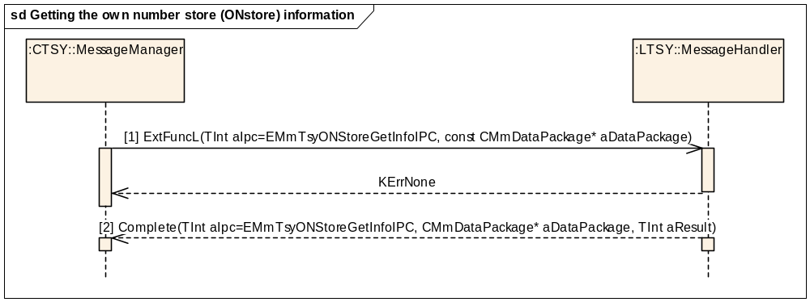
Figure 3.154 Getting the own number store (ONstore) information
Parameters:
[1] aDataPackage.iPtr1 = TInt16, location index.
[2] aDataPackage.iPtr1 = TServiceType
TServiceType.iNumOfEntries
TServiceType.iUsedEntries
TServiceType.iNameLen
TServiceType.iNumLen

Deleting an own number store (ONstore) entry
Precondition: MS is on and the SIM is ready.
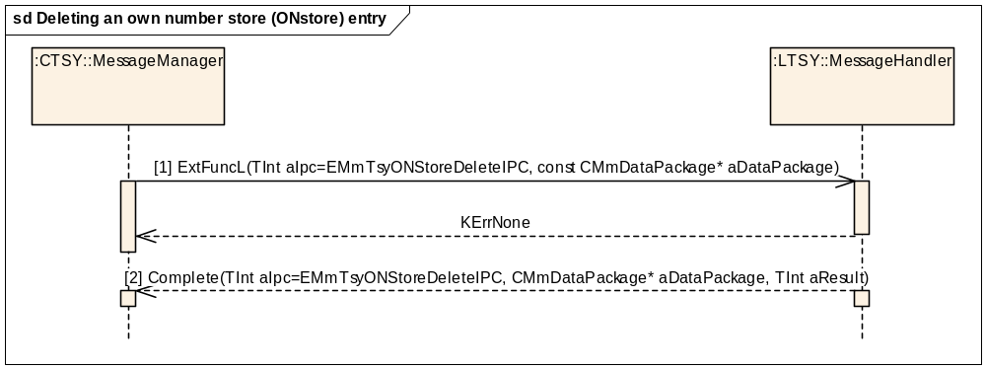
Figure 3.155 Deleting an own number store (ONstore) entry
Parameters:
[1] aDataPackage.iPtr1 = TInt16, location index.
[2] aDataPackage is empty.

Deleting all own number store (ONstore) entries
Precondition: MS is on and the SIM is ready.
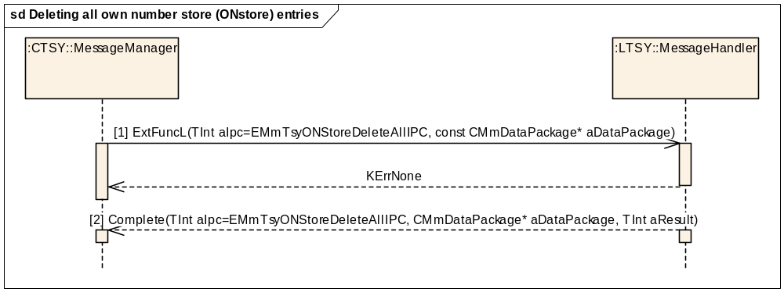
Figure 3.156 Deleting all own number store (ONstore) entries
Parameters:
[1] aDataPackage is empty.
[2] aDataPackage is empty.

Writing own number store (ONstore) entry
Precondition: MS is on and the SIM is ready.
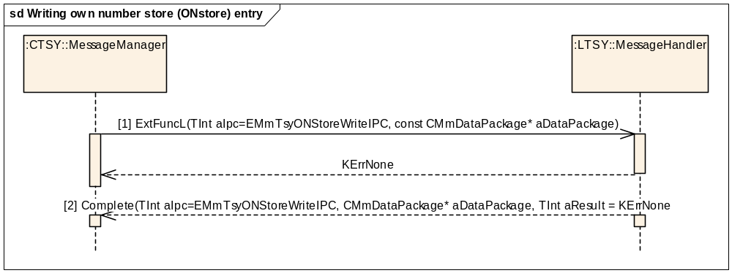
Figure 3.157 Writing own number store (ONstore) entry
Parameters:
[1] aDataPackage RMobileONStore::TMobileONEntryV1Pckg*.
[2] aDataPackage Tint = Entry location.

Reading own number store (ONstore) read size
Precondition: MS is on and the SIM is ready.
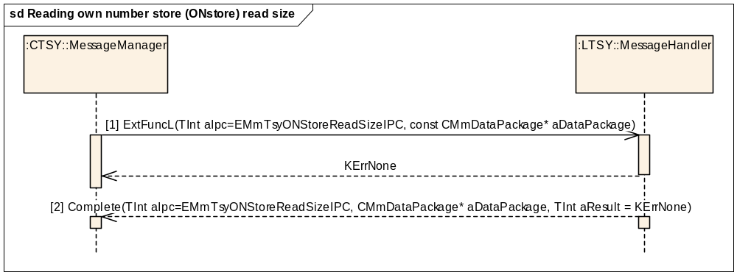
Figure 3.158 Reading own number store (ONstore) read size
Parameters:
[1] aDataPackage TInt size = -1.
[2] aDataPackage Tint = own number store read size.

Reading own number store (ONstore) write size
Precondition: MS is on and the SIM is ready.
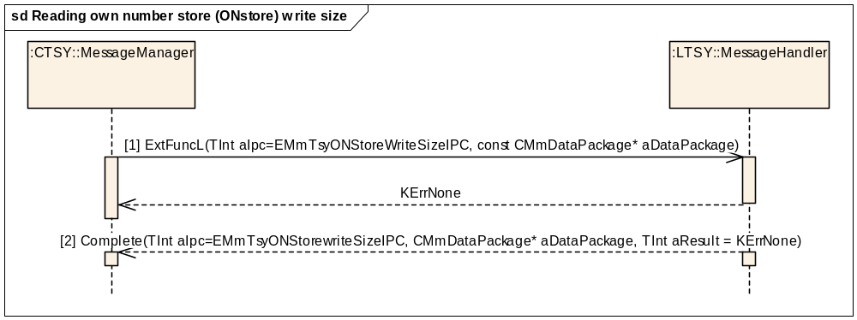
Figure 3.159 Reading own number store (ONstore) write size
Parameters:
[1] aDataPackage TInt size = -1.
[2] aDataPackage Tint = own number store write size.

Reading own number store (ONstore) entry in read all sequence
Precondition: MS is on and the SIM is ready.
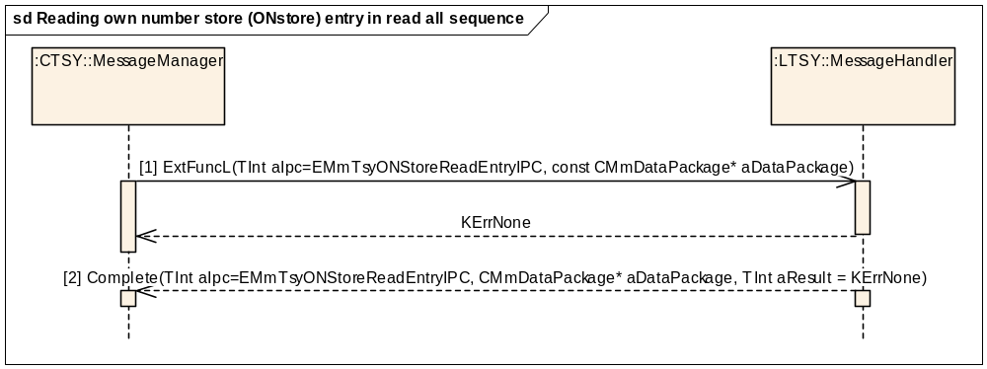
Figure 3.160 Reading own number store (ONstore) entry in read all sequence
Parameters:
[1] aDataPackage is empty.
[2] aDataPackage TONStoreMsg*.

Writing own number store (ONstore) entry in write all sequence
Precondition: MS is on and the SIM is ready.
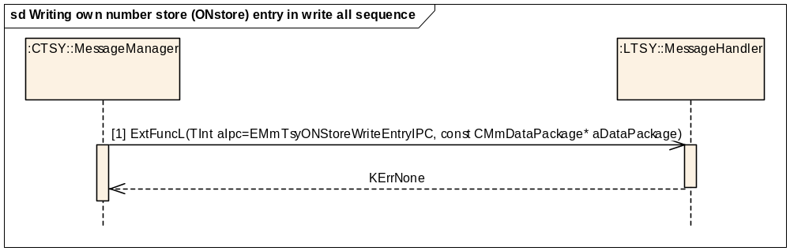
Figure 3.161 Writing own number store (ONstore) entry in write all sequence
Parameters:
[1] aDataPackage RMobileONStore::TMobileONEntryV1
[2] aDataPackage is empty.

WIM interface

Powering SIM on
Precondition: Cellular side APDU functionality must be up and running.
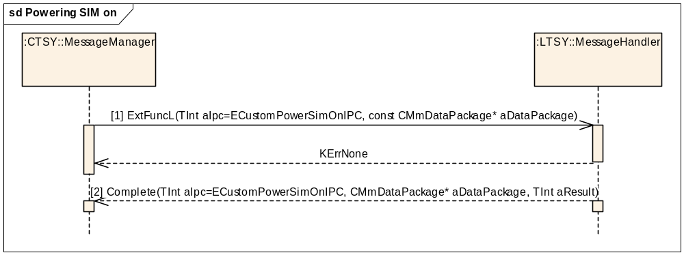
Figure 3.162 Powering SIM on
Parameters:
[1] aDataPackage is empty.
[2] aDataPackage is empty.

Powering SIM off
Precondition: Cellular side APDU functionality must be up and running.
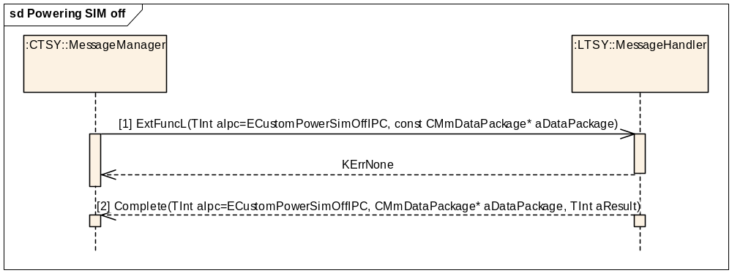
Figure 3.163 Powering SIM off
Parameters:
[1] aDataPackage is empty.
[2] aDataPackage is empty.

SIM warm reset
Precondition: The cellular side APDU functionality must be up and running.
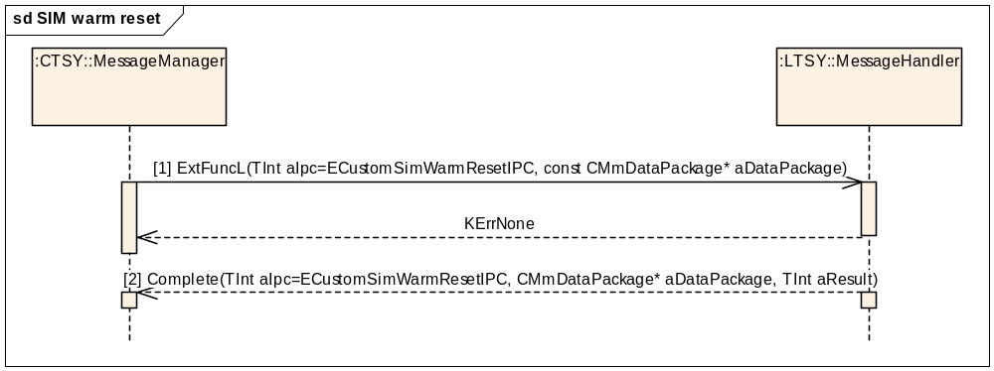
Figure 3.164 SIM warm reset
Parameters:
[1] aDataPackage is empty.
[2] aDataPackage is empty.

Getting an answer to reset status
Precondition: The cellular side APDU functionality must be up and running.
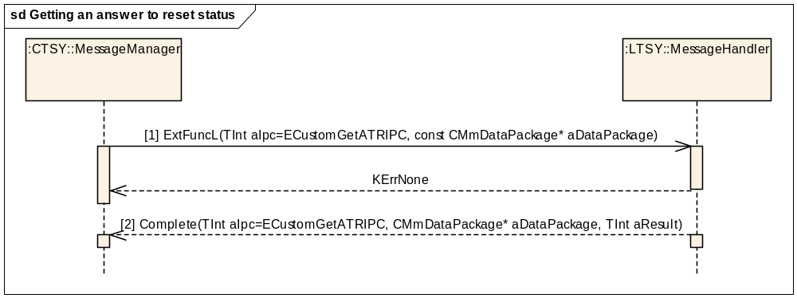
Figure 3.165 Getting an answer to reset status
Parameters:
[1] aDataPackage is empty.
[2] aDataPackage.iPtr1 = TPtrC8*, a pointer to the ATR data got from cellular side.

Sending of an Application Data Unit (APDU)
Precondition: The cellular side APDU functionality must be up and running.
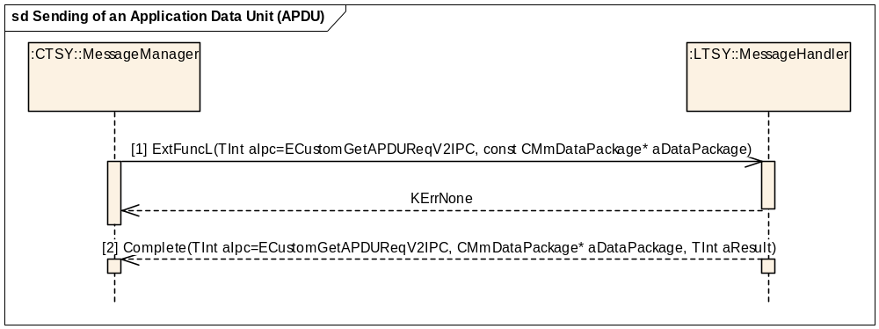
Figure 3.166 Sending of an Application Data Unit (APDU)
Parameters:
[1] aDataPackage.iPtr1 = RMmCustomAPI::TApduParameters*

TApduParameters.iCardReaderId
TApduParameters.iCmdData
TApduParameters.iRspData
[2] aDataPackage.iPtr1 = TPtrC8*, a pointer to the APDU data got from cellular side

Getting SIM CardReader Status
Precondition: Cellular side APDU functionality must be up and running.
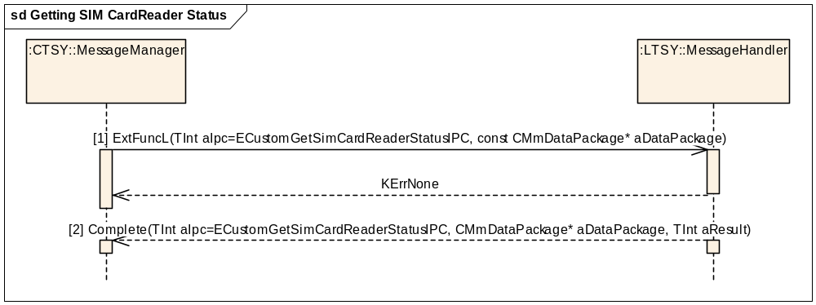
Figure 3.167 Getting SIM CardReader Status
Parameters:
[1] aDataPackage is empty.
[2] aDataPackage.iPtr1 = TPtrC8*, a pointer to the reader status data got from cellular side.

Notify SIM Card Status
Precondition: The cellular side APDU functionality must be up and running.
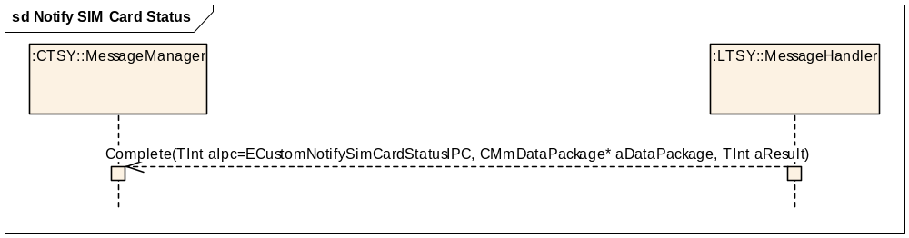
Figure 3.168 Notify SIM Card Status
Parameters:
aDataPackage.iPtr1 = RMmCustomAPI::TSIMCardStatus, a new status of the SIM card.

Send APDU request
Precondition: MS is on and connected to network.
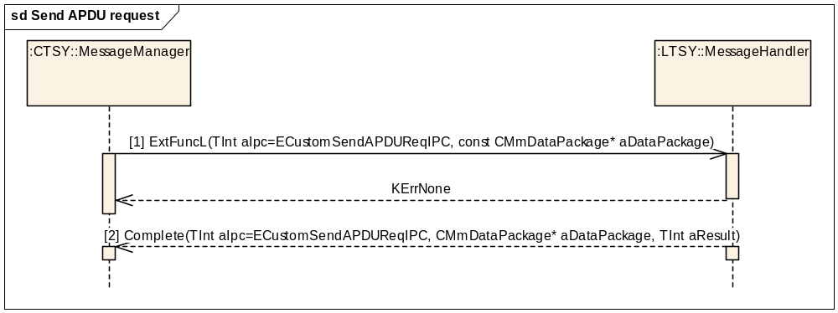
Figure 3.169 Send APDU request
Parameters:

[1] aDataPackage.iPtr1 = RMmCustomAPI::TApdu apduReq
apduReq.iInfo = aInfo
apduReq.iData = aData
[2] aDataPackage.iPtr1 = TPtrC8* info (response information)
aDataPackage.iPtr2 = TPtrC8* data (response data)

SIM interface

Start browsing the SIM Cell Broadcast Topics
Precondition: MS is connected to a network.
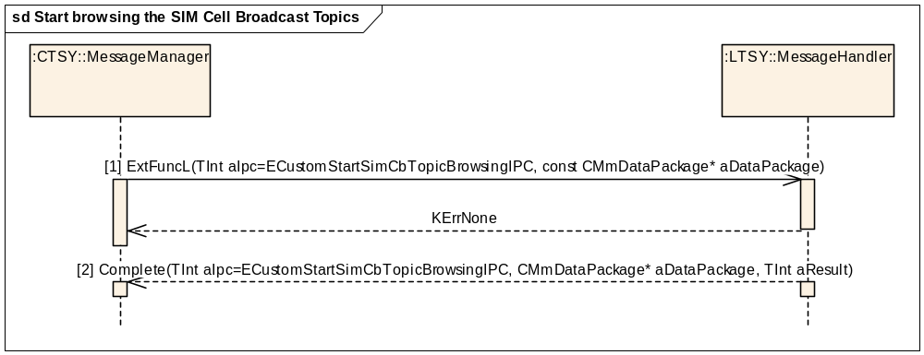
Figure 3.170 Start browsing the SIM Cell Broadcast Topics
Parameters:

[1] aDataPackage is empty
[2] aDataPackage.iPtr1 = <CArrayFixFlat>RMmCustomAPI::TSimCbTopic*

Deleting SIM Cell Broadcast Topic
Precondition: MS is connected to a network.
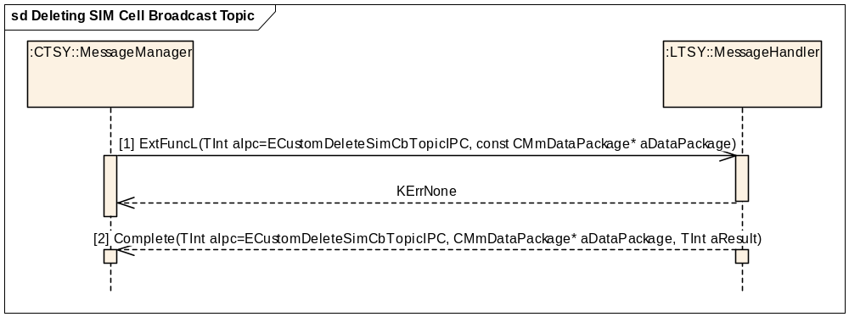
Figure 3.171 Deleting SIM Cell Broadcast Topic
Parameters:
[1] aDataPackage.iPtr1 = TUint (sim cb topic number for delete)
[1] aDataPackage.iPtr2 = TBool (the sim topic being deleted)
[2] aDataPackage is empty.

Reading SIM File
Precondition: MS is connected to a network and SIM is ready.
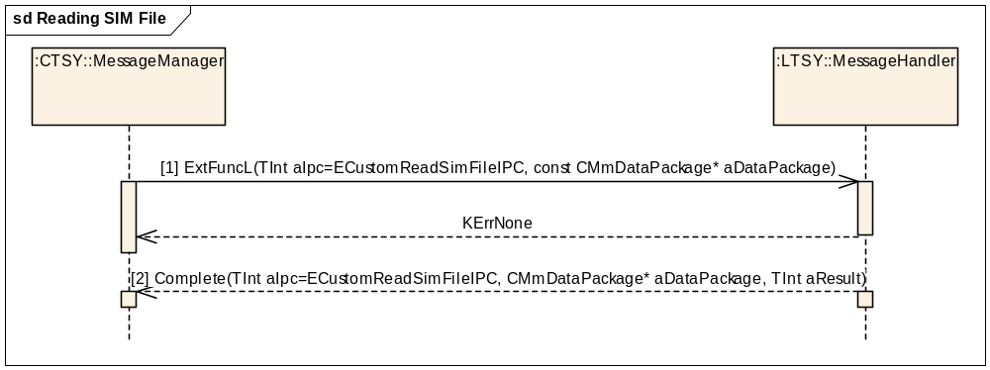
Figure 3.172 Reading SIM File
Parameters:
[1] aDataPackage.iPtr1 = RMmCustomAPI::TSimFileInfo simFileInfo

[2] aDataPackage.iPtr1 = TDesC8* dataPtr

Getting SIM authentication data
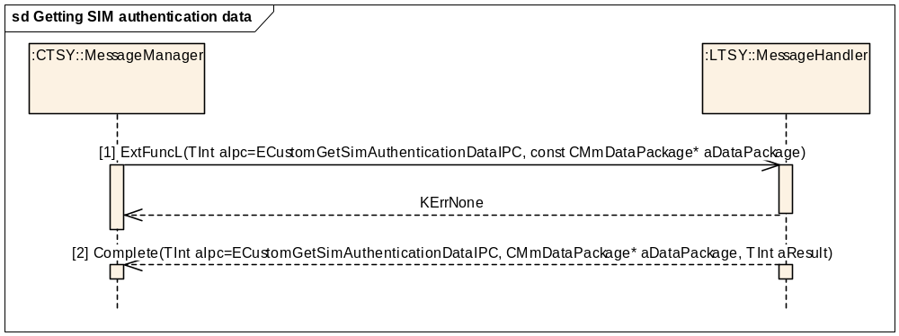
Figure 3.173 Getting SIM authentication data
Parameters:
[1] aDataPackage.iPtr1 = RMmCustomAPI::TSimAuthenticationBase

[1] aDataPackage.iPtr2 = Tint rfStateInfo
[2] aDataPackage.iPtr1 = RMmCustomAPI::TSimAuthenticationEapSim*

Getting IMS authentication data (CustomAPI)
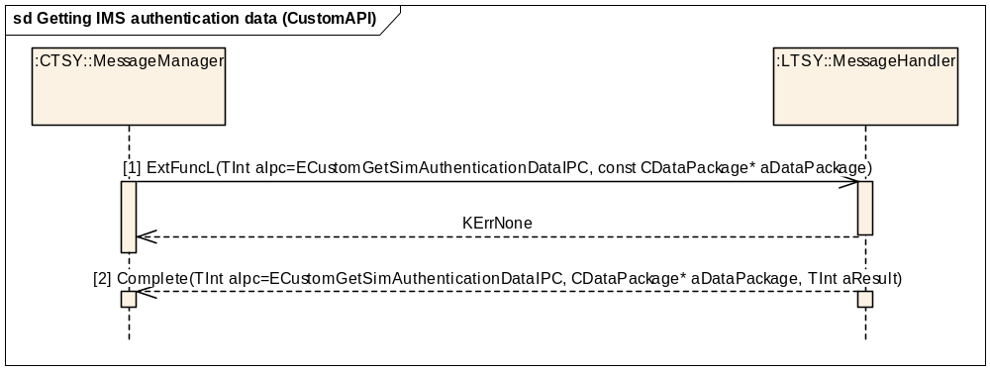
Figure 3.174 Getting IMS authentication data (CustomAPI)

Parameters:
[1] aDataPackage.iPtr1 = RMobilePhone::TImsAuthenticateDataV5*
[2] aDataPackage.iPtr1 = RMobilePhone::TImsAuthenticateDataV5

Getting IMS authorization information
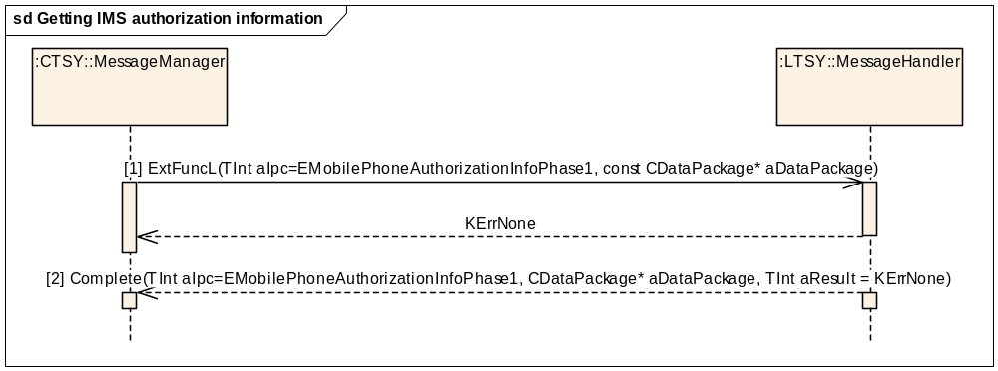
Figure 3.175 Getting IMS authorization information

Parameters:
[1] aDataPackage is empty.
[2] aDataPackage RMobilePhone::CImsAuthorizationInfoV5*.

Authenticating IMS data
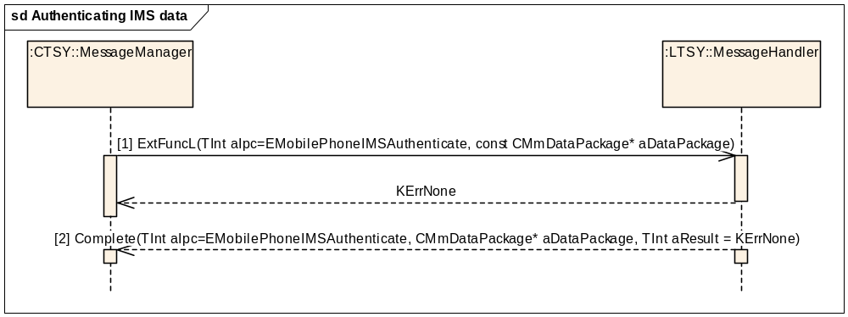
Figure 3.176 Authenticating IMS data
Parameters:
[1] aDataPackage RMobilePhone::TImsAuthenticateDataV5
[2] aDataPackage RMobilePhone::TImsAuthenticateDataV5

Reading ViagHomeZoneParams
Precondition: MS is on and SIM is ready.
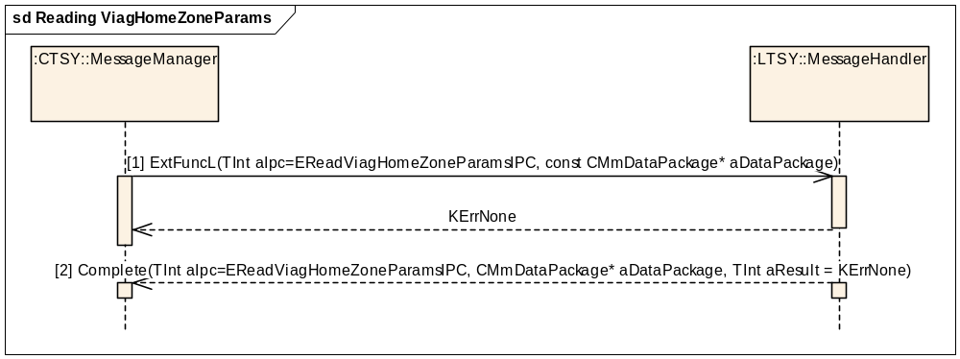
Figure 3.177 Reading ViagHomeZoneParams
Parameters:
[1] aDataPackage is empty.

[2] aDataPackage.iPtr1 = RMmCustomAPI::TViagParams
aDataPackage.iPtr2 = RMmCustomAPI::TViagElements*

Reading ViagHomeZoneCache
Precondition: MS is on and SIM is ready.
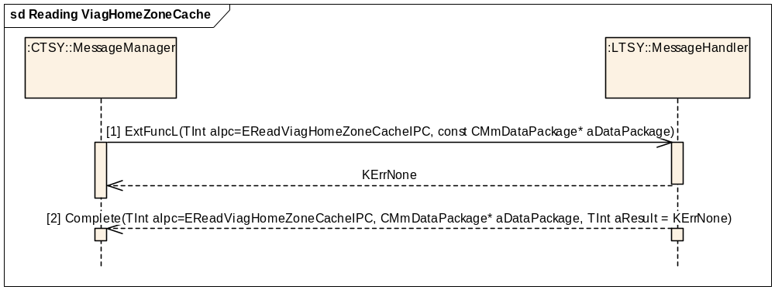
Figure 3.178 Reading ViagHomeZoneCache
Parameters:
[1] aDataPackage.iPtr1 = RMmCustomAPI::TViagCacheRecordId
[2] aDataPackage.iPtr1 = RMmCustomAPI::TViagCacheRecordContent

Writing ViagHomeZoneCache
Precondition: MS is on and SIM is ready.
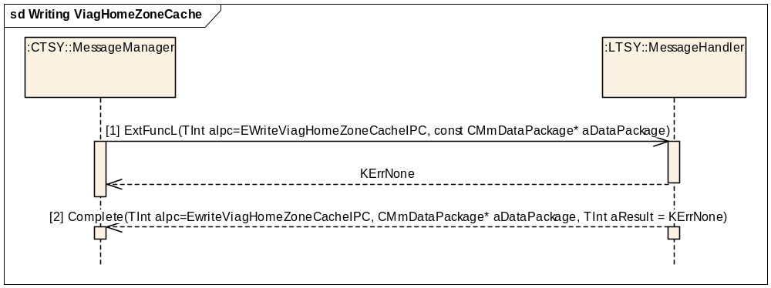
Figure 3.179 Writing ViagHomeZoneCache
Parameters:
[1] aDataPackage.iPtr1 = RMmCustomAPI::TViagCacheRecordId
aDataPackage.iPtr2 = RMmCustomAPI::TViagCacheRecordContent
[2] aDataPackage is empty.

Writing ViagHomeZoneUHZIUESettings
Precondition: MS is on and SIM is ready.
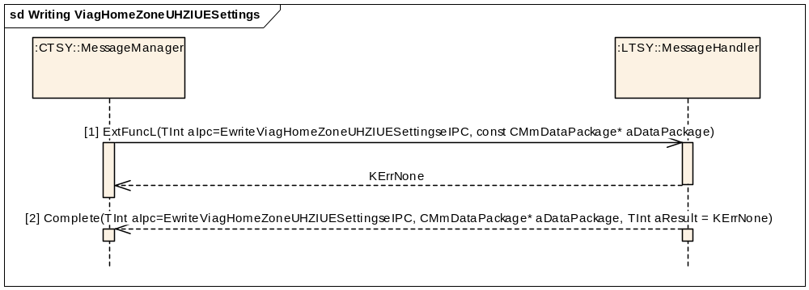
Figure 3.180 Writing ViagHomeZoneUHZIUESettings
Parameters:
[1] aDataPackage RMmCustomAPI::TViagUHZIUESettings.
[2] aDataPackage is empty.

GetNetworkProviderName
Precondition: MS is connected to a network.
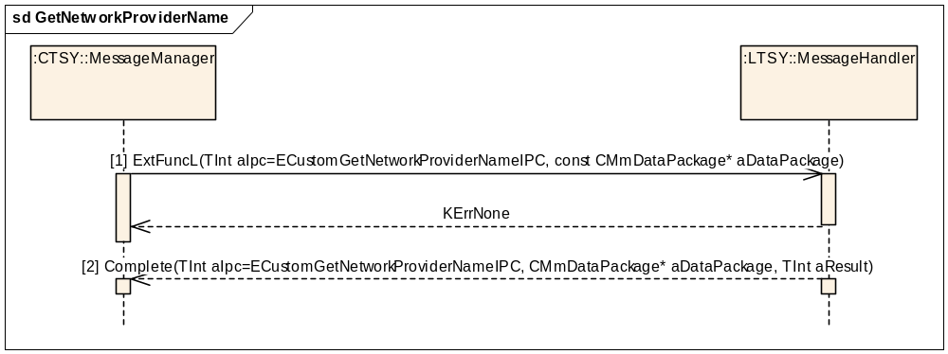
Figure 3.181 GetNetworkProviderName
Parameters:
[1] aDataPackage is empty.
[2] aDataPackage.iPtr1 = TDes* name (network provider name)

SatRefreshComplete Notification
Precondition: SatRefresh completed.
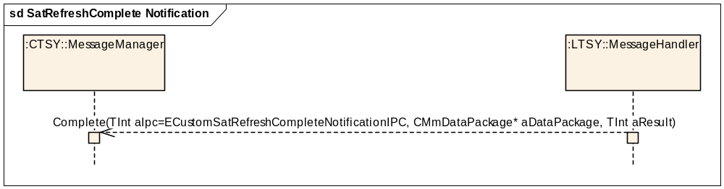
Figure 3.182 SatRefreshComplete Notification
Parameters:
aDataPackage is empty.

SIM Lock interface

Activating SimLock
Precondition: SimLock deactivated.
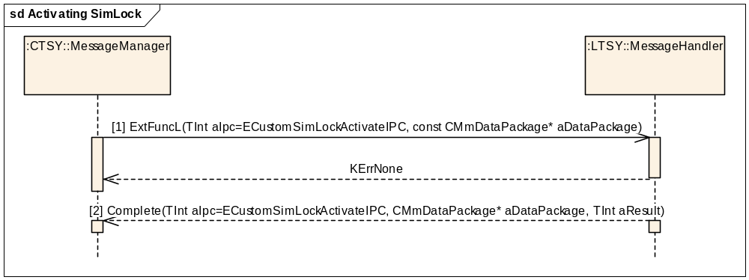
Figure 3.183 Activating SimLock
Parameters:

[1] aDataPackage.iPtr1 = RCustomAPI::TSimLockPassword
[1] aDataPackage.iPtr2 = RCustomAPI::TLockNumber
[2] aDataPackage is empty.

Deactivating SimLock
Precondition: SimLock activated.
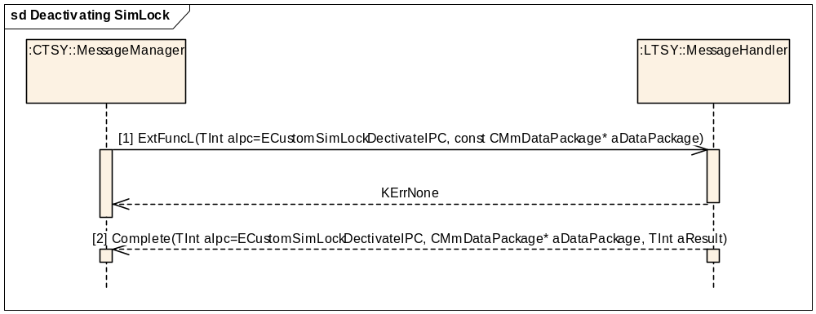
Figure 3.184 Deactivating SimLock
Parameters:

[1] aDataPackage.iPtr1 = RCustomAPI::TSimLockPassword
[1] aDataPackage.iPtr2 = RCustomAPI::TLockNumber
[2] aDataPackage is empty.

Miscellaneous Phone

Getting customer service profile
Precondition: Baseband is ready to access the SIM.
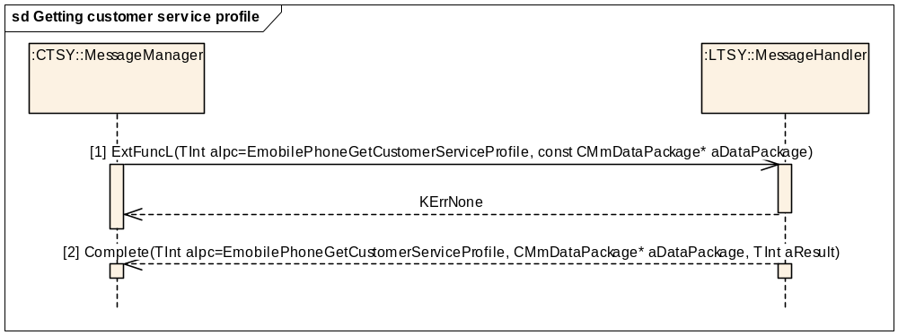
Figure 3.185 Getting customer service profile

Parameters:
[1] aDataPackage is empty.
[2] aDataPackage.iPtr1: - RMobilePhone::TMobilePhoneCspFileV1 (CSP file data in ETel format).

Getting service table
Precondition: Baseband is ready to access the SIM.
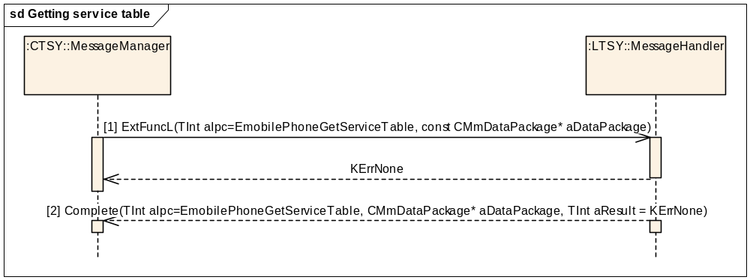
Figure 3.186 Getting service table

Parameters:
[1] aDataPackage.iPtr1: - RMobilePhone::TMobilePhoneServiceTable (Service Table specifier).
[2] aDataPackage.iPtr1: - RMobilePhone::TMobilePhoneServiceTableV1 (SST or UST data).

Getting phone ID
Precondition: Power on.
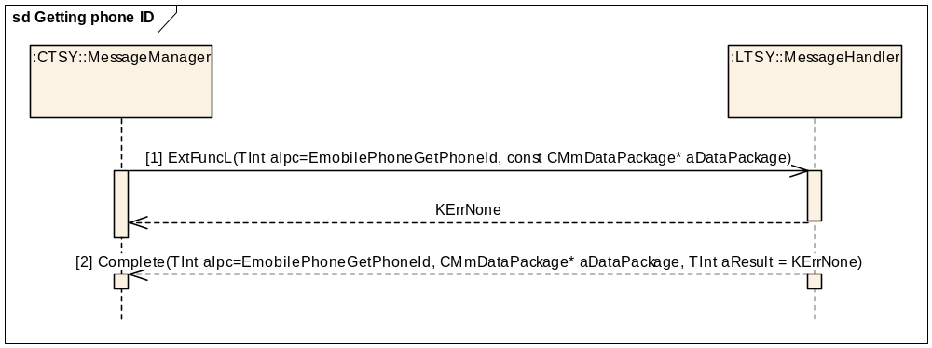
Figure 3.187 Getting phone ID

Parameters:
[1] aDataPackage is empty.
[2] aDataPackage.iPtr1: TBuf8 (serial number data).

Getting subscriber ID
Precondition: Baseband is ready to access the SIM.
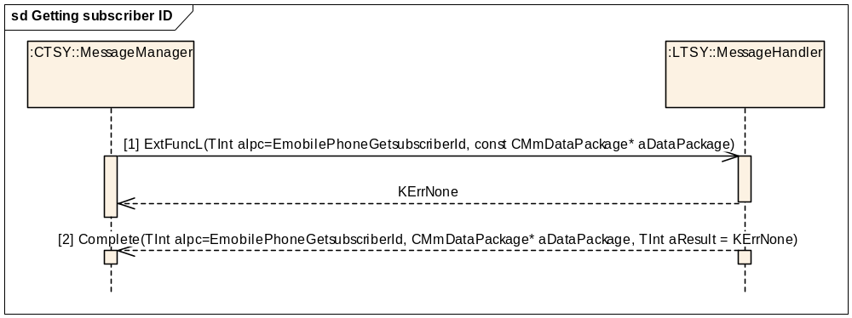
Figure 3.188 Getting subscriber ID

Parameters:
[1] aDataPackage is empty.
[2] aDataPackage.iPtr1: - TBuf8<RMobilePhone::KIMSISize> (IMSI data).

Getting active ALS line
Precondition: Baseband is ready to access the SIM.
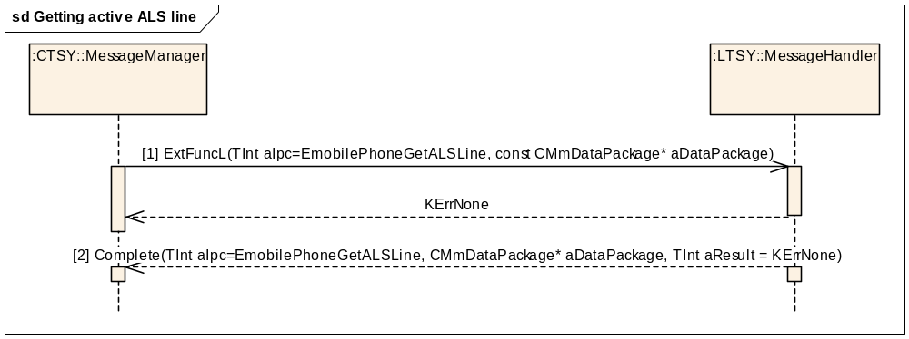
Figure 3.189 Getting active ALS line

Parameters:
[1] aDataPackage is empty.
[2] aDataPackage.iPtr1: - RMobilePhone::TMobilePhoneALSLine (ALS line: EAlternateLinePrimary, EalternateLineAuxiliary or EAlternateLineUnknown).

Setting active ALS line
Precondition: Baseband is ready to access the SIM.
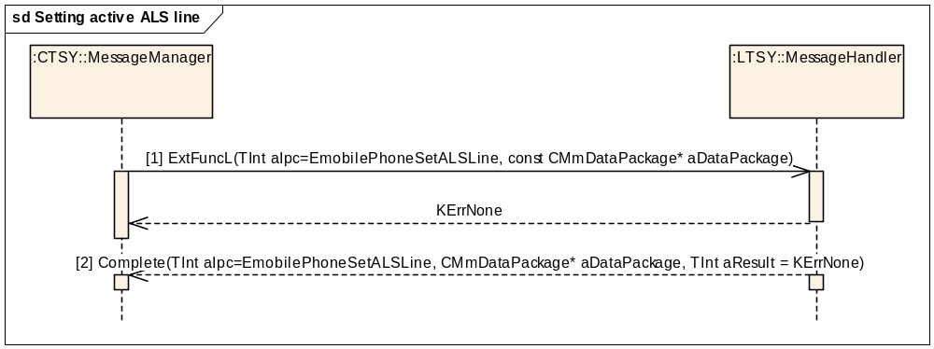
Figure 3.190 Setting active ALS line

Parameters:
[1] aDataPackage.iPtr1: Tint8
[2] aDataPackage is empty.

Getting fixed dialling numbers status
Precondition: Baseband is ready to access the SIM.
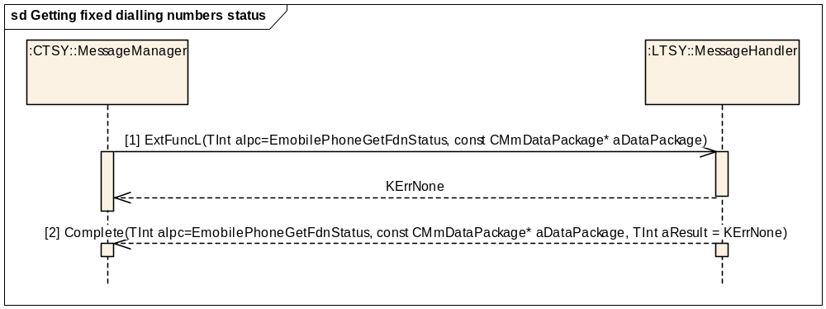
Figure 3.191 Getting fixed dialling numbers status

Parameters:
[1] aDataPackage is empty.
[2] aDataPackage.iPtr1: - RMobilePhone::TMobilePhoneFdnStatus* (FDN list status: EFdnNotActive, EFdnActive or EFdnNotSupported).

Setting fixed dialling numbers setting
Precondition: Baseband is ready to access the SIM.
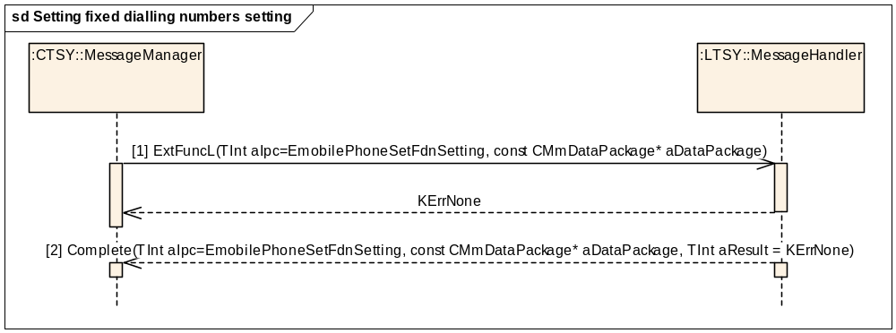
Figure 3.192 Setting fixed dialling numbers setting

Parameters:
[1] aDataPackage.iPtr1: - RMobilePhone::TMobilePhoneFdnSetting* (FDN setting: EFdnSetOn or EFdnSetOff).
[2] aDataPackage is empty.

Getting service provider name
Precondition: Baseband is ready to access the SIM.
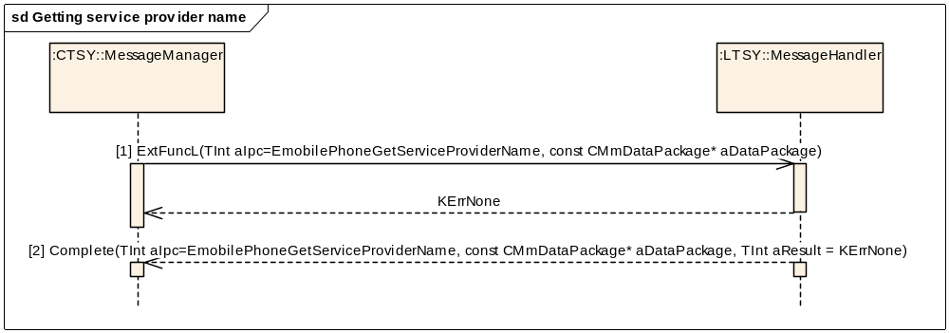
Figure 3.193 Getting service provider name

Parameters:
[1] aDataPackage is empty.
[2] aDataPackage.iPtr1: - RMobilePhone::TMobilePhoneServiceProviderNameV2* (service provider name information).

Setting drive mode
Precondition: Baseband is ready.
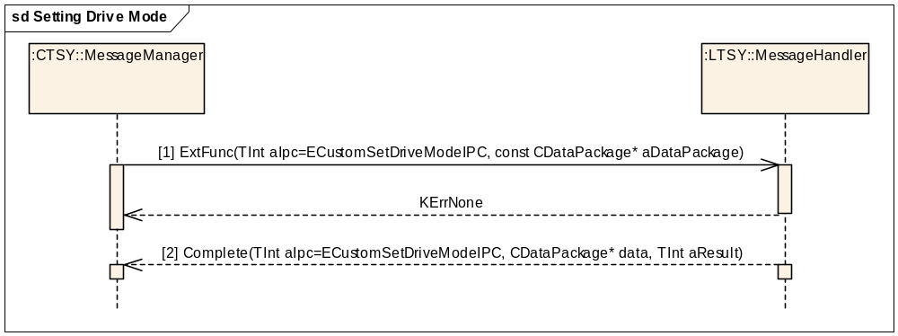
Figure 3.194 Setting Drive Mode

Parameters:
[1] aDataPackage.iPtr1: - RMmCustomAPI::TSetDriveMode* aModeStatus
[2] aDataPackage is empty.

Getting mailbox numbers
Precondition: Baseband is ready to access the SIM.
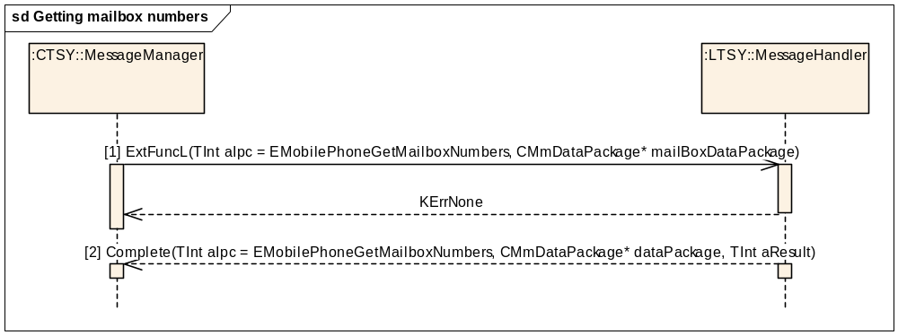
Figure 3.195 Getting mailbox numbers
Parameters:
[1] mailBoxDataPackage: RMobilePhone::TMobilePhoneVoicemailIdsV3
[2] dataPackage: RMobilePhone::TMobilePhoneVoicemailIdsV3

Enumerating Access Point Name (APN) control list entries
Precondition: Baseband is ready to access the SIM.
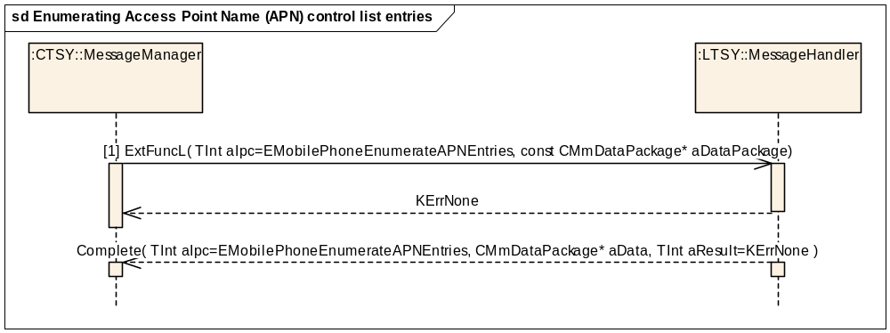
Figure 3.196 Enumerating Access Point Name (APN) control list entries
Parameters:
[1] aDataPackage is empty.
[2] aDataPackage.iPtr1: TUint32 *

Getting Access Point Name (APN) entry
Precondition: Baseband is ready to access the SIM.
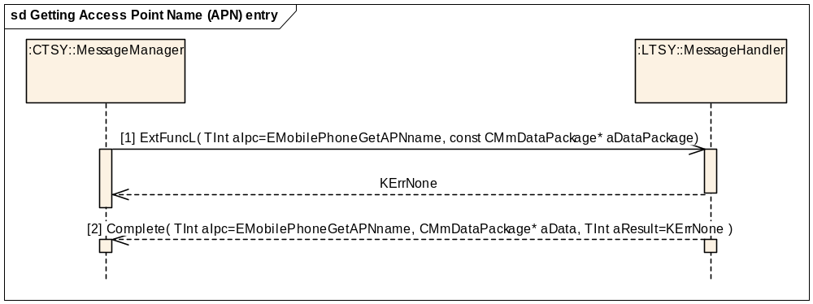
Figure 3.197 Getting Access Point Name (APN) entry
Parameters:
[1] aDataPackage.iPtr1: TUint32*
[2] aDataPackage.iPtr1: RMobilePhone::TAPNEntryV3*

Deleting Access Point Name (APN) entry
Precondition: Baseband is ready to access the SIM.
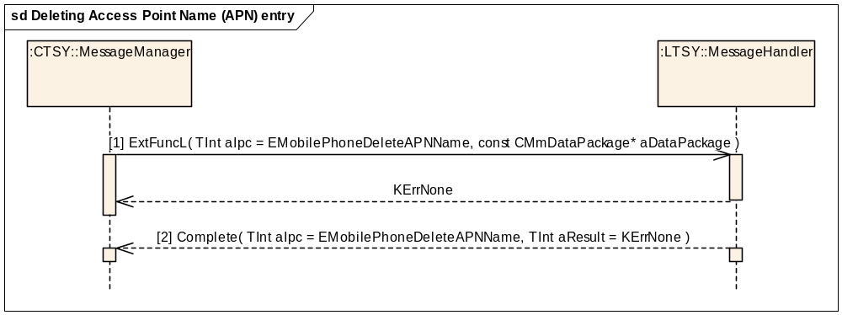
Figure 3.198 Deleting Access Point Name (APN) entry
Parameters:
[1] aDataPackage.iPtr1: TUint32* Index to be deleted

Writing Access Point Name (APN) entry
Precondition: Baseband is ready to access the SIM.
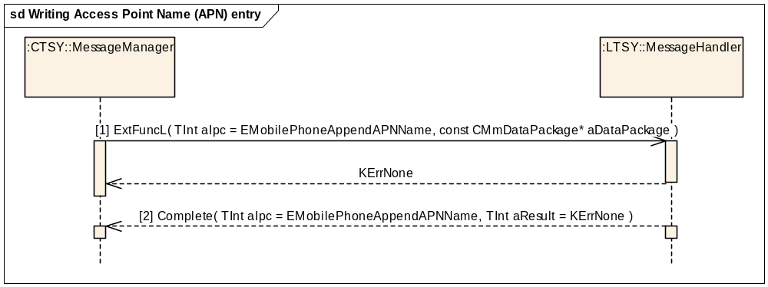
Figure 3.199 Writing Access Point Name (APN) entry
Parameters:
[1] aDataPackage.iPtr1: RMobilePhone::TAPNEntryV3*
[2] aDataPackage is empty.

Getting Access Point Name (APN) control list status
Precondition: Baseband is ready to access the SIM.
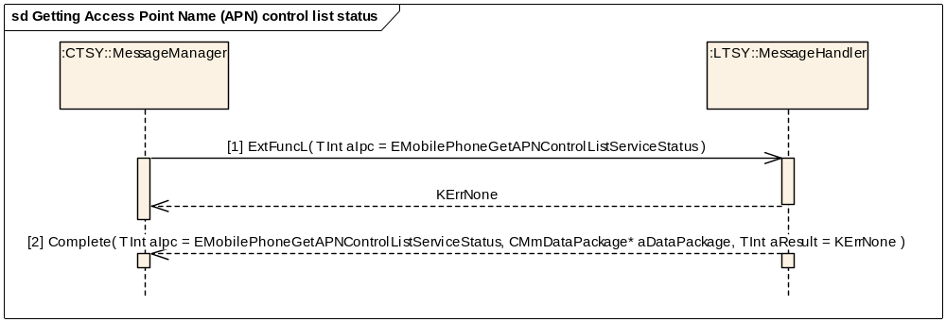
Figure 3.200 Getting Access Point Name (APN) control list status
Parameters:
[1] aDataPackage is empty.
[2] aData.iPtr1: RMobilePhone::TAPNControlListServiceStatus*.

Setting Access Point Name (APN) control list status
Precondition: Baseband is ready to access the SIM.
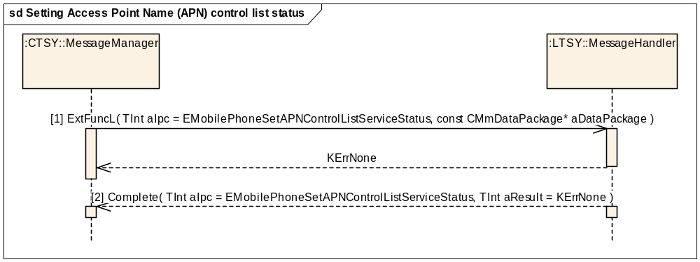
Figure 3.201 Setting Access Point Name (APN) control list status
Parameters:
[1] aDataPackage.iPtr1: RMobilePhone::TAPNControlListServiceStatus*
[2] aDataPackage is empty.

Notifying APN control list service status change
This method allows a client to be notified when the APN control list service status has changed.
Precondition: The Baseband security component is ready. The client has made the EMobilePhoneNotifyAPNControlListServiceStatusChange request to TSY.
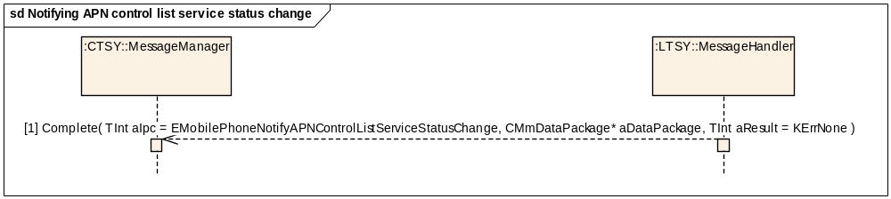
Figure 3.202 Notifying APN control list service status change

Parameters:
[1] aDataPackage.iPtr1: RMobilePhone::TAPNControlListServiceStatus

Notifying APN list change
This method allows a client to be notified when the APN entries in access point control list has changed.
Precondition: The Baseband security component is ready. The client has made the EMobilePhoneNotifyAPNListChanged request to TSY.
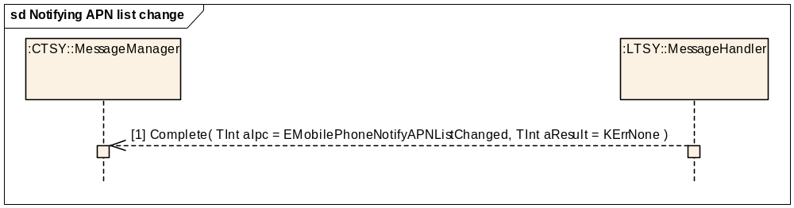
Figure 3.203 Notifying APN list change

Telephony Audio Control

Mobile originated Call setup with Telephony Audio Control
Precondition: Mobile Station (MS) is in the idle state and connected to a network. There are no other calls and Telephony Audio Control Plug-in is implemented by licensee.
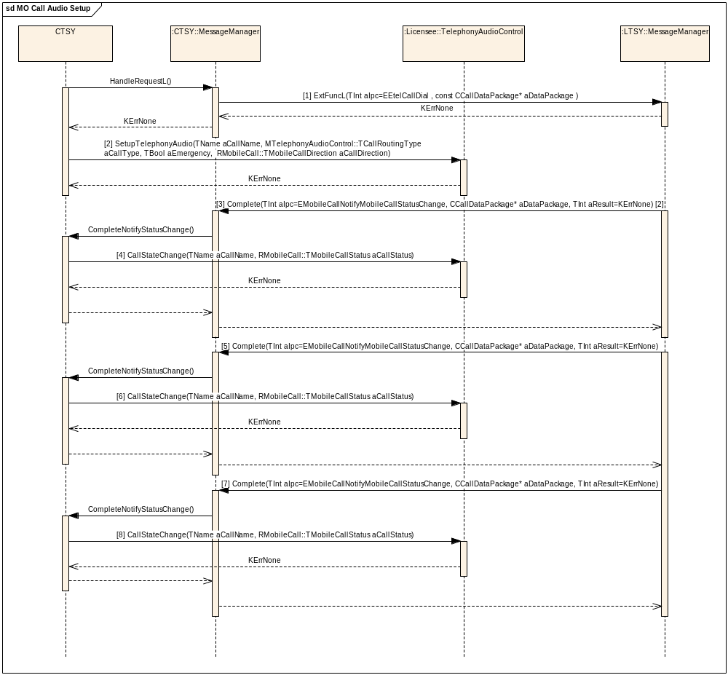
Figure 3.204 MO Call setup with Telephony Audio Control

Parameters:
[1] aDataPackage.iCallId: 0
aDataPackage.iCallMode: RMobilePhone::TMobileService = RMobilePhone::EVoiceService
aDataPackage.iPtr1: RMobileCall::TMobileCallParamsV1Pckg* callParams
aDataPackage.iPtr2: RMobileCall::TMobileCallInfoV1* callInfo
[2] TName aCallName
MCallRoutingControl::TCallRoutingType aCallType = MTelephonyAudioControl::ECallTypeVoice
TBool aEmergency = EFalse
RMobileCall::TMobileCallDirection aCallDirection = EMobileOriginated
[3] aDataPackage.iCallId: Call ID X allocated by the Licencee TSY layer or Baseband (possible values for X = 1-7, and the same value will be shown in the UI).
aDataPackage.iCallMode: RMobilePhone::TMobileService = RMobilePhone::EVoiceService
aDataPackage.iPtr1: RMobileCall::TMobileCallStatus* = RMobileCall::EStatusDialling
[4] TName aCallName
RMobileCall::TMobileCallStatus aCallStatusiCallMode = RMobileCall::EStatusDialling
[5] aDataPackage.iCallId
aDataPackage.iCallMode: RMobilePhone::TMobileService = RMobilePhone::EVoiceService
aDataPackage.Ptr1: RMobileCall::TMobileCallStatus* = RMobileCall::EStatusConnecting
[6] TName aCallName
RMobileCall::TMobileCallStatus aCallStatusiCallMode = RMobileCall::EStatusConnecting
[7] aDataPackage.iCallId: Call ID X.
aDataPackage.iCallMode: RMobilePhone::TMobileService = RMobilePhone::EVoiceService
aDataPackage.Ptr1: RMobileCall::TMobileCallStatus* = RMobileCall::EStatusConnected
[8] TName aCallName
RMobileCall::TMobileCallStatus aCallStatusiCallMode = RMobileCall::EStatusConnected
Cancelling dialing uses the HangUp IPC number (see Sections 3.2.6 and 3.2.7).

Mobile originated call clearing with Telephony Audio Control
Precondition: MS is connected to a network and one voice call is in the Connected state and Telephony Audio Control Plug-in is implemented by licensee.
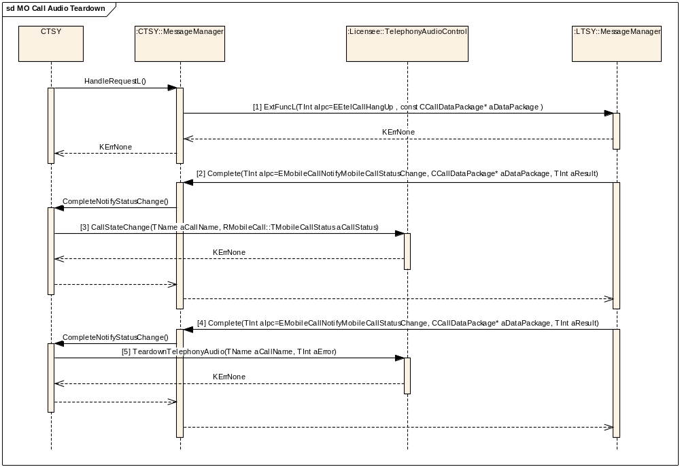
Figure 3.205 Mobile originated call clearing with Telephony Audio Control.
Parameters:
[1] aDataPackage.iCallId: X (the call ID of the connected call)
aDataPackage.iCallMode: RMobilePhone::TMobileService = RMobilePhone::EVoiceService
aDataPackage.iPtr1: TInt* symbianCauseValue (the possible values are KErrGsmReleaseByUser and KErrGsmBusyUserRequest)*
aDataPackage.iPtr2: TBool autoStChangeDisable
(Indicates if a waiting call is wanted to become automatically active)
[2] aDataPackage.iCallId: Call ID X.
aDataPackage.iCallMode: RMobilePhone::TMobileService = RMobilePhone::EVoiceService
aDataPackage.iPtr1: RMobileCall::TMobileCallStatus* = RMobileCall::EStatusDisconnecting
aResult: A Symbian error value #
[3] TName aCallName
RMobileCall::TMobileCallStatus aCallStatusiCallMode = RMobileCall:: EStatusDisconnecting
[4] aDataPackage.iCallId: Call ID X.
aDataPackage.iCallMode: RMobilePhone::TMobileService = RMobilePhone::EVoiceService
aDataPackage.Ptr1: RMobileCall::TMobileCallStatus* = RMobileCall::EStatusIdle
aResult: A Symbian error value #
[5] TName aCallName
aError: A Symbian error value #
# In case of successful call clearing, the Symbian error value must be the same as received with the HangUp request (either KErrGsmReleaseByUser or KErrGsmBusyUserRequest).

Mobile terminated voice call with Telephony Audio Control
Precondition: MS is in the Idle state and connected to a network and Telephony Audio Control Plug-in is implemented by licensee.
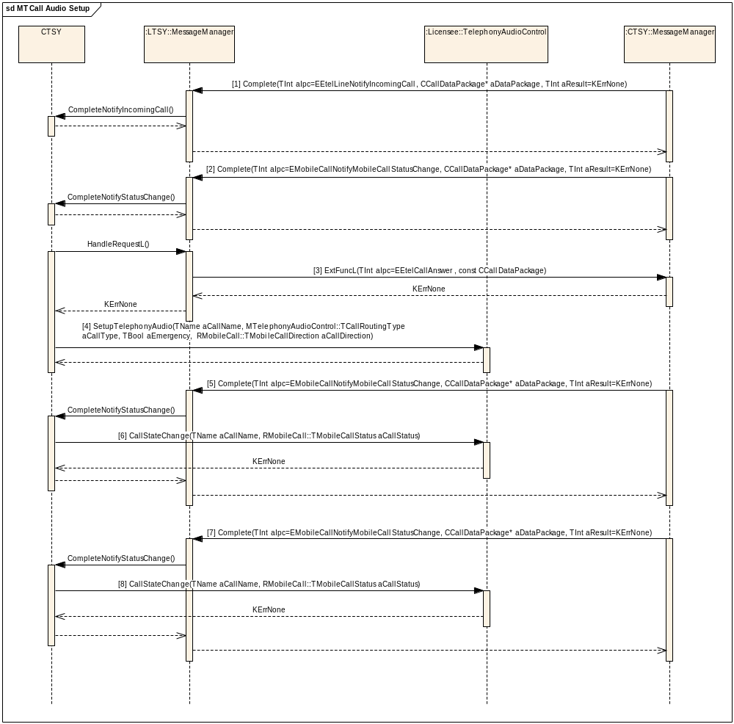
Figure 3.206 Incoming call while there are no other calls with Telephony Audio Control.
Parameters:
[1] aDataPackage.iCallId: X allocated by the Licencee TSY layer or Baseband (possible values for X = 1-7, and the same value will be shown in the UI).
aDataPackage.iCallMode: RMobilePhone::TMobileService = RMobilePhone::EVoiceService
aDataPackage.iPtr1: RMobileCall::TMobileCallInfoV1* callInfo
[2] aDataPackage.iCallId: Call ID X
aDataPackage.iCallMode: RMobilePhone::TMobileService = RMobilePhone::EVoiceService
aDataPackage.iPtr1: RMobileCall::TMobileCallStatus* = RMobileCall::EStatusRinging.
[3] aDataPackage.iCallId: X
aDataPackage.iCallMode: RMobilePhone::TMobileService = RMobilePhone::EVoiceService
[4] TName aCallName
MCallRoutingControl::TCallRoutingType aCallType = MCallRoutingControl::ECallTypeVoice
TBool aEmergency = EFalse
RMobileCall::TMobileCallDirection aCallDirection = EMobileTerminated
[5] aDataPackage.iCallId: Call ID X.
aDataPackage.iCallMode: RMobilePhone::TMobileService = RMobilePhone::EVoiceService
aDataPackage.Ptr1: RMobileCall::TMobileCallStatus* = RMobileCall::EStatusAnswering.
[6] TName aCallName
RMobileCall::TMobileCallStatus aCallStatusiCallMode = RMobileCall::EStatusAnswering
[7] aDataPackage.iCallId: Call ID X.
aDataPackage.iCallMode: RMobilePhone::TMobileService = RMobilePhone::EVoiceService
aDataPackage.Ptr1: RMobileCall::TMobileCallStatus* = RMobileCall::EStatusConnected.
[8] TName aCallName
RMobileCall::TMobileCallStatus aCallStatusiCallMode = RMobileCall::EStatusConnected

Mobile terminated call clearing with Telephony Audio Control
Mobile terminating (MT) call clearing is shown here in two ways. When inband is used, the network sends the Busy tones to MS and then disconnects. When inband is not used, the network just disconnects and MS must play the Busy tones locally.
Precondition: MS is connected to a network and one voice call is in the Connected state and Telephony Audio Control Plug-in is implemented by licensee.
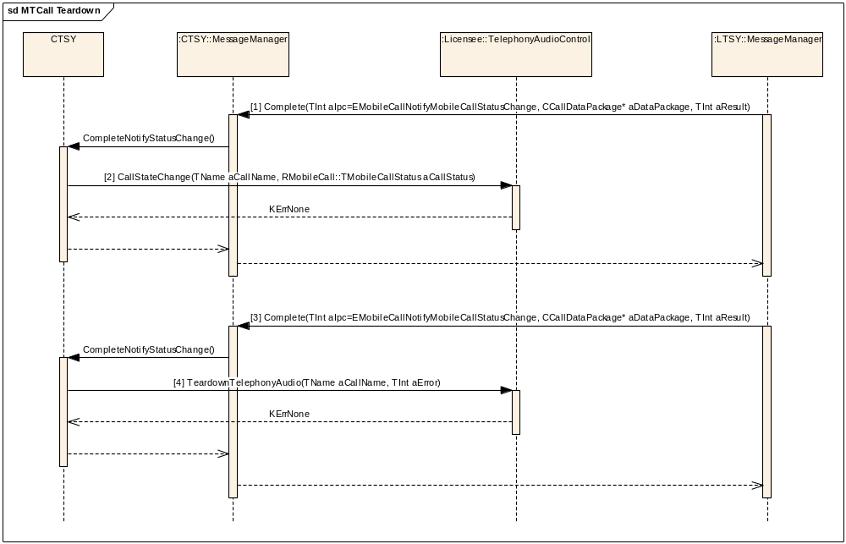
Figure 3.207 MT call clearing with Telephony Audio Control.
Parameters:
[1] aDataPackage.iCallId: Call ID X.
aDataPackage.iCallMode: RMobilePhone::TMobileService = RMobilePhone::EVoiceService
aDataPackage.iPtr1: RMobileCall::TMobileCallStatus* = RMobileCall::EStatusDisconnectingWithInband/RMobileCall::EStatusDisconnecting
aResult: A Symbian error value
[2] TName aCallName
RMobileCall::TMobileCallStatus aCallStatusiCallMode = RMobileCall:: EStatusDisconnectingWithInband/RMobileCall::EStatusDisconnecting
[3] aDataPackage.iCallId: Call ID X.
aDataPackage.iCallMode: RMobilePhone::TMobileService = RMobilePhone::EVoiceService
aDataPackage.Ptr1: RMobileCall::TMobileCallStatus* = RMobileCall::EStatusIdle
aResult: A Symbian error value
[4] TName aCallName
aError: A Symbian error value

Holding and resuming a Voice call with Telephony Audio Control
Precondition: One voice call is in the state RMobileCall::EStatusConnected and Telephony Audio Control Plug-in is implemented by licensee.
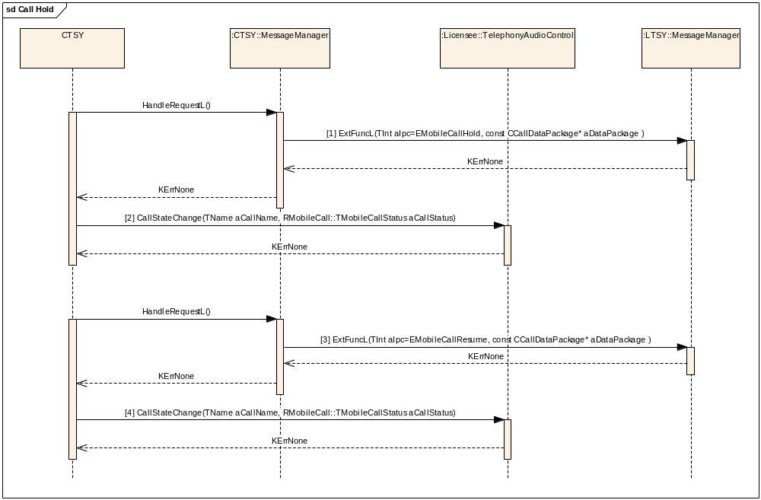
Figure 3.208 Holding and resuming a Voice Call with Telephony Audio Control
[1] aDataPackage.iCallId: X, the call ID of the connected call.
aDataPackage.iCallMode: RMobilePhone::TMobileService = MobilePhone::EVoiceService
[2] TName aCallName
RMobileCall::TMobileCallStatus aCallStatusiCallMode = RMobileCall::EMobileCallHold
[3] aDataPackage.iCallId: X, the call ID of the held call.
aDataPackage.iCallMode: RMobilePhone::TMobileService = MobilePhone::EVoiceService

[4] TName aCallName
RMobileCall::TMobileCallStatus aCallStatusiCallMode = RMobileCall::RMobileCall::EStatusConnected

Telephony Audio Control error reporting
Precondition: Telephony Audio Control Plug-in is implemented by licensee. Since an error can occur when call is connected the Telephony Audio Control can inform CTSY from these errors via MTelephonyAudioControlCallback functions.
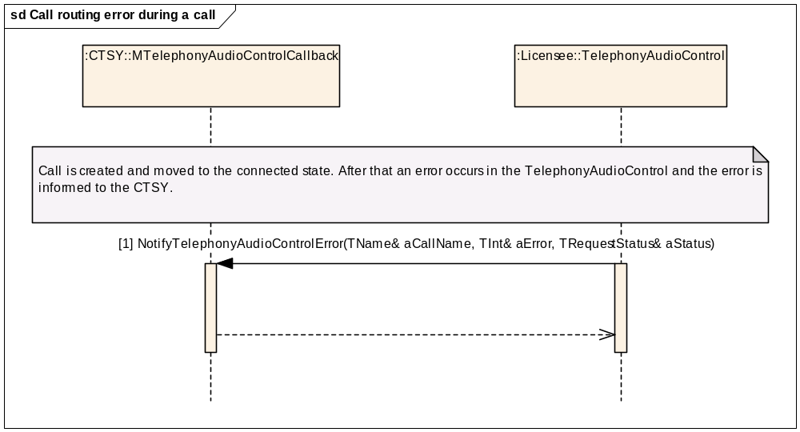
Figure 3.209 Telephony Audio Control error reporting during a connected call.
[1] TName& aCallName
TInt& aError
TRequestStatus& aStatus

Index of supported and unsupported IPCs
This chapter contains all the IPCs from the ETel APIs and shows which IPCs should be supported by Licensee TSY.

Call interface

Voice call IPCs
*These IPCs are also used for CSD calls.

Call IPCs that are supported by Common TSY and need implementation in Licensee TSY
EEtelCallDial*
EEtelCallAnswer*
EEtelCallHangUp*
EmobileCallHold
EmobileCallResume
EmobileCallSwap
EmobileCallDeflect
EmobileCallTransfer
EmobileCallGoOneToOne
EMobileCallNotifyCallEvent (used only for indications when a remote call event occurs)*
EMobileCallNotifyMobileCallStatusChange*
EmobileCallDialEmergencyCall
EMobileCallNotifyPrivacyConfirmation
EMobileCallGetMobileCallInfo (used only for indications when mobile call information changes)
EMobileCallDialISV
EMobileCallAnswerISV
EMobileCallActivateUUS
EMobileCallReceiveUUI

Call IPCs that are supported by Common TSY but do not need implementation in Licensee TSY
EEtelCallGetInfo*
EEtelCallNotifyHookChange*
EEtelCallNotifyStatusChange (used only for indications when the mobile call status changes)*
EEtelCallNotifyDurationChange*
EEtelCallCapsChangeNotification*
EEtelCallAcquireOwnership*
EEtelCallGetStatus*
EEtelCallGetCaps*
EEtelCallGetCallParams
EEtelCallGetCallDuration*
EMobileCallGetMobileCallCaps*
EMobileCallNotifyMobileCallCapsChange*
EMobileCallGetMobileCallStatus*
EMobileCallNotifyRemotePartyInfoChange*

Call IPCs that are not used in Common TSY
EEtelCallNotifyHookChangeCancel
EEtelCallNotifyStatusChangeCancel
EEtelCallNotifyDurationChangeCancel
EEtelCallCapsChangeNotificationCancel
EEtelCallAcquireOwnershipCancel
EEtelCallDialCancel
EEtelCallAnswerCancel
EetelCallHangUpCancel
EetelCallTransferOwnership
EEtelCallGetOwnershipStatus
EMobileCallDeflect
EMobileCallSwitchAlternatingCall
EMobileCallNotifyAlternatingCallSwitch
EMobileCallSetPrivacy
EMobileCallSetTrafficChannel
EMobileCallNotifyTrafficChannelConfirmation
EMobileCallNotifyVoiceFallback
EMobileCallGetUUSCaps
EMobileCallNotifyUUSCapsChange
EMobileCallActivateUUS
EMobileCallSendUUI
EMobileCallHangupWithUUI
EMobileCallAnswerWithUUI
EMobileCallAnswerMultimediaCallAsVoice
EMobileCallDialNoFdnCheck
EMobileCallNotifyAudioToneEvent
EMobileCallSwitchAlternatingCallCancel
EMobileCallNotifyAlternatingCallSwitchCancel
EMobileCallNotifyMobileCallCapsChangeCancel
EMobileCallHoldCancel
EMobileCallResumeCancel
EMobileCallSwapCancel
EMobileCallDeflectCancel
EMobileCallTransferCancel
EMobileCallGoOneToOneCancel
EMobileCallNotifyCallEventCancel
EMobileCallNotifyMobileCallStatusChangeCancel
EMobileCallDialEmergencyCallCancel
EMobileCallNotifyPrivacyConfirmationCancel
EMobileCallNotifyTrafficChannelConfirmationCancel
EMobileCallGetMobileCallInfoCancel
EMobileCallNotifyRemotePartyInfoChangeCancel
EMobileCallNotifyVoiceFallbackCancel
EMobileCallActivateCCBSCancel
EMobileCallNotifyUUSCapsChangeCancel
EMobileCallActivateUUSCancel
EMobileCallSendUUICancel
EMobileCallReceiveUUICancel
EMobileCallHangupWithUUICancel
EMobileCallAnswerWithUUICancel
EMobileCallAnswerMultimediaCallAsVoiceCancel
EMobileCallDialNoFdnCheckCancel
EMobileCallNotifyAudioToneEventCancel

Line IPCs
*These IPCs are also used for CSD calls.

Line IPCs that are supported by Common TSY and need implementation in Licensee TSY
EEtelLineNotifyIncomingCall

Line IPCs that are supported by Common TSY but do not need implementation in Licensee TSY
EEtelLineGetInfo*
EEtelLineNotifyIncomingCall*
EEtelLineNotifyHookChange*
EEtelLineNotifyStatusChange*
EEtelLineNotifyCallAdded*
EEtelLineCapsChangeNotification*
EEtelLineGetCaps*
EEtelLineGetStatus*
EEtelLineGetHookStatus*
EEtelLineEnumerateCall*
EEtelLineGetCallInfo*
EMobileLineGetMobileLineStatus*
EMobileLineNotifyMobileLineStatusChange*
EEtelLineGetHookStatus*

Line IPCs that are not used in Common TSY
EEtelLineNotifyIncomingCallCancel*
EEtelLineNotifyHookChangeCancel*
EEtelLineNotifyStatusChangeCancel*
EEtelLineNotifyCallAddedCancel*
EEtelLineCapsChangeNotificationCancel*
EMobileLineNotifyMobileLineStatusChangeCancel*

DTMF IPCs

DTMF IPCs that are supported by Common TSY and need implementation in Licensee TSY
EMobilePhoneSendDTMFTones
EMobilePhoneStartDTMFTone
EMobilePhoneStopDTMFTone
EMobilePhoneNotifyStopInDTMFString
EMobilePhoneContinueDTMFStringSending
EMobilePhoneSendDTMFTonesCancel
ECustomNotifyDtmfEventIPC (from Custom API)

DTMF IPCs that are supported by Common TSY but do not need implementation in Licensee TSY
EMobilePhoneGetDTMFCaps
EMobilePhoneNotifyDTMFCapsChange

DTMF IPCs that are not used in Common TSY
EMobilePhoneReadDTMFTones
EMobilePhoneNotifyDTMFEvent
EMobilePhoneNotifyDTMFCapsChangeCancel
EMobilePhoneNotifyStopInDTMFStringCancel
EMobilePhoneReadDTMFTonesCancel
EMobilePhoneNotifyDTMFEventCancel

Conference call IPCs

Conference call IPCs that are supported by Common TSY and need implementation in Licensee TSY
EMobileConferenceCallCreateConference
EMobileConferenceCallAddCall
EMobileConferenceCallSwap
EMobileConferenceCallHangUp
EMobileConferenceCallNotifyConferenceEvent

Conference call IPCs that are supported by Common TSY but do not need implementation in Licensee TSY
EMobileConferenceCallGetCaps
EMobileConferenceCallNotifyCapsChange
EMobileConferenceCallEnumerateCalls
EMobileConferenceCallGetMobileCallInfo
EMobileConferenceCallGetConferenceStatus
EMobileConferenceCallNotifyConferenceStatusChange
EMobileConferenceCallNotifyCapsChangeCancel
EMobileConferenceCallCreateConferenceCancel
EMobileConferenceCallAddCallCancel
EMobileConferenceCallSwapCancel
EMobileConferenceCallHangUpCancel
EMobileConferenceCallNotifyConferenceStatusChangeCancel
EMobileConferenceCallNotifyConferenceEventCancel

Custom Call IPCs

Custom IPCs that are supported by Common TSY and need implementation in Licensee TSY
ECustomGetDiagnosticOctetsIPC
ECustomSetAlsBlockedIPC
ECustomGetAlsBlockedIPC
ECustomCheckAlsPpSupportIPC
ECustomGetRemoteAlertingToneStatusIPC
ECustomTerminateCallIPC
ECustomClearCallBlackListIPC
ECustomGetLifeTimeIPC
ECustomCheckEmergencyNumberIPC

Custom call IPCs that are supported by Common TSY but do not need implementation in Licensee TSY
ECustomCallOriginIPC
ECustomNotifyAlsBlockedChangedIPC
ECustomGetAirTimeDurationIPC

CSD IPCs
These IPCs are specific for CSD calls. There are also same IPCs that are listed under voice call; they have different implementation for CSD. Those CSD IPCs that have the same implementation as in voice calls are marked within Sections 4.1.1 and 4.1.2 with “*”.

CSD IPCs that are supported by Common TSY and do not need implementation in Licensee TSY
EEtelCallAcquireOwnership
EEtelCallConnect
EEtelCallTransferOwnership
EEtelCallGetOwnershipStatus
EMobileCallGetMobileDataCallCaps
EMobileCallNotifyMobileDataCallCapsChange (optional, for completing from Licensee TSY)
EMobileCallGetCurrentHscsdInfo

CSD IPCs that are supported by Common TSY and need implementation in Licensee TSY
EEtelCallLoanDataPort
EetelCallRecoverDataPort
EEtelCallGetBearerServiceInfo
EEtelCallGetCallParams
EMobileCallSetDynamicHscsdParams
EMobileCallNotifyHscsdInfoChange
ECustomNotifyMultimediaDataRateChangeIPC (from custom API)
EEtelPhoneNotifyModemDetected

CSD IPCs that are not used in Common TSY for CSD call
EEtelCallConnect
EEtelCallAcquireOwnershipCancel
EEtelCallTransferOwnership
EEtelCallGetOwnershipStatus
EEtelCallDialCancel
EEtelCallConnectCancel
EEtelCallAnswerCancel
EEtelCallLoanDataPortCancel
EEtelCallGetFaxSettings
EEtelCallSetFaxSettings
EMobileCallGetMobileDataCallRLPRange
EMobileCallSwitchAlternatingCall
EMobileCallNotifyAlternatingCallSwitch
EMobileCallHold
EMobileCallResume
EMobileCallSwap
EMobileCallDeflect
EMobileCallTransfer
EMobileCallGoOneToOne
EMobileCallDialEmergencyCall
EMobileCallSetPrivacy
EMobileCallSetTrafficChannel
EMobileCallNotifyTrafficChannelConfirmation
EMobileCallNotifyVoiceFallback
EMobileCallActivateCCBS
EMobileCallRejectCCBS
EMobileCallGetUUSCaps
EMobileCallNotifyUUSCapsChange
EMobileCallActivateUUS
EMobileCallSendUUI
EMobileCallReceiveUUI
EMobileCallHangupWithUUI
EMobileCallAnswerWithUUI
EMobileCallAnswerMultimediaCallAsVoice
EMobileCallDialNoFdnCheck,
EMobileCallNotifyAudioToneEvent
EMobileCallNotifyMobileDataCallCapsChangeCancel
EMobileCallGetMobileDataCallRLPRangeCancel
EMobileCallNotifyHscsdInfoChangeCancel
EMobileCallSetDynamicHscsdParamsCancel
EMobileCallSwitchAlternatingCallCancel
EMobileCallNotifyAlternatingCallSwitchCancel
EMobileCallHoldCancel
EMobileCallResumeCancel
EMobileCallSwapCancel
EMobileCallDeflectCancel
EMobileCallGoOneToOneCancel
EMobileCallDialEmergencyCallCancel
EMobileCallNotifyTrafficChannelConfirmationCancel
EMobileCallNotifyVoiceFallbackCancel
EMobileCallActivateCCBSCancel
EMobileCallNotifyUUSCapsChangeCancel
EMobileCallActivateUUSCancel
EMobileCallSendUUICancel
EMobileCallReceiveUUICancel
EMobileCallHangupWithUUICancel
EMobileCallAnswerWithUUICancel
EMobileCallAnswerMultimediaCallAsVoiceCancel
EMobileCallDialNoFdnCheckCancel
EMobileCallNotifyAudioToneEventCancel

Network IPCs

Network IPCs that are supported by Common TSY and need implementation in Licensee TSY
EMobilePhoneNotifySignalStrengthChange
EMobilePhoneGetNetworkRegistrationStatus
EMobilePhoneNotifyNetworkRegistrationStatusChange
EMobilePhoneNotifyModeChange
EMobilePhoneNotifyCurrentNetworkChange
EMobilePhoneGetHomeNetwork
EMobilePhoneSetNetworkSelectionSetting
EMobilePhoneNotifyNetworkSelectionSettingChange
EMobilePhoneSelectNetwork
EMobilePhoneNotifyNITZInfoChange
EMobilePhoneNotifyNetworkSecurityLevelChange
EMobilePhoneGetCipheringIndicatorStatus
EMobilePhoneGetDetectedNetworksV2Phase1
EMobilePhoneGetDetectedNetworksCancel
EMobilePhoneSelectNetworkCancel
ECustomGetCipheringInfoIPC (from Custom API)
ECustomNetWakeupIPC (from Custom API)
ECustomGetOperatorNameIPC (from Custom API)
ECustomResetNetServerIPC (from Custom API)
ECustomNotifyNetworkConnectionFailureIPC (from Custom API)
ECustomGetSystemNetworkModesIPC (from Custom API)
ECustomSetSystemNetworkModeIPC (from Custom API)
ECustomGetCurrentSystemNetworkModesIPC (from Custom API)
ECustomReadHSxPAStatusIPC (from Custom API)
ECustomWriteHSxPAStatusIPC (from Custom API)
ECustomNotifyHSxPAStatusIPC (from Custom API)
ECtsyPhoneCellInfoIndReq
ECtsyPhoneCellInfoReq
ECtsyPhoneCellInfoIndComp
ECtsyPhoneCellInfoComp

Network IPCs that are supported by Common TSY but do not need implementation in Licensee TSY
EMobilePhoneGetSignalStrength
EMobilePhoneGetNetworkCaps
EMobilePhoneGetCurrentMode
EMobilePhoneGetCurrentNetwork
EMobilePhoneGetNetworkSelectionSetting
EMobilePhoneGetNITZInfo
EMobilePhoneGetNetworkSecurityLevel
EMobilePhoneGetDetectedNetworksV2Phase2
ECustomNotifyCipheringInfoChangeIPC (from Custom API)
ECustomNotifyNSPSStatusIPC (from Custom API)
EMobilePhoneGetCellInfo
EMobilePhoneNotifyCellInfoChange

Network IPCs that are not used in Common TSY
EMobilePhoneGetDetectedNetworksPhase1
EMobilePhoneGetDetectedNetworksPhase2
EMobilePhoneGetDefaultPrivacy
EMobilePhoneSetDefaultPrivacy
EMobilePhoneNotifyDefaultPrivacyChange
EMobilePhoneGetHomeNetworkSearchPeriod
EMobilePhoneGetLastUsedAccessTechnology
EMobilePhoneGetNetworkInvScanSetting
EMobilePhoneNotifyNetworkInvScanChange
EMobilePhoneNotifyNetworkInvScanEvent
EMobilePhoneGetNetworkName
EMobilePhoneGetPreferredNetworksPhase1
EMobilePhoneGetPreferredNetworksPhase2
EMobilePhoneStorePreferredNetworksList
EMobilePhoneNotifyStorePreferredNetworksListChange
EMobilePhoneNotifyCipheringIndicatorStatus
EMobilePhoneGetSignalStrengthCancel
EMobilePhoneNotifySignalStrengthChangeCancel
EMobilePhoneGetNetworkRegistrationStatusCancel
EMobilePhoneNotifyNetworkRegistrationStatusChangeCancel
EMobilePhoneNotifyModeChangeCancel
EMobilePhoneGetCurrentNetworkCancel
EMobilePhoneNotifyCurrentNetworkChangeCancel
EMobilePhoneGetHomeNetworkCancel
EMobilePhoneSetNetworkSelectionSettingCancel
EMobilePhoneNotifyNetworkSelectionSettingChangeCancel
EMobilePhoneNotifyNITZInfoChangeCancel
EMobilePhoneSetDefaultPrivacyCancel
EMobilePhoneNotifyDefaultPrivacyChangeCancel
EMobilePhoneGetNetworkSecurityLevelCancel
EMobilePhoneNotifyNetworkSecurityLevelChangeCancel
EMobilePhoneGetHomeNetworkSearchPeriodCancel
EMobilePhoneGetLastUsedAccessTechnologyCancel
EMobilePhoneNotifyNetworkInvScanChangeCancel
EMobilePhoneNotifyNetworkInvScanEventCancel
EMobilePhoneGetNetworkNameCancel
EMobilePhoneGetPreferredNetworksCancel
EMobilePhoneStorePreferredNetworksListCancel
EMobilePhoneNotifyStorePreferredNetworksListChangeCancel
EMobilePhoneGetCipheringIndicatorStatusCancel
EMobilePhoneNotifyCipheringIndicatorStatusCancel
EMobilePhoneGetDetectedNetworksV2Cancel
ECustomGetProgrammableOperatorLogoIPC (from Custom API)
ECustomNotifyProgrammableOperatorLogoChangeIPC (from Custom API)

Packet data IPCs

Packet context IPCs

Packet context IPCs that are supported by Common TSY and need implementation in Licensee TSY
EPacketContextSetConfig
EPacketContextNotifyConfigChanged
EPacketContextActivate
EPacketContextDeactivate
EPacketContextDelete
EPacketContextNotifyStatusChange
EPacketContextNotifyConnectionSpeedChange
EPacketContextInitialiseContext
EPacketContextGetDataVolumeTransferred
EPacketContextAddPacketFilter
EPacketContextModifyActiveContext
EPacketContextNotifyDataTransferred
EPacketContextNotifyConnectionInfoChange

Packet context IPCs that are supported by Common TSY but do not need implementation in Licensee TSY
EPacketContextGetConfig
EPacketContextGetStatus
EPacketContextGetProfileName
EPacketContextGetConnectionSpeed
EPacketContextGetLastErrorCause
EPacketContextEnumeratePacketFilters
EPacketContextGetPacketFilterInfo
EPacketContextRemovePacketFilter
EPacketContextGetDNSInfo
EPacketContextGetConnectionInfo

Packet context IPCs that are not used in Common TSY
EPacketContextLoanCommPort
EPacketContextRecoverCommPort
EPacketContextCreateNewTFT
EPacketContextDeleteTFT
EPacketContextSetConfigCancel
EPacketContextGetConfigCancel
EPacketContextNotifyConfigChangedCancel
EPacketContextActivateCancel
EPacketContextDeactivateCancel
EPacketContextDeleteCancel
EPacketContextLoanCommPortCancel
EPacketContextRecoverCommPortCancel
EPacketContextNotifyStatusChangeCancel
EPacketContextNotifyDataTransferredCancel
EPacketContextGetConnectionSpeedCancel
EPacketContextNotifyConnectionSpeedChangeCancel
EPacketContextGetDataVolumeTransferredCancel
EPacketContextInitialiseContextCancel
EPacketContextEnumeratePacketFiltersCancel
EPacketContextGetPacketFilterInfoCancel
EPacketContextAddPacketFilterCancel
EPacketContextRemovePacketFilterCancel
EPacketContextModifyActiveContextCancel
EPacketContextGetDNSInfoCancel
EPacketContextCreateNewTFTCancel
EPacketContextDeleteTFTCancel

Packet service IPCs

Packet service IPCs that are supported by Common TSY and need implementation in Licensee TSY
EPacketNotifyContextAdded
EPacketAttach
EPacketDetach
EPacketNotifyStatusChange
EPacketNotifyContextActivationRequested
EPacketRejectActivationRequest
EPacketGetNtwkRegStatus
EPacketNotifyChangeOfNtwkRegStatus
EPacketNotifyMSClassChange
EPacketSetPrefBearer
EPacketNotifyDynamicCapsChange
EPacketSetAttachMode
EPacketGetAttachMode
EPacketSetDefaultContextParams
EPacketNotifyReleaseModeChange
EPacketNotifyAttachModeChange
EPacketInitProxiesIPC defined MmTsy_IPCdefs.h: Used for initialising some values in Common TSY. It is not completing anything, only returning an INT value when Common TSY is created in boot. In Licensee TSY, it can be used for proxy initialisation in boot.
EMmTsyNotifyEGprsInfoChangeIPC
EPacketNotifyTransferCapsIPC
ECustomNotifyRauEventIPC (from Custom Api)
ECustomSetAlwaysOnModeIPC (from Custom Api)

Packet service IPCs that are supported by Common TSY but do not need implementation in Licensee TSY
EPacketGetStatus
EPacketEnumerateContexts
EPacketGetContextInfo
EPacketGetMSClass
EPacketGetPrefBearer
EPacketGetStaticCaps
EPacketGetDynamicCaps
EPacketGetDefaultContextParams
EPacketEnumerateNifs
EPacketGetNifInfo
EPacketEnumerateContextsInNif
EPacketGetContextNameInNif
EPacketPrepareOpenSecondary

Packet service IPCs that are not used in Common TSY
EPacketSetMSClass
EPacketGetCurrentReleaseMode
EPacketDeactivateNIF
EPacketNotifyContextAddedCancel
EPacketAttachCancel
EPacketDetachCancel
EPacketNotifyStatusChangeCancel
EPacketNotifyContextActivationRequestedCancel
EPacketRejectActivationRequestCancel
EPacketEnumerateContextsCancel
EPacketGetContextInfoCancel
EPacketGetNtwkRegStatusCancel
EPacketNotifyChangeOfNtwkRegStatusCancel
EPacketGetMSClassCancel
EPacketSetMSClassCancel
EPacketSetPrefBearerCancel
EPacketNotifyMSClassChangeCancel
EPacketNotifyDynamicCapsChangeCancel
EPacketSetAttachModeCancel
EPacketGetAttachModeCancel
EPacketSetDefaultContextParamsCancel
EPacketGetDefaultContextParamsCancel
EPacketGetCurrentReleaseModeCancel
EPacketNotifyReleaseModeChangeCancel
EPacketEnumerateNifsCancel
EPacketGetNifInfoCancel
EPacketEnumerateContextsInNifCancel
EPacketGetContextNameInNifCancel
EPacketNotifyAttachModeChangeCancel
EPacketGetPrefBearerCancel
EPacketDeactivateNIFCancel

QoS IPCs

QoS IPCs that are supported by Common TSY and need implementation in Licensee TSY
EPacketQoSSetProfileParams
EPacketQoSNotifyProfileChanged

QoS IPCs that are supported by Common TSY but do not need implementation in Licensee TSY
EPacketQoSGetProfileParams
EPacketQoSGetProfileCaps

QoS IPCs that are not used in Common TSY
EPacketQoSSetProfileParamsCancel
EPacketQoSGetProfileParamsCancel
EPacketQoSGetProfileCapsCancel
EPacketQoSNotifyProfileChangedCancel

Supplementary service IPCs

Call forwarding IPCs

Call forwarding IPCs that are supported by Common TSY and need implementation in Licensee TSY
EMobilePhoneGetCallForwardingStatusPhase1
EMobilePhoneSetCallForwardingStatus
EMobilePhoneNotifyCallForwardingStatusChange
EMobilePhoneNotifyCallForwardingActive

Call forwarding IPCs that are supported by Common TSY but do not need implementation in Licensee TSY
EMobilePhoneGetCallForwardingStatusPhase2

Call forwarding IPCs that are not used in Common TSY
EMobilePhoneGetCallForwardingIndicator
EMobilePhoneGetCallForwardingIndicatorCancel
EMobilePhoneGetCallForwardingStatusCancel
EMobilePhoneSetCallForwardingStatusCancel
EMobilePhoneNotifyCallForwardingStatusChangeCancel
EMobilePhoneNotifyCallForwardingActiveCancel

Call barring IPCs

Call barring IPCs that are supported by Common TSY and need implementation in Licensee TSY
EMobilePhoneGetBarringStatusPhase1
EMobilePhoneSetCallBarringStatus
EMobilePhoneSetSSPassword
EMobilePhoneNotifyCallBarringStatusChange

Call barring IPCs that are supported by Common TSY but do not need implementation in Licensee TSY
EMobilePhoneGetBarringStatusPhase2
EMobilePhoneGetBarringStatusCancel
EMobilePhoneSetCallBarringStatusCancel
EMobilePhoneNotifyCallBarringStatusChangeCancel
EMobilePhoneSetSSPasswordCancel

Call barring IPCs that are not used in Common TSY
EMobilePhoneSetCallBarringPassword (superseded by EMobilePhoneSetSSPassword)
EMobilePhoneGetCompMethodName
EMobilePhoneSetCallBarringPasswordCancel
EMobilePhoneGetCompMethodNameCancel

Call waiting IPCs

Call waiting IPCs that are supported by Common TSY and need implementation in Licensee TSY
EMobilePhoneGetWaitingStatusPhase1
EMobilePhoneSetCallWaitingStatus
EMobilePhoneNotifyCallWaitingStatusChange

Call waiting IPCs that are supported by Common TSY but do not need implementation in Licensee TSY
EMobilePhoneGetWaitingStatusPhase2
EMobilePhoneGetWaitingStatusCancel
EMobilePhoneSetCallWaitingStatusCancel
EMobilePhoneNotifyCallWaitingStatusChangeCancel

Identity service IPCs

Identity service IPCs that are supported by Common TSY and need implementation in Licensee TSY
EMobilePhoneGetIdentityServiceStatus

Identity service IPCs that are supported by Common TSY but do not need implementation in Licensee TSY
EMobilePhoneGetIdentityServiceStatusCancel

Identity service IPCs that are not used in Common TSY
EMobilePhoneSetIdentityServiceStatus
EMobilePhoneNotifyIdentityServiceStatus
EMobilePhoneNotifyIdentitySuppressionRejected
EMobilePhoneSetIdentityServiceStatusCancel
EMobilePhoneNotifyIdentityServiceStatusCancel
EMobilePhoneNotifyIdentitySuppressionRejectedCancel

Advice of Charge Service IPCs

Advice of Charge service IPCs that are not used in Common TSY
EMobilePhoneGetCostCaps
EMobilePhoneNotifyCostCapsChange
EMobilePhoneClearCostMeter
EMobilePhoneSetMaxCostMeter
EMobilePhoneSetPuct
EMobilePhoneGetCostInfo
EMobilePhoneNotifyCostInfoChange
EMobilePhoneNotifyCostCapsChangeCancel
EMobilePhoneClearCostMeterCancel
EMobilePhoneSetMaxCostMeterCancel
EMobilePhoneSetPuctCancel
EMobilePhoneGetCostInfoCancel
EMobilePhoneNotifyCostInfoChangeCancel

CCBS Service IPCs

CCBS service IPCs that are not used in Common TSY
EMobilePhoneGetCCBSStatus
EMobilePhoneNotifyCCBSStatusChange
EMobilePhoneDeactivateCCBS
EMobilePhoneNotifyCCBSRecall
EMobilePhoneAcceptCCBSRecall
EMobilePhoneRefuseCCBSRecall
EMobilePhoneNotifyCCBSStatusChangeCancel
EMobilePhoneGetCCBSStatusCancel
EMobilePhoneDeactivateCCBSCancel
EMobilePhoneNotifyCCBSRecallCancel
EMobilePhoneAcceptCCBSRecallCancel

USSD Service IPCs

USSD service IPCs IPCs that are supported by Common TSY and need implementation in Licensee TSY
EMobilePhoneSendNetworkServiceRequest
EMobilePhoneNotifySendNetworkServiceRequest

USSD service IPCs IPCs that are supported by Common TSY but do not need implementation in Licensee TSY
EMobilePhoneNotifySendNetworkServiceRequestCancel

USSD Service IPCs that are not used in Common TSY
EMobilePhoneSendNetworkServiceRequestCancel
EMobilePhoneNotifySendNetworkServiceRequestCancel

Custom Supplementary Service IPCs

Custom SS IPCs that are supported by Common TSY but do not need implementation in Licensee TSY
ECustomSsAdditionalInfoNotificationIPC (from Custom API)
ECustomNotifySsRequestCompleteIPC (from Custom API)
ECustomNotifySsNetworkEventIPC (from Custom API)

Message Waiting Indicator IPCs

MWIS IPCs that are supported by Common TSY and need implementation in Licensee TSY
EMobilePhoneGetIccMessageWaitingIndicators
EMobilePhoneSetIccMessageWaitingIndicators

MWIS IPCs that are supported by Common TSY but do not need implementation in Licensee TSY
EMobilePhoneNotifyIccMessageWaitingIndicatorsChange

MWIS IPCs that are supported by Common TSY but do not need implementation in Licensee TSY
EMobilePhoneGetIccMessageWaitingIndicatorsCancel
EMobilePhoneSetIccMessageWaitingIndicatorsCancel
EMobilePhoneNotifyIccMessageWaitingIndicatorsChangeCancel

Security IPCs

Custom API Security IPCs that are supported by Common TSY and need implementation in Licensee TSY
EMmTsyBootNotifyModemStatusReadyIPC
EMmTsyBootNotifySimStatusReadyIPC
EMmTsyBootNotifySecurityReadyIPC
EMmTsyBootGetRFStatusIPC
EMmTsySimGetICCType
ECustomSecurityDeliverCodeIPC
EMmTsyPhoneGetPin1DisableSupportedIPC
ECustomIsBlockedIPC (from Custom API)
ECustomCheckSecurityCodeIPC (from Custom API)
ECustomDisablePhoneLockIPC (from Custom API)
ECustomGetActivePinIPC (from Custom API)
ECustomCheckSecurityCodeCancelIPC (from Custom API)
EMmTsySecurityGetSimActivePinStateIPC (from MmTsy_IPCdefs.h.)

Security IPCs that are supported by Common TSY and need implementation in Licensee TSY
EMobilePhoneGetLockInfo
EMobilePhoneNotifyLockInfoChange
EMobilePhoneSetLockSetting
EMobilePhoneChangeSecurityCode
EMobilePhoneNotifySecurityEvent
EMobilePhoneVerifySecurityCode
EMobilePhoneAbortSecurityCode
EMobilePhoneGetSecurityCodeInfo
EMobilePhoneNotifySecurityCodeInfoChange

Security IPCs that are supported by Common TSY but do not need implementation in Licensee TSY
EMobilePhoneNotifySecurityCapsChange
EMobilePhoneGetSecurityCaps

Security IPCs that are not used in Common TSY
ECustomGetSecurityCodeIPC
EMobilePhoneNotifySecurityCapsChangeCancel
EMobilePhoneGetLockInfoCancel
EMobilePhoneNotifyLockInfoChangeCancel
EMobilePhoneSetLockSettingCancel
EMobilePhoneChangeSecurityCodeCancel
EMobilePhoneNotifySecurityEventCancel
EMobilePhoneVerifySecurityCodeCancel

Phone store IPCs
Phone store IPCs are defined in MmTsy_IPCdefs.h.
# These IPCs are also used for SMS storage.

Phonebook Store IPCs

Phonebook store IPCs that are supported by Common TSY and need implementation in Licensee TSY
EMobilePhoneStoreGetInfo#
EMobilePhoneStoreDelete#
EMobilePhoneStoreDeleteAll#
EMmTsyPhoneBookStoreReadIPC#
EMmTSYPhoneBookStoreWriteIPC
EMmTSYPhoneBookStoreGetInfoIPC
EMmTSYPhoneBookStoreDeleteIPC
EMmTSYPhoneBookStoreDeleteAllIPC
EMmTSYPhoneBookStoreCacheIPC
EMmTSYPhoneBookStoreInitIPC
EMmTSYPhoneBookStoreResetCacheIPC
EMobilePhoneStoreGetInfo
EMobilePhoneStoreRead
EMobilePhoneStoreWrite
EMobilePhoneStoreDelete
EMobilePhoneStoreDeleteAll
EMobilePhoneStoreReadAllPhase1

Phonebook store IPCs that are supported by Common TSY but do not need implementation in Licensee TSY
EMobilePhoneStoreNotifyStoreEvent#
EMobilePhoneBookStoreRead
EMobilePhoneBookStoreWrite
EMobilePhoneStoreNotifyStoreEvent
EMobilePhoneStoreReadAllPhase2

Phonebook store IPCs that are not used in Common TSY
EMobilePhoneStoreGetInfoCancel
EMobilePhoneStoreDeleteCancel
EMobilePhoneStoreDeleteAllCancel
EMobilePhoneStoreNotifyStoreEventCancel
EMobilePhoneStoreReadAllCancel
EMobilePhoneStoreReadAllV4Cancel
EMobilePhoneStoreReadAllV4Phase1
EMobilePhoneStoreReadAllV4Phase2
EMobilePhoneStoreReadCancel
EMobilePhoneStoreWriteCancel
EMmTSYPhoneBookStoreReadCancelIPC
EMmTSYPhoneBookStoreWriteCancelIPC
EMmTSYPhoneBookStoreGetInfoCancelIPC
EMmTSYPhoneBookStoreDeleteCancelIPC
EMmTSYPhoneBookStoreDeleteAllCancelIPC
EMmTSYPhoneBookStoreNotifyStoreEventIPC
EMmTSYPhoneBookStoreNotifyStoreEventCancelIPC
EMmTSYPhoneBookStoreReadAllPhase1IPC
EMmTSYPhoneBookStoreReadAllPhase2IPC
EMmTSYPhoneBookStoreReadAllCancelIPC

Emergency Number Store IPCs

Emergency Number Store IPCs that are supported by Common TSY and need implementation in Licensee TSY
EMobilePhoneStoreGetInfo#
EMobilePhoneStoreRead#
EMobilePhoneStoreReadAllPhase1#
EMmTsyENStoreReadIPC
EMmTsyENStoreGetInfoIPC
EMmTsyENStoreReadAllPhase1IPC

Emergency Number store IPCs that are supported by Common TSY but do not need implementation in Licensee TSY
EMobilePhoneStoreReadAllPhase2

Emergency Number store IPCs that are not used in Common TSY
EMobilePhoneStoreGetInfoCancel
EMobilePhoneStoreReadCancel
EMobilePhoneStoreReadAllCancel
EMmTsyENStoreWriteIPC
EMmTsyENStoreReadCancelIPC
EMmTsyENStoreWriteCancelIPC
EMmTsyENStoreGetInfoCancelIPC
EMmTsyENStoreDeleteIPC
EMmTsyENStoreDeleteCancelIPC
EMmTsyENStoreDeleteAllIPC
EMmTsyENStoreDeleteAllCancelIPC
EMmTsyENStoreNotifyStoreEventIPC
EMmTsyENStoreNotifyStoreEventCancelIPC
EMmTsyENStoreReadAllPhase2IPC
EMmTsyENStoreReadAllCancelIPC

Own Number Store IPCs

Own Number Store IPCs that are supported by Common TSY and need implementation in Licensee TSY
EMobilePhoneStoreGetInfo#
EMobilePhoneStoreRead#
EMobilePhoneStoreWrite#
EMobilePhoneStoreDelete#
EMobilePhoneStoreDeleteAll#
EMobilePhoneStoreReadAllPhase1#
EMmTsyONStoreReadIPC
EMmTsyONStoreWriteIPC
EMmTsyONStoreGetInfoIPC
EMmTsyONStoreDeleteIPC
EMmTsyONStoreDeleteAllIPC
EMmTsyONStoreStoreAllIPC
EMmTsyONStoreReadSizeIPC
EMmTsyONStoreWriteSizeIPC
EMmTsyONStoreWriteEntryIPC
EMmTsyONStoreReadEntryIPC

Own Number store IPCs that are supported by Common TSY but do not need implementation in Licensee TSY
EMobilePhoneStoreNotifyStoreEvent
EMobilePhoneStoreReadAllPhase2

Own Number store IPCs that are not used in Common TSY
EMobilePhoneStoreGetInfoCancel
EMobilePhoneStoreReadCancel
EMobilePhoneStoreWriteCancel
EMobilePhoneStoreDeleteCancel
EMobilePhoneStoreDeleteAllCancel
EMobilePhoneStoreNotifyStoreEventCancel
EMobilePhoneStoreReadAllCancel
EMobileONStoreStoreAll
EMobileONStoreStoreAllCancel
EMmTsyONtoreReadCancelIPC
EMmTsyONStoreWriteCancelIPC
EMmTsyONStoreGetInfoCancelIPC
EMmTsyONStoreDeleteCancelIPC
EMmTsyONStoreDeleteAllCancelIPC
EMmTsyONStoreNotifyStoreEventIPC
EMmTsyONStoreNotifyStoreEventCancelIPC
EMmTsyONStoreReadAllPhase1IPC
EMmTsyONStoreReadAllPhase2IPC
EMmTsyONStoreReadAllCancelIPC
EMmTsyONStoreStoreAllCancelIPC
EMmTsyONStoreCountEntriesIPC

Messaging IPCs

SMS IPCs

SMS IPCs that are supported by Common TSY and need implementation in Licensee TSY
EMobileSmsMessagingAckSmsStored
EMobileSmsMessagingNackSmsStored
EMobileSmsMessagingResumeSmsReception
EMobileSmsMessagingSendMessage
EMobileSmsMessagingReceiveMessage
EMobileSmsMessagingGetMessageStoreInfo
EMobileSmsMessagingGetSmspListPhase1
EMobileSmsMessagingSetMoSmsBearer
EMmTsySmsSendSatMessage (defined in Common TSY in MmTsy_IPCdefs.h)
EMmTsyActivateSmsRouting
EMmTsyDeactivateSmsRouting

SMS IPCs that are supported by Common TSY but do not need implementation in Licensee TSY
EMobileSmsMessagingGetCaps
EMobileSmsMessagingGetReceiveMode
EMobileSmsMessagingSetReceiveMode
EMobileSmsMessagingNotifyReceiveModeChange
EMobileSmsMessagingGetMoSmsBearer
EMobileSmsMessagingNotifyMoSmsBearerChange
EMobileSmsMessagingEnumerateMessageStores
EMobileSmsMessagingGetSmspListPhase2
EMobileSmsMessagingNotifySmspListChange
EMobileSmsMessagingStoreSmspList

SMS IPCs that are not used in Common TSY
EMobileSmsMessagingSendMessageNoFdnCheck
EMobileSmsMessagingSetReceiveModeCancel
EMobileSmsMessagingNotifyReceiveModeChangeCancel
EMobileSmsMessagingAckSmsStoredCancel
EMobileSmsMessagingNackSmsStoredCancel
EMobileSmsMessagingResumeSmsReceptionCancel
EMobileSmsMessagingSendMessageCancel
EMobileSmsMessagingSetMoSmsBearerCancel
EMobileSmsMessagingNotifyMoSmsBearerChangeCancel
EMobileSmsMessagingReceiveMessageCancel
EMobileSmsMessagingGetMessageStoreInfoCancel
EMobileSmsMessagingGetSmspListCancel
EMobileSmsMessagingStoreSmspListCancel
EMobileSmsMessagingNotifySmspListChangeCancel
EMobileSmsMessagingSendMessageNoFdnCheckCancel

USSD IPCs

USSD IPCs that are supported by Common TSY and need implementation in Licensee TSY
EMobileUssdMessagingReceiveMessage
EMobileUssdMessagingSendMessage
EMobileUssdMessagingSendRelease
EMobileUssdMessagingNotifyNetworkRelease

USSD IPCs that are supported by Common TSY but do not need implementation in Licensee TSY
EMobileUssdMessagingGetCaps
EMobileUssdMessagingNotifyNetworkReleaseCancel

USSD IPCs that are not used in Common TSY
EMobileUssdMessagingSendMessageNoFdnCheck
EMobileUssdMessagingReceiveMessageCancel
EMobileUssdMessagingSendMessageCancel
EMobileUssdMessagingSendMessageNoFdnCheckCancel
EMobileUssdMessagingSendReleaseCancel
ECustomCancelUssdSessionIPC

Cell BroadCast IPCs

Cell BroadCast IPCs that are supported by Common TSY and need implementation in Licensee TSY
EMobileBroadcastMessagingReceiveMessage
EBroadcastMessagingSetFilterSetting
EBroadcastMessagingSetLanguageFilter
EBroadcastMessagingStoreIdList
EMmTsyGsmBroadcastNotifyMessageReceived
EMmTsyWcdmaBroadcastNotifyMessageReceived
EMobileBroadcastMessagingReceiveMessageCancel

Cell BroadCast IPCs that are supported by Common TSY but do not need implementation in Licensee TSY
EMobileBroadcastMessagingGetCaps
EMobileBroadcastMessagingGetFilterSetting
EMobileBroadcastMessagingNotifyFilterSettingChange
EMobileBroadcastMessagingGetLanguageFilter
EMobileBroadcastMessagingNotifyLanguageFilterChange
EMobileBroadcastMessagingGetIdListPhase1
EMobileBroadcastMessagingGetIdListPhase2
EMobileBroadcastMessagingNotifyIdListChange

Cell BroadCast IPCs that are not used in Common TSY
EMobileBroadcastMessagingSetFilterSettingCancel
EMobileBroadcastMessagingNotifyFilterSettingChangeCancel
EMobileBroadcastMessagingGetLanguageFilterCancel
EMobileBroadcastMessagingSetLanguageFilterCancel
EMobileBroadcastMessagingNotifyLanguageFilterChangeCancel
EMobileBroadcastMessagingGetIdListCancel
EMobileBroadcastMessagingStoreIdListCancel
EMobileBroadcastMessagingNotifyIdListChangeCancel

SIM Interface

SIM IPCs

SIM IPCs that are supported by Common TSY and need implementation in Licensee TSY
ECustomStartSimCbTopicBrowsingIPC (from Custom API)
ECustomDeleteSimCbTopicIPC (from Custom API)
ECustomReadSimFileIPC (from Custom API)
ECustomGetSimAuthenticationDataIPC (from Custom API)
EMobilePhoneIMSAuthenticate
EReadViagHomeZoneParamsIPC (from Custom API)
EReadViagHomeZoneCacheIPC (from Custom API)
EWriteViagHomeZoneCacheIPC (from Custom API)
ECustomGetNetworkProviderNameIPC (from Custom API)
ECustomSendAPDUReqIPC (from Custom API)
ECustomSetSimConnectionIPC (from Custom API)
ECustomSatRefreshCompleteNotificationIPC
EWriteViagHomeZoneUHZIUESettingsIPC (from Custom API)
EMobilePhoneAuthorizationInfoPhase1

SIM IPCs that are supported by Common TSY but do not need implementation in Licensee TSY
ECustomGetNextSimCbTopicIPC (from Custom API)
ECustomNotifyPndCacheReadyIPC (from Custom API)
ECustomGetPndCacheStatusIPC (from Custom API)
EGet3GPBInfoIPC (from Custom API)

SIM Lock IPCs

SIM Lock IPCs that are supported by Common TSY and need implementation in Licensee TSY
ECustomSimLockActivateIPC (from Custom API)
ECustomSimLockDeActivateIPC (from Custom API)

WIM IPCs

WIM IPCs that are supported by Common TSY and need implementation in Licensee TSY
ECustomPowerSimOnIPC (from Custom API)
ECustomPowerSimOffIPC (from Custom API)
ECustomSimWarmResetIPC (from Custom API)
ECustomGetATRIPC (from Custom API)
ECustomSendAPDUReqV2IPC (from Custom API)
ECustomGetSimCardReaderStatusIPC (from Custom API)
ECustomNotifySimCardStatusIPC (from Custom API)
ECustomSimWarmResetIPC (from Custom API)
ECustomGetATRIPC (from Custom API)

Info IPCs

Info IPCs that are supported by Common TSY and need implementation in Licensee TSY
ECustomCheckTwoDigitDialSupportIPC (from Custom API)

GPRS IPCs

GPRS IPCs that are supported by Common TSY but do not need implementation in Licensee TSY:
ECustomReleaseFileIPC (from Custom API)
ECustomRestartFileIPC (from Custom API)
ECustomNotifyEGprsInfoChangeIPC (from Custom API)
ECustomGetEGprsInfoIPC (from Custom API)

Miscellaneous Phone IPCs

Miscellaneous Phone IPCs that are supported by Common TSY and need implementation in Licensee TSY
EMobilePhoneGetCustomerServiceProfile
EMobilePhoneGetServiceTable
EMobilePhoneGetPhoneId
EMobilePhoneGetSubscriberId
EMobilePhoneGetALSLine
EMobilePhoneSetALSLine
EMobilePhoneGetFdnStatus
EMobilePhoneSetFdnSetting
EMobilePhoneGetServiceProviderName
EMmTsyGetCustomVendorExtPtrIPC
ECustomSetDriveModeIPC
EMobilePhoneGetMailboxNumbers
EMobilePhoneEnumerateAPNEntries
EMobilePhoneGetAPNname
EMobilePhoneAppendAPNName
EMobilePhoneDeleteAPNName
EMobilePhoneSetAPNControlListServiceStatus
EMobilePhoneGetAPNControlListServiceStatus
EMobilePhoneNotifyAPNControlListServiceStatusChange
EMobilePhoneNotifyAPNListChanged
EMobilePhoneTerminateAllCalls

Miscellaneous Phone IPCs that are supported by Common TSY but do not need implementation in Licensee TSY
EMobilePhoneGetMultimodeCaps
EMobilePhoneGetIccAccessCaps
EMobilePhoneNotifyIccAccessCapsChange
EMobilePhoneGetBatteryCaps
EMobilePhoneGetSignalCaps
EMobilePhoneGetIdentityCaps
EMobilePhoneGetCallServiceCaps
EMobilePhoneNotifyCallServiceCapsChange
EMobilePhoneNotifyALSLineChange
EMobilePhoneNotifyFdnStatusChange

Miscellaneous Phone IPCs that are not used in Common TSY
EMobilePhoneGetPhoneStoreInfo
EMobilePhoneGetBatteryInfo
EMobilePhoneNotifyBatteryInfoChange
EMobilePhoneGetIndicatorCaps
EMobilePhoneGetIndicator
EMobilePhoneNotifyIndicatorChange
EMobilePhoneProgramFeatureCode
EMobilePhoneGetFeatureCode
EMobilePhoneGetCompletionRequestsPhase1
EMobilePhoneGetCompletionRequestsPhase2
EMobilePhoneGetAlternatingCallCaps
EMobilePhoneNotifyAlternatingCallCapsChange
EMobilePhoneGetAlternatingCallMode
EMobilePhoneSetAlternatingCallMode
EMobilePhoneNotifyAlternatingCallModeChange
EMobilePhoneNotifyMessageWaiting
EMobilePhoneGetMulticallParams
EMobilePhoneSetMulticallParams
EMobilePhoneNotifyMulticallParamsChange
EMobilePhoneGetIncomingCallType
EMobilePhoneSetIncomingCallType
EMobilePhoneNotifyIncomingCallTypeChange
EMobilePhoneGetUUSSetting
EMobilePhoneSetUUSSetting
EMobilePhoneNotifyUUSSettingChange
EMobilePhoneGetMultimediaCallPreference
EMobilePhoneSetMultimediaCallPreference
EMobilePhoneNotifyMultimediaCallPreferenceChange
EMobilePhoneEnumerateUSimApplications
EMobilePhoneSetUSimApplicationStatus
EMobilePhoneGetUSimApplicationsInfo
EMobilePhoneNotifyUSimApplicationsInfoChange
EMobilePhoneGetUSimAppsSelectionMode
EMobilePhoneSetUSimAppsSelectionMode
EMobilePhoneNotifyUSimAppsSelectionModeChange
EMobilePhoneSendNetworkServiceRequestNoFdnCheck
EMobilePhoneMMInitialise
EMobilePhoneNotifyMailboxNumbersChange
EMobilePhoneNotifyMmsUpdate
EMobilePhoneSetMmsUserConnParams
EMobilePhoneSetMmsUserPreferences
EMobilePhoneGetMmsConfig
EMobilePhoneNotifyMmsConfig
EMobilePhoneEnumerateAPNEntries
EMobilePhoneGetAPNname
EMobilePhoneGetAirTimeDuration
EMobilePhoneNotifyAirTimeDurationChange
EMobilePhoneClearBlacklist
EMobilePhoneGetPersonalisationCaps
EMobilePhoneGetPersonalisationStatus
EMobilePhoneSetPersonalisationStatus
EMobilePhoneNotifyMulticallIndicatorChange
EMobilePhoneGetPhoneStoreInfoCancel
EMobilePhoneNotifyIccAccessCapsChangeCancel
EMobilePhoneGetCustomerServiceProfileCancel
EMobilePhoneGetServiceTableCancel
EMobilePhoneGetBatteryInfoCancel
EMobilePhoneNotifyBatteryInfoChangeCancel
EMobilePhoneGetIndicatorCancel
EMobilePhoneNotifyIndicatorChangeCancel
EMobilePhoneGetPhoneIdCancel
EMobilePhoneGetSubscriberIdCancel
EMobilePhoneNotifyCallServiceCapsChangeCancel
EMobilePhoneProgramFeatureCodeCancel
EMobilePhoneGetFeatureCodeCancel
EMobilePhoneGetCompletionRequestsCancel
EMobilePhoneNotifyAlternatingCallCapsChangeCancel
EMobilePhoneSetAlternatingCallModeCancel
EMobilePhoneNotifyAlternatingCallModeChangeCancel
EMobilePhoneSetALSLineCancel
EMobilePhoneNotifyALSLineChangeCancel
EMobilePhoneNotifyMessageWaitingCancel
EMobilePhoneSetFdnSettingCancel
EMobilePhoneNotifyFdnStatusChangeCancel
EMobilePhoneGetMulticallParamsCancel
EMobilePhoneSetMulticallParamsCancel
EMobilePhoneNotifyMulticallParamsChangeCancel
EMobilePhoneGetIncomingCallTypeCancel
EMobilePhoneSetIncomingCallTypeCancel
EMobilePhoneNotifyIncomingCallTypeChangeCancel
EMobilePhoneGetUUSSettingCancel
EMobilePhoneSetUUSSettingCancel
EMobilePhoneNotifyUUSSettingChangeCancel
EMobilePhoneGetMultimediaCallPreferenceCancel
EMobilePhoneSetMultimediaCallPreferenceCancel
EMobilePhoneNotifyMultimediaCallPreferenceChangeCancel
EMobilePhoneGetServiceProviderNameCancel
EMobilePhoneEnumerateUSimApplicationsCancel
EMobilePhoneSetUSimApplicationStatusCancel
EMobilePhoneGetUSimApplicationsInfoCancel
EMobilePhoneNotifyUSimApplicationsInfoChangeCancel
EMobilePhoneGetUSimAppsSelectionModeCancel
EMobilePhoneSetUSimAppsSelectionModeCancel
EMobilePhoneNotifyUSimAppsSelectionModeChangeCancel
EMobilePhoneSendNetworkServiceRequestNoFdnCheckCancel
EMobilePhoneGetFdnStatusCancel
EMobilePhoneMMInitialiseCancel
EMobilePhoneGetMailboxNumbersCancel
EMobilePhoneNotifyMailboxNumbersChangeCancel
EMobilePhoneNotifyMmsUpdateCancel
EMobilePhoneSetMmsUserConnParamsCancel
EMobilePhoneSetMmsUserPreferencesCancel
EMobilePhoneGetMmsConfigCancel
EMobilePhoneNotifyMmsConfigCancel
EMobilePhoneEnumerateAPNEntriesCancel
EMobilePhoneGetAPNnameCancel
EMobilePhoneNotifyAirTimeDurationChangeCancel
EMobilePhoneTerminateAllCallsCancel
EMobilePhoneClearBlacklistCancel
EMobilePhoneGetPersonalisationCapsCancel
EMobilePhoneGetPersonalisationStatusCancel
EMobilePhoneSetPersonalisationStatusCancel
EMobilePhoneNotifyMulticallIndicatorChangeCancel

Further Information

References

No. | Document Reference | Version | Description
[R1] | ETelMM API Specification |  | Symbian OS guide » Telephony » ETel Multimode engineering documents » Multimode ETel API Design Document
[R2] | ETel Core API Specification |  | Symbian OS guide » Telephony » ETel 3rd Party API engineering documents » ETel Core API Design
[R3] | ETel Packet Data API Specification |  | Symbian OS guide » Telephony » Etelpckt engineering documents » Multimode ETel Packet Data API Design Document
[R4] | Common TSY Multimode ETel Custom API Design Document |  | Common_TSY_Multimode_ETel_Custom_API_Design.doc
[R5] | Common TSY Common TSY Design Document |  | Common_TSY_Design.doc
[R6] | 3GPP TS 22.030 V5.0.0 |  | http://www.3gpp.org/

Open Issues
- The Common TSY Plug-in API does not support SIM Application Toolkit. It needs to be implemented as a separate TSY module, which can use Licensee TSY when communicating with Baseband.
- Internal fax is not supported in Symbian.
- See also Section 4 for a detailed list of ETel sub-features that are not used in Symbian.
- The Common TSY Plug-in API does not support CDMA.

Glossary
Term | Definition
CTSY | Common TSY
LTSY | Licensee TSY
TSY | Symbian OS Telephony Subsystem
UI | User Interface

- <Error Mapping>
  - Common TSY Error codes
This table shows the mapping between Common TSY and GSM cause values:

Error code | Description | GSM cause value | Common TSY error note | Common TSY error tone
KErrGsmCCUnassigned  Number | The number is in a valid format but is not currently assigned. | 1 |  | Special information
KErrGsmCCNoRouteTo  TransitNetwork | The transit network cannot be reached.
KErrGsmCCNoRouteTo  Destination | The destination number cannot be reached. | 3 | Error in connection | Special information
KErrGsmCCChannel  Unacceptable | The channel most recently identified is not acceptable to the sending entity for use in this call. | 6 | Error in connection | Special information
KErrGsmCCOperator  Determined  Barring | The MS has tried to access a service that the MS's network operator or service provider is not prepared to allow. | 8 | Number barred | Special information
KErrNone | Normal call clearing. | 16
KErrGsmCCUserBusy | The called user cannot accept another call. | 17 | Number busy | User busy
KErrGsmCCUserNot  Responding | The called user does not respond to a call establishment message with either an alerting or connect indication within the prescribed period of time allocated. | 18 | No answer | Special information
KErrGsmCCUser  AlertingNoAnswer | The called user has provided an alerting indication but has not provided a connect indication within a prescribed period of time. | 19 | No answer | Special information
KErrGsmCCCall  Rejected | The user does not wish to accept the incoming call. | 21 |  | Special information
KErrGsmCCNumber  Changed | The called party number is no longer assigned. | 22
KErrGsmCCNonSelectedUserClearing | Cause not supported, treated as KErrGsmCCNormalUnspecified. | 26 |  | Special information
KErrGsmCCDestinationOutOfOrder | The destination is not functioning correctly. | 27 | Error in connection | Special information
KErrGsmCCInvalid  NumberFormat | The called party number is not in a valid format or is incomplete. | 28 | Invalid phone number | Special information
KErrGsmCCFacility  Rejected | The network cannot provide a facility requested by the user. | 29 |  | Special information
KErrGsmCCResponseTo  StatusEnquiry | Cause included in STATUS messages. | 30 |  | Radio path not available
KErrGsmCCNormal  Unspecified | Normal unspecified. | 31 |  | Radio path not available
KErrGsmCCNoChannel  Available | There is no appropriate circuit/channel presently available to handle the call. | 34 | Network busy | Congestion
KErrGsmCCNetworkOut  OfOrder | The network is not functioning correctly and the condition is likely to last for a long time. | 38 | Error in connection | Special information
KErrGsmCCTemporary  Failure | The network is not functioning correctly and the condition is not likely to last for a long time. | 41 | Network busy | Congestion
KErrGsmCCSwitching  EquipmentCongestion | The switching equipment is congested. | 42 | Network busy | Congestion
KErrGsmCCAccess  InformationDiscarded | The network could not deliver access information to the remote user. | 43 | Error in connection | Special information
KErrGsmCCRequested  ChannelNot  Available | The requested channel cannot be provided. | 44 | Network busy | Congestion
KErrGsmCCResource  NotAvailable | A resource is not available. | 47 | Error in connection | Special information
KErrGsmCCQualityOf  ServiceNotAvailable | The requested QoS cannot be provided. | 49 | Error in connection | Congestion
KErrGsmCCRequested  FacilityNot  Subscribed | The user has not subscribed to the requested facility. | 50 |  | Special information
KErrGsmCCIncoming  CallsBarredIn  Cug | Incoming calls are not allowed within this CUG. | 55 | Number barred | Special information
KErrGsmCCBearer  CapabilityNot  Authorised | The MS is not authorized to use the requested bearer. | 57 |  | Special information
KErrGsmCCBearer  CapabilityNot  CurrentlyAvailable | The requested bearer is currently unavailable. | 58 |  | Congestion
KErrGsmCCServiceNot  Available | The requested service is not available. | 63 |  | Special information
KErrGsmCCBearer  ServiceNot  Implemented | The bearer service is not implemented. | 65 |  | Special information
KErrGsmCCChannel  TypeNotImplemented | The channel type is not implemented. |  |  | Special information
KErrGsmCCAcmGreater  ThanACMmax | The call clearing is due to Acm being greater or equal to ACMmax. | 68 |  | Special information
KErrGsmCCRequested  FacilityNot  Implemented | The requested service is not implemented. | 69 |  | Special information
KErrGsmCCOnly  RestrictedDigital  InformationBC  Available | Unrestricted bearer service is not supported. | 70 |  | Special information
KErrGsmCCServiceNot  Implemented | The service is not implemented. | 79 |  | Special information
KErrGsmCCInvalidCallReferenceValue |  | 81 | Error in connection
KErrGsmCCChannelDoesNotExist |  |  |  | Special information
KErrGsmCCSuspended  CallExistsButCall  IdentityDoesNotWork |  |  |  | Special information
KErrGsmCCCall  IdentityInUse |  |  |  | Special information
KErrGsmCCNoCall  Suspended |  |  |  | Special information
KErrGsmCCRequested  CallIdentityAlready  Cleared |  |  |  | Special information
KErrGsmCCUserNotIn  Cug | The called user for the incoming CUG call is not a member of the specified CUG. | 87 | Number not in closed group | Special information
KErrGsmCC  Incompatible  Destination | The call has some compatibility attributes that cannot be accommodated. | 88 | Error in connection | Special information
KErrGsmCCInvalid  TransitNetwork  Selection | Treated as  KErrGsmCCIncompatible  SegmentedMessage. | 91 | Error in connection | Special information
KErrGsmCC  Incompatible  SegmentedMessage |  |  |  | Special information
KErrGsmCC  Semantically  IncorrectMessage | Message with semantically incorrect content. | 95 | Error in connection | Special information
KErrGsmCCInvalid  MandatoryInformation | Message with a non-semantical mandatory IE error. | 96 |  | Special information
KErrGsmCCNonExistentMessageType | Message with a message type not recognized either because this is a message not defined, or defined but not implemented. | 97 |  | Special information
KErrGsmCC  IncompatibleMessage  InProtocolState | Message not compatible with the protocol state. | 98 | Error in connection | Special information
KErrGsmCCNonExistentInformationElement | Message that includes information elements is not recognized because the information element identifier is not defined, or it is defined but not implemented. | 99 |  | Special information
KErrGsmCCConditionalIEError | Message with a conditional IE error. | 100 | Error in connection | Special information
KErrGsmCC  IncompatibleMessage  InCall | State message incompatible with the call state. | 101 |  | Special information
KErrGsmCCRecoveryOn  TimerExpiry | A procedure has been initiated by the expiry of a timer. | 102 |  | Special information
KErrGsmCCUnspecifiedProtocolError | Unspecified protocol error. | 111 | Error in connection | Special information
KErrGsmCCUnspecifiedInterworkingError | There has been interworking with a network that does not provide causes or actions it takes. | 127 |  | Special information

